CRS/UGANDA VISITORS’ SECURITY BRIEFING DOCUMENT

- PURPOSE OF DOCUMENT

The purpose of this Security Visitors’ Security Briefiing Document is to assure the personal safety of CRS national and international staff and other CRS visitors coming into Uganda.

B. INFORMATION BEFORE TRAVEL FOR NON-UGANDAN STAFF & VISITORS

VISA/REQUIREMENTS
All international guests to Uganda (except citizens of East African Community and COMESA countries) will require an entry visa. As you plan your travel to Uganda, please apply for the Uganda visa online: http://visas.immigration.go.ug/#/apply.

Visas will be approved within 24 hrs from submission date. If approved, you may either pay online, or print the approval form, present it to immigration upon arrival at the airport, and pa. $50 USD for the single-entry visa (ensure you have exactly $50 USD.

Select either tourist or visitor visa.

A Letter of Invitation from CRS/Uganda will be provided upon receipt of your passport biodata page to facilitate your visa application.

CLIMATE
Uganda has mild weather year-round. Temperatures range between 20⁰C - 25⁰C (70⁰F - 80⁰F). The rainy season is between March and May/June, and September-November. Visitors are recommended to bring rain gear in case of need.

HEALTH
Visitors to Uganda will need to present Certificates of Vaccination (yellow fever) at the airport, upon entrance and exit.

It is recommended that travelers are vaccinated for: Cholera, Typhoid, and Hepatitis A, and take malaria prophylaxis for the duration of their visit. Additional precautions against malaria include: mosquito repellent and mosquito nets.

Well-trained doctors, reasonably adequate medical facilities, and amply-stocked pharmacies are available if health problems arise.

FOOD AND WATER
Fresh tropical fruits/vegetables are plentiful throughout Uganda, as is fresh-water fish. Both traditional and continental dishes are served in the hotels and restaurants. Visitors may sample the local cuisine, but avoid eating uncooked, unpeeled fruits/vegetables. Do not drink tap water; bottled water is available throughout the country.

LANGUAGE
Uganda’s official language is English. Swahili is spoken also, especially among businessmen, police, and the military. Tribal languages are spoken regionally. Luganda is the local language for Kampala and most the central region; Luo is spoken in the northern region.

STAFF LOCATOR
All CRS Staff travelling to Uganda must complete the Staff Locator and download Uganda-specific information from the Security Portal, both on the CRS intranet.

YOUR INTINERARY
Please ensure your updated itinerary has been forwarded to the CRS Uganda office. This information is necessary for arranging your airport pick-up.

CRS/UGANDA ADDRESS
It is essential that you have the full address and contact details of CRS/Uganda BEFORE you arrive in case of emergencies en route.

Check the CRS/Uganda “Constant Companion” for details.

ELECTRICAL APPLIANCES
Standard, domestic electrical equipment is 220v. with rectangular 3-pin plugs.

RECOMMENDED PACKING LIST
- For high-level meetiings: Business clothes
(Men: sports jacket/tie. Women: dress pants, dress/skirt, and blouse)
- For field visits: Casual/comfortable clothes (temperate highland areas, cool evenings)
- Long-sleeved shirts or blouses (to prevent insect bites)
- Hat (for field visits)
- Comfortable, closed shoes for walking (sneakers, boots)
- Shower sandals
- Light jacket/sweater; windbreaker/rain coat
- Insect repellent, minimum 50% DEET
- Hand sanitizer
- Over-the-counter pain medication and anti-diarrheal medicine, Pepto Bismol tablets
- Camera
- I-Pad/book
- Extra batteries (if needed)
- Sunglasses
- Money belt or neck pouch
- Luggage locks
- Sunblock

C. INFORMATION ON ARRIVAL IN UGANDA

ARRIVAL TO ENTEBBE
The CRS office is located in Kampala, Nsambya suburb (behind the US Embassy). All international flights terminate at Entebbe International Airport.

AIRPORT PICK-UP/TAXI
Silver Fleet, CRS’ contracted taxi company, will handle your airport pick-up and your daily commute from your hotel/CRS Office at scheduled times, mornings and evenings. Identify the driver holding a CRS placard. If you do not see him, call him at the number on Confirmation of Airport Transfers sent yo you.

CRS vehicles are equipped with seat belts; all passengers must wear them when traveling.

PAYMENT FOR AIRPORT PICK-UP SERVICE
You will not need to pay Silver Fleet drivers for airport transfer services, unless communicated in advance. Drivers will present to you a Transfer Sheet for you to fill-in with the appropriate business unit (donor source/project number combination), for your travel expenses.

HOTEL BOOKING
CRS Uganda will handle your hotel booking in one of its contracted Kampala hotels, or field-program towns. Please provide the DSPN to pay for your accommodation and other expenses while in the country. Visitors are encouraged to pay for meals/personal expenses prior to hotel check-out.

CURRENCY
The Ugandan shilling is currently trading around 3,650/1 USD. CRS Uganda will pay for hotel accommodations/transportations.

If visiters wish to exchange USD for souvenir shopping, inform the CRS office on the first day; staff will exchange the currency. Do not exchange USD at the airport

DURING YOUR STAY

- Culture/Dressing:
Ugandans are friendly, open people accepting of foreigners. Men and women greet each other by shaking hands. Both men and women dress conservatively. Many men commonly wearing neckties during business hours (however, not CRS). For evenings/weekends, casual wear (including jeans) are acceptable.

- Security:
To reduce risk, always remain aware of surroundings when walking/driving.
- Visitors should take general safety precautions, particularly in the cities. However, Uganda is a relatively safe country and Kampala is a safe city;
- Avoid walking alone at night;
- In a car, keep doors locked/windows closed. Do not leave valuables visible;
Avoid displaying valuables (jewelry, laptops, cameras, phones).
Carry no more cash than is necessary;
- Watch your possessions closely, especially at airports and crowded tourist places.

- Communication:
Cell phone network coverage is reliable/available nationwide, but may be spotty between major cities. The CRS office is equipped with wireless access; visitors with laptops/smart phones will be given password(s) upon arrival. Wireless USB donglesare available for internet connection outside of the office.

Visitors will be provided with a modest mobile phone and local network SIM card, to facilitate communication with CRS staff in-country.

- Personal Documents:
Carry a photocopy of your passport & visa page with you always. CRS may collect passports before field-travel and secure them in the CRS office safe.

All visitors should register with their respective embassies. (Americans: US State Department Smart Traveler Enrollment: https://step.state.gov/step/). The loss or theft of a foreign passport should be reported immediately to the local police and the respective embassy or consulate and keep the the CR and Security Manager informed

- In Case Of A Medical Emergency:
Visitors are advised to contact the Uganda CP CR, as soon as possible, upon arrival.
The Surgery Hospital +256 312 256 001/2/3, or +256 772 756 003
International Hospital Kampala (see Constant Companion)

- Driving:
CRS International staff, with clearance from the CR, may drive CRS vehicles in Kampala. A valid International Drivier’s License and a Uganda Driver’ License are mandatory.

- Practical DOs and DON’Ts
- Alcohol: Consumption is socially acceptable; precautions should be taken in public not to drink in excess. Visitors should curb drinking to conform to the generally accepted conduct.

- Public Conduct: Loud/raucous behavior may attract unwanted attention; offended locals may start a fight. You may be targeted for theft;.

- Political Discussions: If speaking with locals and conversation becomes political, listen but not to offer opinions; this may cause upsets/lead to arguments

- Smoking: Visitors may not smoke in public; gazette places are fine.

- Walking: Visitors/international staff are strongly advised not to walk or travel alone at night (from 7 PM - 5 AM), within any city/town; always travel in a group.

AVOIDIING HEALTH ISSUES
Drink bottled water only. Avoid raw vegetables and street food. Protect yourself from mosquitos/insecs; wear long-sleeved shirts/trousers if outdoors at night. Do not handle animals (especially monkeys, stray dogs/cats).

- INFORMATION ON SECURITY THREATS FOR UGANDA STAFF AND VISITORS
Uganda is in stable security condition; Ugandans are warm and hospitable.

TERRORIST ATTACKS
In 2010, Uganda was affected by the Al-shabab Islamist Group, blamed for more than 80 deaths from simulteneous attacks at 2 locations during the final match of The World. The group still threatens further attacks, but government remains vigilant since that last attack in 2010.

URBAN CRIME
Armed burglary in homes/on streets and carjackings are reported occasionally in Kampala and other cities.

ABDUCTIONS
Kidnapping/abduction incidents for ransom is increasing. Although not prevalent in the past in Kampala, it is rampant in most other parts of the country.

LAND CONFLICTS
Predominently in the central and north, there is “land grabbing” and inter-tribal conflicts, which make environments insecure. Caution is advised also in certain volatile areas during election periods.

ROAD HAZZARDS BETWEEN CITIES
Most common road-threats include: traffic accidents, carjacking, police road-checks; reckless driving, non-observance of speed limits/traffic laws, aggressive driving; incompetent drivers, un-roadworthy vehicles, overloaded vehicles; intoxicated drivers, poor road conditions, etc.

INCREASED CRIME, SEPTEMBER - DECEMBER
Due to the holiday season approaching, road banditry, accidents, and armed attacks are more prevalent.

- GENERAL SECURITY GUIDANCE

SECURITY BRIEFING
All visitors must ensure they receive a security briefing 48 hours of arrival.

PERSONAL VIGILANCE
All staff/visitors must maintain a high state of vigilance; always exercise caution and personal awareness (particlarly in/around Kampala, around large gatherings, hotels; markets, malls, and places of worship). Do not share with your security staff/domestic help the whereabouts of money or expensive assets.

CONSTANT COMPANION
Always carry the CRS Uganda Constant Companion, in case of emergency.

STAFF LOCATOR
All international and national staff must update the Staff Locator (CRS intranet), prior to all field/international travel. With regards to international travel for private purposes, any destination other than one’s home-country, the staff member must inform the CR of that country to be visited, prior to departing Uganda.

URBAN CRIME
In the event of an armed-attack or attempted carjacking, comply with the criminals’ demands. You are the most important asset. Always keep some cash in separate areas of your home, in case of an armed robbery.

INCIDENT REPORT
You must report all security incidents to the Security Point Person and the CR immediately; complete the CRS Incident Report.

- CULTURALLY SENSITIVE BEHAVIOR

It is extremely important to treat all people with respect in Uganda at all times; the following could place staff in danger and is totally unacceptable:

- Heated disputes or arguments, particularly in view of others;
- Insults or perceived humiliation of anyone;
- Comments or behavior perceived as disrespectful of local culture, religion, or national pride;
- Hate speeches.

- GUIDANCE FOR DOMESTIC TRAVEL

- If a CRS vehicle is unavailable, the Fleet Officer will arrange with the hired transport company to handle all business travel. National staff may travel in public taxis for personal business. For safety reasons, it is recommended that CRS visitors solicit local Administration support for referral in the arrangements of taxis when planning personal trips.
- Driving any CRS vehicle under the influence of alcohol or narcotics is prohibited.
- Absolutely no driving in CRS vehicles outside urban areas/destinations after 7 PM by CRS staff (International, national, visitors/consultants.
- During field travel, CRS vehicles must be parked at the hotel/facility where staff are accommodated, no later than 8 PM.
- Carrying weapons, contraband substances, banned alcohol, or pornography in/on CRS vehicles/propoerties is prohibited.
- Transport of non–CRS employees in CRS vehicles should be avoided, if at all possible;
- All CRS business travel must comply with latest departure times. Under no circumstance should a CRS vehicle depart from a location after the indicated time. The driver is responsible for ensuring this and is mandated to remind the Responsible Officer of that trip of the latest departure time and should refuse to depart after the latest departure time.
- Maximum speed limits are 100km/h on highways, 30 - 60km/h in towns/villages;
- All passengers must wear seat belts;
- On weekends, any use of CRS vehicles should be restricted to only essential purposes.

- GENERAL & TEMPORARY RESTRICTIONS ON DOMESTIC TRAVEL

CRS International staff are not allowed to drive vehicles outside of Kampala without prior approval from the Country Representative/designate.

Due to the occasional uprisings and security situation in the country, CRS Uganda will updte regularly staff on issues.

CRS International staff/visitors who wish to travel outside of Kampala (or Uganda) on personal business must seek approval from the Country Representative and inform the Security Point Person of their travel plans.

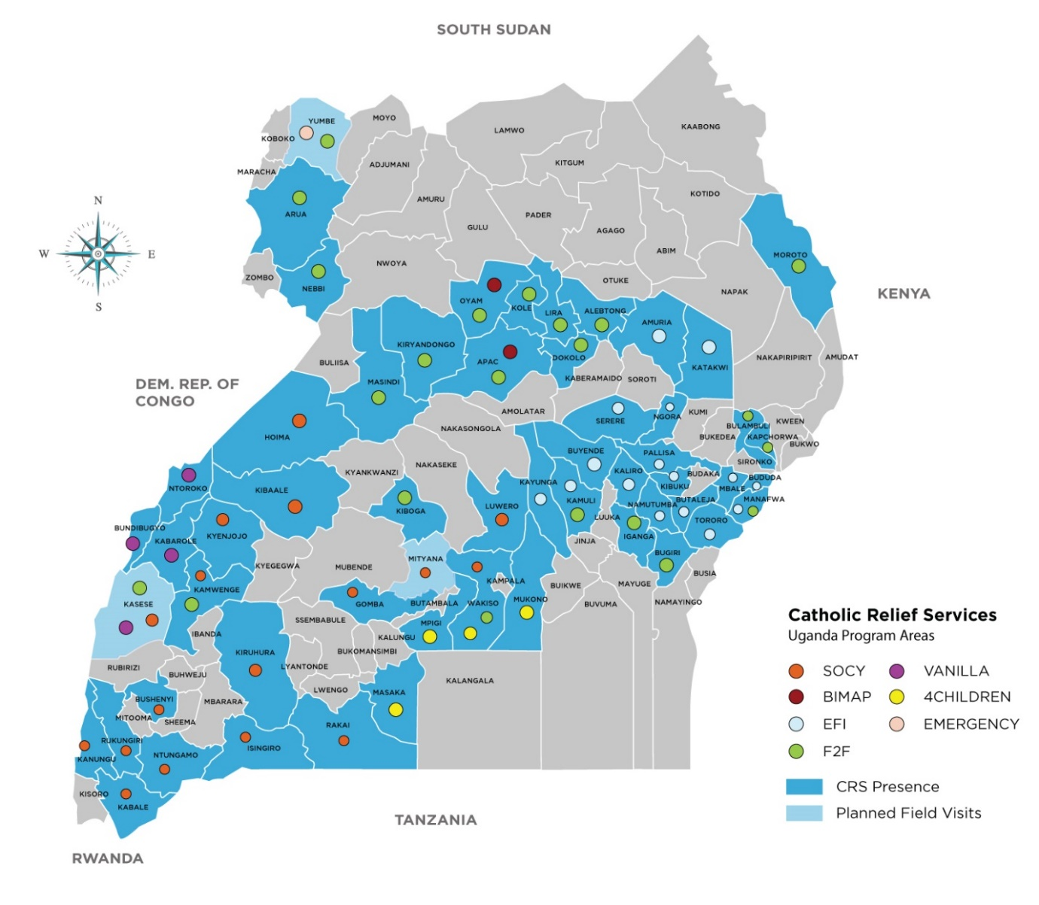
- CRS UGANDA PROGRAM AREAS

