volunteer toolkit

&

electronic library

VOLUNTEER TOOLKIT
Welcome! We are excited to offer this volunteer toolkit where all our volunteers can come to prepare for future assignments, or check on the progress of host organizations with whom they have volunteered. All our volunteers prepare group presentations and final reports detailing their statement of work, how they met those challenges, and future recommendations. You can search by topic, host organization, or a volunteers last name.

Group Presentations
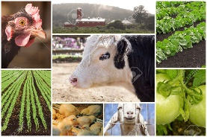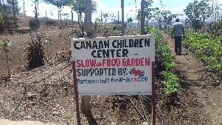
  - By Topic By Host Organization By Last Name

Final Reports

By Last Name

Country Logistics
It’s important to know what you need before you head out. This section will help you figure out what to pack, some things to expect when you arrive in country, and what you may need to consider when making plans for additional independent travel pre, or post assignment.

Ethiopian Kenya

Tanzania Uganda

ELECTRONIC LIBRARY
The Electronic Library is in the process of being built, and will house some of the materials that past volunteers have used in delivering their technical services to our recipients. Specifically, materials you can use to help strengthen the capacity of the host organizations you will be serving. An email with a link to the Library will go out once it has been completed.

FACEBOOK
We would like to continue the collaborations even after the assignments ends. Please join our CRS Farmer to Farmer Connecting Group. https://www.facebook.com/groups/979840875467579/ . The group is open to past volunteers, members of host organizations, and all CRS Farmer to Farmer Staff. It’s a wonderful way to keep in touch with members of your host organization while opening them up to a complement of others that may also be able to help them address additional areas of concern. Request to join, and the Librarian will approve your memberships.
Should you have any question, or need additional assistance, please contact our Electronic Resource Librarian, Adamaah.grayse@crs.org

