Social Media: Taking Photos & Videos

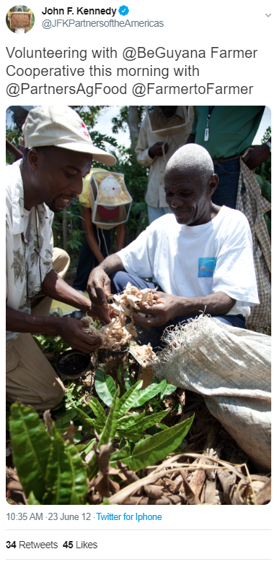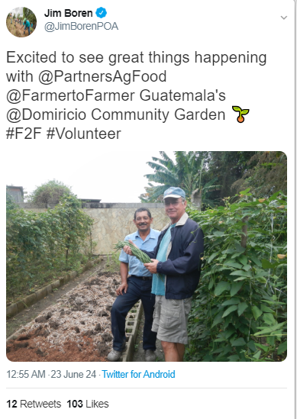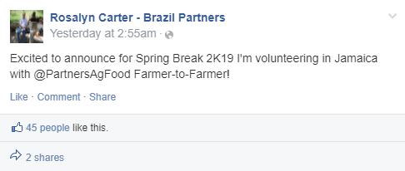

***Posting on Social Media?***

Tag **Farmer-to-Farmer!**

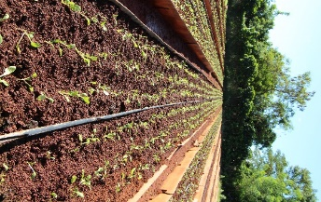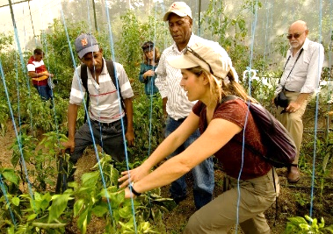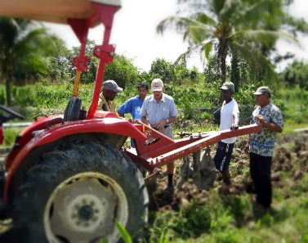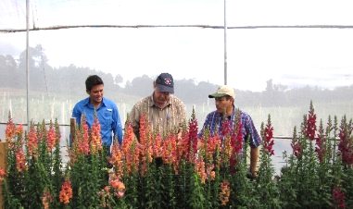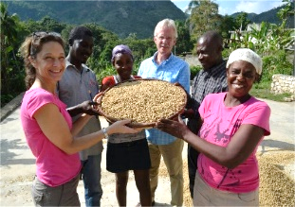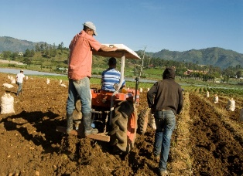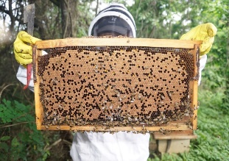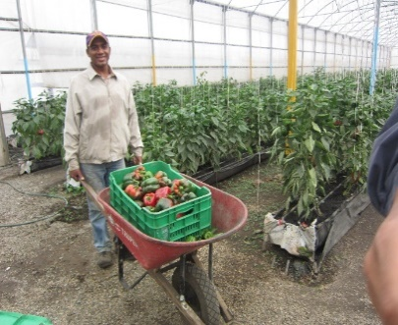

***Social Media***

Volunteers are welcome to post photos on social media throughout their assignment. Be sure to tag Farmer-to-Farmer.

Volunteers are welcome to use their cell phone for photos and videos. Please have a minimum dpi of 300 for photos.

*Ideas for photos:*

* Livestock, Crops, Participants
* You outside the host organization location
* You in action during the assignment with the host – *teaching, learning, engaging*
* Before & After shots – *A photo of a site or project before and after you finish your volunteer assignment*
* Time-lapse video of the weather
* You with your hosts
* Working with the field staff
* Trying new foods
* Local markets
* With new friends

*Ideas for posting on social media*

* Photos of your day
* Short introduction video of your host location
* Shoutout on location to your university, business, or family & friends
* “Here & There” Photo: *Shot of your office and your new on-location “office” on your assignment*