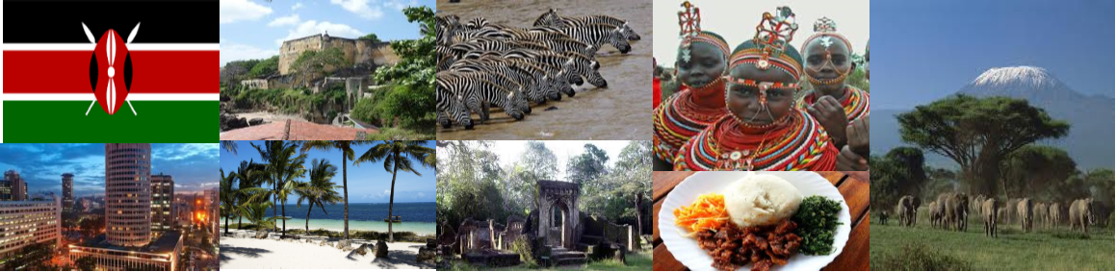
KENYAN LOGISTICS

Here is where you “strap in” and investigate all that Kenya has waiting for you, and what you need to do, or bring with you to make this a memorable, safe, and fun assignment. We have provided a few links to resources that will prepare you for your journey ahead. If you plan to take vacation before or after your assignment, please let your recruiter know to ensure adequate travel arrangements and proper insurance coverage.
The link below gives you an overview of Kenya’s: history, people, cultures, tribes, food, government, constitution, currency, population, religion(s), animals, agriculture, safaris, parks and game reserves.
KENYAN OVERVIEW
The link below tells you about getting there, travel tips, types of safari, car rentals, hotel, tour, and vacation apartment/ cottage Booking.
Facts to know before you travel to Kenya

Basic Kenya facts
Currency | Kenya shilling (KES). See more information on Kenya currency and conversion.
Electric Voltage | Current is 220/240AC 50HZ. See a photo of the plug adapter you need in Kenya.
Language | Swahili and English are the official languages in Kenya. Swahili is the national language while English is the business language. Kenyans speak other local languages as well.
Holidays & Business Hours | In addition to Christmas and Easter holidays, Kenya celebrates nine public holidays. See Kenyan Holidays for more information on holidays celebrated in Kenya, including business/shopping hours. Most businesses, banks, schools and government offices remain closed during Kenyan public holidays.
Kenya Newspapers | There are eight major local newspapers. See Kenya Newspapers for more information.
Temperature | 45 - 93°F on average. More about the climate and weather in Kenya
Time Zone | GMT +3
Topography | Low-lying coastal region fringed with coral reefs and islands; some dry regions covered with savannah and thorn bush; rich plateaus (highlands) as high as 10,000 ft.; and arid and semi-arid northern Kenya.

PRACTICE THE LAUNGUAGE
http://www.magicalkenya.com/visit-kenya/learn-swahili/
http://www.kenya-information-guide.com/kenya-language.html

OTHER SITES FOR ADDITIONAL RESEARCH
2017 Holidays
Time and Weather
Climate
Agricultural Country Stats/ Old Site – Overview of land use and major crops grown at a glance.
Agricultural Country Stats/New Site – You must select the “Search and Visualize” tab. Then select the vibrating file. It will open to a selection of tables that share information on agricultural production, crops, and the population.
http://www.magicalkenya.com/ - Kenya Tourism Board Website

WHAT TO PACK

