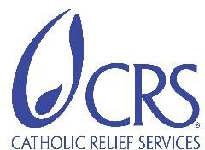
CRS/UGANDA VISITORS GUIDE

A. PURPOSE OF DOCUMENT

The purpose of this security management plan is to assure the personal safety of CRS national and international staff and other CRS visitors coming into Uganda

B INFORMATION BEFORE TRAVEL FOR NON-UGANDAN STAFF & VISITORS

CLIMATE
Uganda has mild weather throughout the year. Temperatures range between 20⁰C and 25⁰C (70⁰F - 80⁰F). Rainy season occurs primarily between March and May/June, and September through November. The rainy season at times come in either early/late during the year, so visitors are recommended to bring rain gear in case of need.

HEALTH
Visitors to Uganda will be asked to present certificates of vaccination against yellow fever at the airport upon entrance and exit. Travelers often chose to be vaccinated against Cholera, Typhoid, and Hepatitis A/B, and take malaria prophylaxis for the duration of their visit. Please consult a doctor. Additional precautions against malaria include the use of mosquito repellent and sleeping under a mosquito net. Well-trained doctors, reasonably adequate medical facilities, and amply-stocked pharmacies are available if health problems arise.

FOOD AND WATER
Fresh tropical fruits and vegetables are plentiful throughout the country, as is fresh-water fish from lakes and rivers. A wide range of dishes, both traditional and continental are served in the hotels and restaurants. Visitors should not be afraid to try the local cuisine, but should avoid eating uncooked, unpeeled fruits and vegetables. One should not drink water from the tap.
Bottled water is available for sale throughout the country.

LANGUAGE
Uganda’s official language is English, although Swahili is also spoken especially among businessmen, police, and the military. Many tribal languages are used in different regions – Luganda being the local language for Kampala and most parts of the central region, and Luo for the northern region.

1

CRS/UGANDA ADDRESS:
It is essential that you have the full address and contact details of CRS/Uganda BEFORE you arrive in case of emergencies en route; The CRS/Uganda “Constant Companion” has all the details to guide you.

ELECTRICAL APPLIANCES:
Standard domestic electrical equipment use is based on 220volts with the rectangular 3 pin plugs.

RECOMMENDED PACKING LIST
Business clothes for high-level meetings (For men: sports jacket and tie. For women: dress pants, dress or skirt and blouse)
Casual/comfortable clothes for field visits in temperate highland areas with cool evenings Shirts or blouses with long sleeves (to prevent insect bites)
Hat (for field visits)
Comfortable, closed shoes for walking (sneakers, boots) Shower sandals
Light jacket/sweater Windbreaker/rain coat
Insect repellent with at least 50% DEET Hand sanitizer
Over-the-counter pain medication and anti-diarrheal medicine Pepto Bismol tablets
Camera
I-Pad/book
Extra batteries (if needed) Sunglasses
Money belt or neck pouch Luggage locks
Sunblock

CRS Uganda Country Program

INFORMATION ON ARRIVAL IN UGANDA

  - Arrival in Entebbe:
The CRS office is located in Kampala city surburb of Nsambya – just behind the United States of American Embassy. All international flights terminate at the Entebbe International Airport.

Hotel Booking: CRS Uganda will handle your hotel booking in one of its contracted hotels in Kampala and or upcountry towns. Visitors are encouraged to pay for their meals and personal expenses prior to checking out of the hotel.

  - Currency: The country’s currency is the Ugandan shilling, foreign exchange usually changes but is currently trading at around 3,650 per U.S. dollar. CRS Uganda will pay for hotel accommodations and transportation for our guests. However, if any guests want to exchange dollars for souvenir shopping, please let us know the first day, and staff will take care of the currency exchange. Please do not exchange dollars at the airport

During Your Stay In Uganda

  - Culture/Dressing: Ugandans are friendly and open people and are accepting of foreigners. Men and women greet each other by shaking hands.

Both men and women tend to dress conservatively, with many men commonly wearing neckties during business hours (however, not normally CRS). For evenings and weekends, casual wear, including jeans are acceptable.

  - Security: To reduce the element of risk while in Uganda, we recommend that you always be aware of what is going on around you, especially when walking or driving.

    - Visitors should take general safety precautions, particularly in the cities. However, Uganda is a relatively safe country and Kampala is a safe city.

    - Avoid walking alone at night.

    - If you are in a car, keep all doors locked and windows closed and do not leave any valuables visible in the car.
    - Avoid displaying items of value such as jewelry, laptops, cameras and mobile phones and carry no more cash than is necessary.

3

    - Keep your eyes on your possessions, especially at airports and crowded tourist places.

  - Communication: Cell phone network coverage is available nationwide and is reliable. Although coverage can be spotty between major cities. The CRS office is equipped with wireless access, so visitors with laptops or smart phones will be given access to the password upon arrival. Wireless USB dongles are available for internet connection needs outside of the office.

Visitors shall be provided with a modest mobile phone with a sim card on the local network to enable ease of communication with staff in the country program.

Personal Documents: Carry a photocopy of your passport & visa page with you always. CRS may collect the passports before travelling to the field and secure them in the CRS office safe. All travelers are encouraged to register with their respective embassies (US State Department Smart Traveler Enrollment: https://step.state.gov/step/). The loss or theft of a foreign passport should be reported immediately to the local police and the respective embassy or consulate

- In Case Of A Medical Emergency in Kampala: Visitors are advised to contact the Uganda Country Representative as soon as possible and try to reach either The Surgery Hospital + 256 312 256 001/2/3 or +256 772 756 003 or International Hospital Kampala (as per details indicated on the Constant Companion)

Practical Dos And Don’ts

  - Alcohol: Consumption of alcohol is socially acceptable though precautions should be taken not to drink to excess in public. Visitors should be aware of this, and curb their drinking to conform to the generally accepted conduct.

  - Public Conduct: Loud and raucous behavior may attract unwanted attention from locals who might find your actions offensive and try to start a fight, and you might be targeted for theft as your defenses are down.

  - Political Discussions: If you are speaking with locals and the talk turns to politics or religion, it is advisable to listen but not to offer any opinions as this too can cause upset and lead to arguments

  - Smoking: Visitors must not smoke in public places. Smoking can only be done in gazetted places.

  - Walking: Visitors and international staff are strongly advised not to walk at night or travel at night between the hours of 7PM and 5 AM within any city or towns in Uganda on their own, and if you need to travel, always travel in a group.

  - Avoiding Health Issues: Avoid drinking tap water. Always drink bottled water. Also avoid raw vegetables and street food. You must also protect yourself from mosquito and other insect bites by wearing long sleeved shirts and trousers when going outdoors at night. Don’t handle animals (especially monkeys, stray dogs and cats) to avoid bites and serious diseases.

CRS Uganda Country Program 4

INFORMATION ON SECURITY THREATS FOR UGANDA STAFF AND VISITORS
Uganda is generally in a stable security conditions and Ugandans are very warm and hospitable people.

Terrorist Attacks
Uganda has in the past been affected by Al-shabab Islamist group and is blamed for the deaths of more than 80 people in 2 separate attacks in 2010 during the final match of world cup. The group still threaten to carry out more attacks but the government has been very vigilant since the last attack in 2010.

Urban Crime
Armed burglary in homes or on the streets and carjacking are reported occasionally in Kampala and in other cities.

Abductions
Kidnapping and abduction incidents of both locals by some dissidents for the purpose of extorting money or ransom is on the increase. This has not been prevalent in the Capital Kampala in the past but is very rampant in the most parts of the country.

Land Conflicts
The country is affected by the land grabbing and more especially in the central region. Some parts of Uganda especially the Central and the North experience intermittent land grabbing and inter- tribal conflicts, which make such environments generally insecure. General caution is also advised for field trips to certain volatile areas during election periods.

Threats On The Roads Between Cities
Most common threats on the roads are road traffic accidents, carjacking, traffic checks by police officials for reckless driving, no respect for speed limits or road regulations, aggressive driving); incompetence of drivers; non roadworthy vehicles, overloading of vehicles; intoxicated drivers, poor conditions of roads etc.

Increased Crime Rate From September To December
Road banditry, accidents and armed attacks are more prevalent during this period due to approaching holiday (December) season.

GENERAL SECURITY GUIDANCE
- Security Briefing: All visitors to Uganda must ensure that they are given a security briefing upon arrival within 48 hours.

CRS Uganda Country Program 5

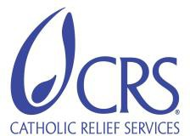
CRS/UGANDA VISITORS SECURITY SUMMARY

- Personal Vigilance: All staff & visitors must maintain a high state of vigilance, exercise caution and personal awareness, particularly in and around Kampala and more especially where there are large gatherings, hotels, markets and malls, and places of worship. Also, do not let your security staff or other workers in your place of residence know about the presence of money or expensive assets.

- Constant Companion: Always carry the CRS/Uganda Constant Companion to contact the security point person in case of an emergency.

- Staff Locator: All CRS/Uganda international and national staff must update the staff locator on the CRS intranet, prior to any field or international travel. With regards to international
travel for private purposes to a destination other than the staff member’s home country, the staff member must also inform the CR of the country being visited of their travel plans before leaving Uganda.

- Urban Crime: In the event of an attack by an armed robber or carjacking attempt, comply
with criminals’ demands. You are the most important asset for you and CRS.
Always keep some cash at home in a separate place to respond to an attack by armed robbers.

- Incident Report: You must report all security incidents to the security point person and the CR immediately and complete the CRS incident report.

CULTURALLY SENSITIVE BEHAVIOR

It is extremely important to treat all people with respect in Uganda at all times; the following could place staff in danger and is totally unacceptable:

- Heated disputes or arguments, particularly in view of others;
- Insults or perceived humiliation of anyone;
- Comments or behavior perceived as disrespectful of local culture, religion, or national pride;
- Hate speeches.

GUIDANCE FOR DOMESTIC TRAVEL

  - If CRS vehicles are not available, the fleet officer will arrange with the hired transport company to handle all business travels. National staff can travel with public taxis for their personal travels. For safety reasons, it is recommended that CRS visitors solicit local Administration support for referral in the arrangements for hired taxis when planning personal trips.
  - Driving any CRS vehicle under the influence of alcohol or narcotics is prohibited.
  - Absolutely no driving in CRS vehicles outside urban areas/destinations after 7pm by CRS staff (International and national) as well as visitors/consultant.
  - During field travel, CRS vehicles must be parked at the hotel/facility where staff are accommodated latest by 8pm
  - Carrying weapons, contraband substances, banned alcohol, pornography into CRS premises/vehicles is prohibited.
Revised:February 20, 2019 6

CRS/UGANDA VISITORS SECURITY SUMMARY

  - Transport of non –CRS employees in CRS vehicles should as much as possible be avoided
  - All CRS business travel must comply with latest departure times. Under no circumstance should a CRS vehicle depart from a location after the indicated time. The driver is responsible for ensuring this and has the mandate to remind the Responsible officer on that trip of the latest departure time and to refuse to depart the location after the latest departure time.
  - Maximum speed limits are 100km/h on highways and 30km - 60km/h while travelling through towns and villages
  - All passengers must wear seat belts.
  - Movement of CRS vehicles should be restricted to only essential purposes on /during weekends.

GENERAL & TEMPORARY RESTRICTIONS ON DOMESTIC TRAVEL

  - CRS International staff are not allowed to drive vehicles outside the Capital Kampala without prior approval from the Country Representative or his designate.

  - Due to the occasional uprisings and security situation in the country, CRS Uganda will keep and regularly staff on issues at hand.

  - CRS international staff or visitors who wish to travel outside the Kampala or Uganda on personal business must seek approval from the Country Representative and inform the Security Point person of their travel plans.

Revised:February 20, 2019 7

APPENDIX 2

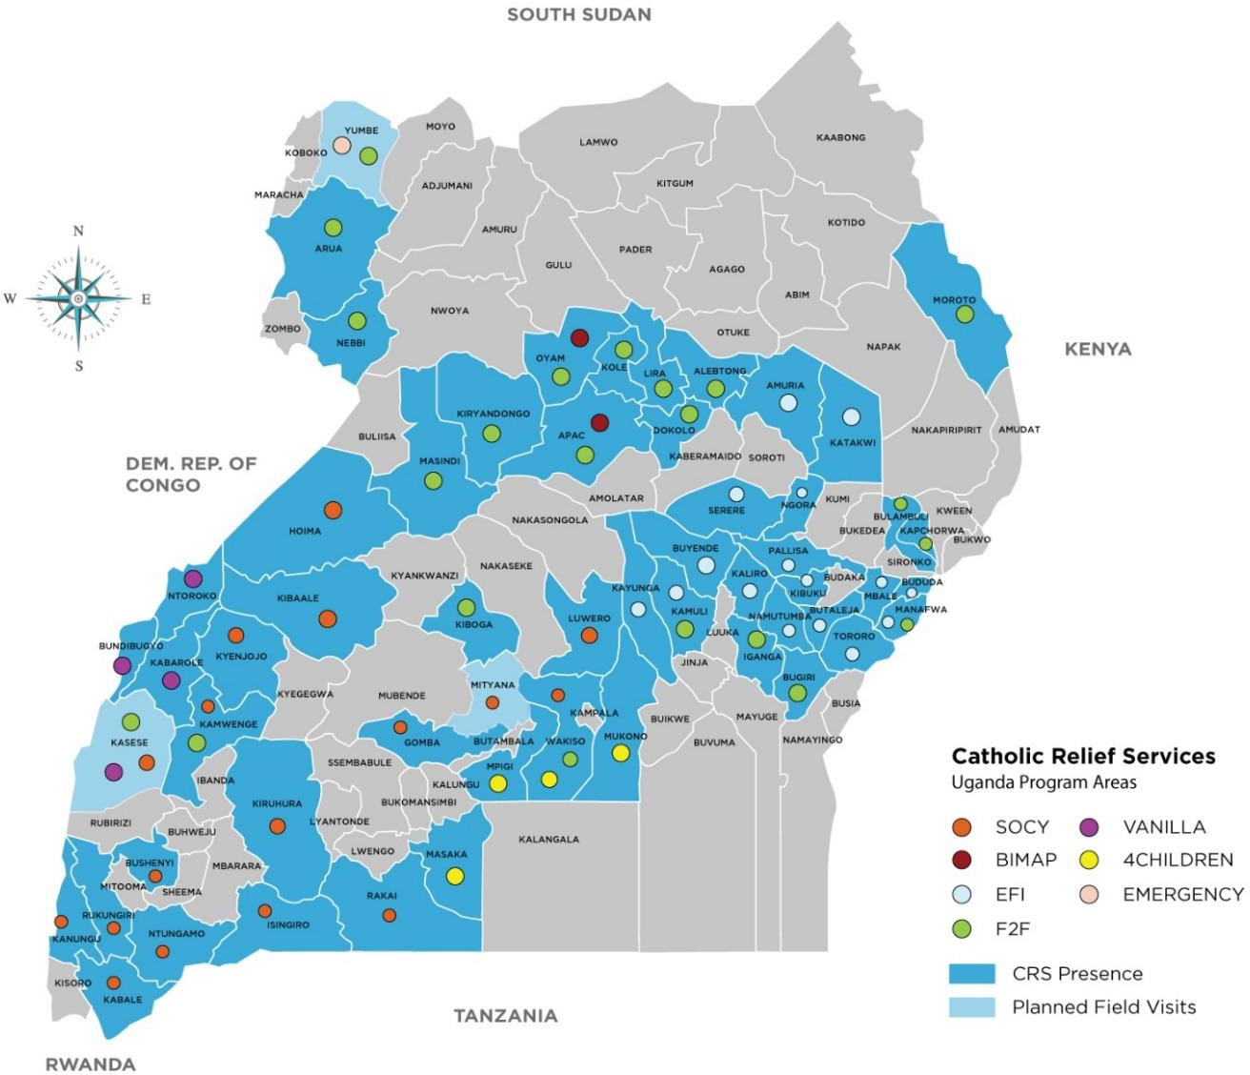

Revised:February 20, 2019 1

