Farmer to Farmer
Volunteer Assignment Scope of Work

Summary Information
Assignment Code |  | UG206
Country | Uganda
Country Project | Livestock Country Project
Host Organization | Kyeyo Farm
Type of Volunteer Assistance | Technology Transfer (T)
Type of Value Chain Activity | Information and Input Support Services (S)
Assignment Title | Poultry Waste Management
Assignment preferred dates | April- May, 2019
Objectives of the assignment | Design a poultry waste management system for Kyeyo Farm
Desired volunteer skill/expertise | An agriculture waste management specialist – specifically for the livestock sector. Expertise in designing cost effective waste management systems that can be adopted on medium to large scale farms in developing county contexts. Hands on experience on farm management.
PERSUAP classification | Not Applicable

- BACKGROUND
CRS Farmer -to-Farmer program (F2F) is a USAID funded program that will be implemented for five years (2019- 2023) with a primary goal of reducing hunger, malnutrition, and poverty across six countries: Benin, East Timor, Ethiopia, Nepal, Rwanda and Uganda. The program aims at achieving this goal through advancing inclusive and sustainable agriculture led growth aimed at generating sustainable, broad-based economic growth in the agricultural sector. The program’s secondary goal is to increase US public understanding of international development issues and programs and share the knowledge back in the US. To achieve its goals, F2F program provides volunteer technical assistance to farmers and farmer groups (associations and cooperatives), private agribusinesses, agriculture education institutions in developing countries like Uganda to address host identified technical needs in selected agricultural value chains. F2F volunteers are pooled from abroad range of US agricultural expertise, from private farmers with varied experience, University professors, bankers/certified accountants, animal health and nutrition specialists, soil scientists, agronomists who support local host organisations F2F program introduces innovation and develops local organisations capacity for more productive, profitable, sustainable and equitable agricultural systems while providing an opportunity for people- to-people interactions within the agricultural sector. In Uganda F2F program will focus its technical interventions in the livestock and agribusiness value chains

Kyeyo Farm located 23 miles (37 km) West of Kampala City along Hoima road is a private enterprise owned by Mrs. Lucy Mbonye, a progressing local farmer. The farm sits on a total land area of 400 acres currently with 243 improved (Friesian breed) dairy cows comprising of 63 milking cows, 19 dry herds and the rest as young stock including calves. The farm also boasts of 63 improved goats, 78 ducks/geese and over 5,000 layer-birds., and recently introduced 2,000 broiler parent stock. Milk production currently averages 19-22 liters per cow per day making a daily total milk production is about 800 liters per day however, this has dropped to 400 liters due to the newly installed automated milking equipment. Approximately 180 acres of the total farm area are utilized for planting corn (maize) or forage grass for animal feeding; The rest (100 acres) lies fallow with native pasture. In addition, Kyeyo farm has a poultry section (laying birds- for egg production) which has been in existence for two years now and has recently introduced broilers for parent stock production. The farm continues to grow steadily with a recent introduction of the battery cage system of poultry rearing, to accommodate increased numbers and better management, the increase in bird numbers has equally increased the amount of waste generated on the farm, the management team lacks knowledge and expertise on how to manage this waste in a cost effective (in terms of time and labour) manner
- ISSUE DESCRIPTION
The poultry subsector is fundamental to the agriculture sector contributing greatly to sector growth., It’s also a source of proteins for meeting nutrition needs in households. Poultry has been noted as an attractive economic activity mostly for women and poor households. Statistics show an increase in demand for poultry products in future due to growing urbanization, population and income growth. The 2016- 2020 Agriculture Sector Strategic Plan (ASSP) reported poultry production at 54,868 Metric Tons (MT) in 2014 with a projected increase to 63,647 MT by 2020. Matching the increase in productivity with the projected increase in poultry product demand. The ministry of agriculture is targeting support investments to establishment of exotic layer and broiler grandparent stock farms to provide seed stock to improve local availability, providing technical support, training, monitoring and supervision of hatchery operators of the grandparent stock among other priority investments. Kyeyo Farm is greatly contributing to growth in the poultry subsector- specifically now where its raising broiler parent stock for local availability of seed stock to small holder farmers with in its locality ensuring availability of good quality chicks. In addition to its original raising of layers for egg production, the farm currently owns a total of 7,000 birds, this is considered a large-scale poultry farm by Ugandan standards.
Kyeyo Farm’s large-scale bird facility has come with its share of challenges especially in the amount of poultry waste generated on the farm. Substantial amounts of poultry waste are generated which has become labour and time intensive to collect the waste, in addition to raising issues of potential environmental impact, human health for the farm workers, and the health of birds, while considering long-term growth and sustainability of the facility, other neighboring areas will be affected. The farm has installed the battery cage poultry management system which is designed in a way that the poultry droppings collect in a pit below the cages. Farm workers have to manually climb into the pit twice a week to collect the waste- this exercise is cumbersome, laborious, time intensive and jeopardizes the health status of the staff. The waste is transferred to pasture fields to replenish the soils. However, the process of collecting the waste is labour intensive and weighs heavily on the staff which has resulted into infrequent collection of the waste leading to its build up in the poultry houses, the situation is aggravated when some birds pass out watery droppings which leads to build up of ammonia. Kyeyo farm is therefore seeking for F2F volunteer technical support to advise and design a more effective waste management system for the poultry enterprise. See attached annex with some photos.
- OBJECTIVES OF THE ASSIGNMENT
The main objective of this volunteer assignment is to assess the current poultry waste management system employed by Kyeyo farm and recommend and /or develop a more appropriate waste management system.

Specific objectives:
- Assess existing poultry waste management system and its potential risks to human health and poultry health, the current disposal of waste in the crop fields and any potential or future effects on crop and soil health and existing water systems in terms of pollution and how this affects other enterprises on the farm.
- Design a more appropriate poultry waste management system and advise on options for proper disposal – provide alternatives of disposal based on assessment.

- HOST CONTRIBUTION
Kyeyo Farm has committed to avail staff involved in the poultry section to work alongside the volunteer. The farm manager will be available to work closely with the volunteer for the entire duration of the assignment.
- ANTICIPATED RESULTS FROM THE ASSIGNMENT DELIVERABLES
The anticipated assignment deliverables will include:
- Trainings conducted, and people trained
- A separate assessment report with detailed recommendations, options and considerations for poultry waste management
- Debriefing with USAID and in country group presentations after assignment
- Field trip report and expense report

- SCHEDULE OF VOLUNTEER ACTIVITIES IN COUNTRY (DRAFT)
Day | Activity
Day 1 | Travel from home to US international airport
Day 2 | Arrival at Uganda Entebbe Airport, the volunteer will be picked by Fairway hotel shuttle to Kampala and check in at Hotel.
Day 3 | At 9.00 am, the volunteer is greeted at the hotel by CRS staff and thereafter go to CRS office for introductions and briefings including host brief, logistics and expectations and anticipated outcomes. Any materials for printing will be prepared at CRS offices.
Day 4 | In the morning, travel to host location in wakiso CRS introduces the volunteer to the Kyeyo Farm management team. Together with CRS and the management, the volunteer will review and finalise the work-plan. The action plan should include group presentations to be done after the assignment.  Familiarise with Kyeyo Farm operations, and the poultry section – understand current practices and challenges in poultry waste management
Day 5-13 | Review current waste management and disposal options. Design a more appropriate poultry waste management system
Day 14 | Work with Kyeyo poultry staff in immediate or short-term options for managing waste.
Day 15 | Review recommendations and draw an action plan for their implementation with Kyeyo farm manager/owner and CRS F2F teams.
Day 16 | Debriefing at CRS office with USAID Mission and CRS staff.  Volunteer will finalize his/her reporting at CRS office and fill out all necessary M&E forms as well finalize advances and expenditures with finance.
Day 17 | Depart for USA
TBD | Outreach event in the US
Note: This is a draft schedule that will be finalized based on volunteer actual dates of availability, Sundays are typical rest days and working on Saturday is, per the host’s request

- ACCOMMODATION AND OTHER IN-COUNTRY LOGISTICS
The volunteer will stay at Fairway hotel, www.fairwayhotel.co.ug. for the entire duration of the assignment. The volunteer will be provided with a modem from the CRS field office for internet access while in the field and a mobile phone to facilitate in country communications.

CRS will pay for hotel accommodation and provide volunteer with per diems to cater for meals and other incidentals. The volunteer may get an advance which has to be cleared before departing Uganda. For more information, please refer to country information that will be provided

- RECOMMENDED ASSIGNMENT PREPARATIONS
- Before leaving U.S.:
- Learn about different poultry waste management challenges and available options in tropical climates
ii) In-country activities/tasks
- Assess current production levels, waste management options and associated challenges
- Together with management, design appropriate waste management options
- CRS-F2F designs assignments with the assumption of some pre-departure preparation by the volunteer. Actual preparation time will vary based on the experience of the volunteer, as well as informational or training resources the volunteer has readily available. CRS relies on the volunteer to assess the tasks outlined in this SOW and to make his or her own judgment about how much and what kind of preparation is needed prior to arriving in Uganda
- The volunteer should prepare materials for hand out which can be printed at CRS office in Kampala before commencement of the assignment. Flip charts, markers, masking tapes can be obtained at CRS offices.
- CRS strongly recommends that the volunteer become familiar with CRS programs in Uganda, especially the livestock country project description and other information in the briefing pack before arrival to Uganda

- KEY CONTACTS
CRS Baltimore | CRS EA Regional Office
Maria Figueroa  US F2F Operations Manager  EA Farmer to Farmer Program  228 W. Lexington Street  Baltimore, MD 21201  410-951-7366  Email: maria.figueroa@crs.org | Nyambura Theuri  Deputy Project Director  EA Farmer to Farmer Program  P.O. Box 49675 – 00100  Nairobi, Kenya  St. Augustine Court Karuna Close Road  Email: nyambura.theuri@crs.org
CRS Country Program
George Ntibarikure  Project Director  Farmer to Farmer Program  Uganda  Office Tel: +256 031 226 5658  Mobile cell phone +256 772 472 103  Email: George.ntibarikure@crs.org | Maria Nakayiza  Senior Project Coordinator  Farmer to Farmer Program  Uganda  Office Tel: +256 031 226 5658  Mobile cell phone +256 783922882  Email: maria.nakayiza@crs.org
Host Organization:
Bob Nsaba
Kyeyo Farm, Wakiso
Farm Manager
Email: 'oglogbob@hotmail.com'
Mobile: +256 778 563 399

Annex1: Photo illustrations to describe poultry waste management issue
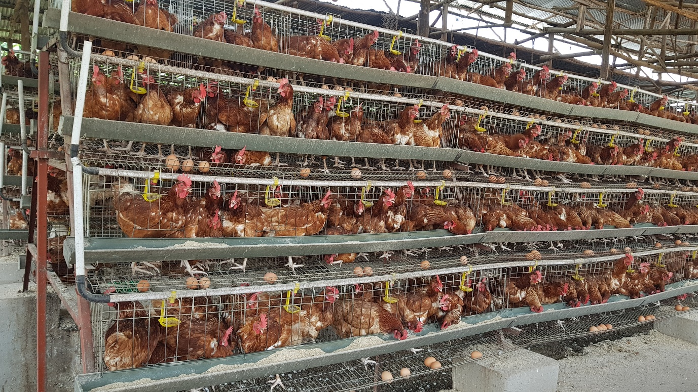
Cage system installed at Kyeyo Farm

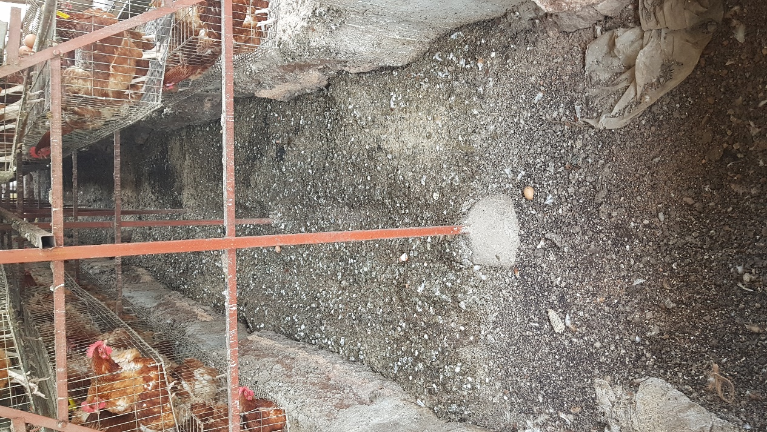
Hole dug between two cages to trap poultry waste

