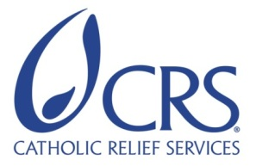
Farmer to Farmer East Africa
Volunteer Assignment Scope of Work
NOTE: THIS SCOPE OF WORK IS AWAITING FINAL EDITS
Assignment Summary
Assignment Code | TZ97
Country | Tanzania
Country Project | Horticulture
Host Organization | Karagwe Development Cooperative Union (KDCU)
Assignment Title | Strengthening the Governance, Management and Organizational Capacity of (KDCU)
Assignment objective | The overall objective of the assignment is to impart the requisite skills to the board and management so as to be a leader on development of the coffee industry in the region. This will be achieved through a TNA and follow on training on:  - Organizational capacity assessment of the board and management  - Design a training plan /module for the board and management to specifically address the governance and management gaps identified  - Conduct the designed training with the board, management and the LWR support teams  - Facilitate the board and management to clearly understand how to implement the strategic plan and/or modify the strategic plan to meet current needs
Desired skills | Organizational governance, development and management specialist especially for farmer cooperatives in developing countries.
Assignment preferred dates | Open – All year round

- Background:

The Farmer-to-Farmer (F2F) East Africa program is a program that uses short-term US volunteer expertise to assist small holder farmers and small scale processors in East Africa to improve their business practices through volunteer assignments conducted with host organizations. The goal of the (F2F) project is to increase incomes and improve nutritional status of Tanzanian smallholder farmers through; smallholder farmers increased productivity of agricultural crops, improved access to and utilization of markets and credit and preservation and enhanced natural resources upon which target communities depend. The program reaches out and establishes partnership with like- minded organizations, the latest been the Lutheran World Relief (LWR) that has been supporting the Karagwe District Cooperative Union (KDCU) since 2015 to strengthen this apex organization in the best way to serve its’ members, a three-year program.

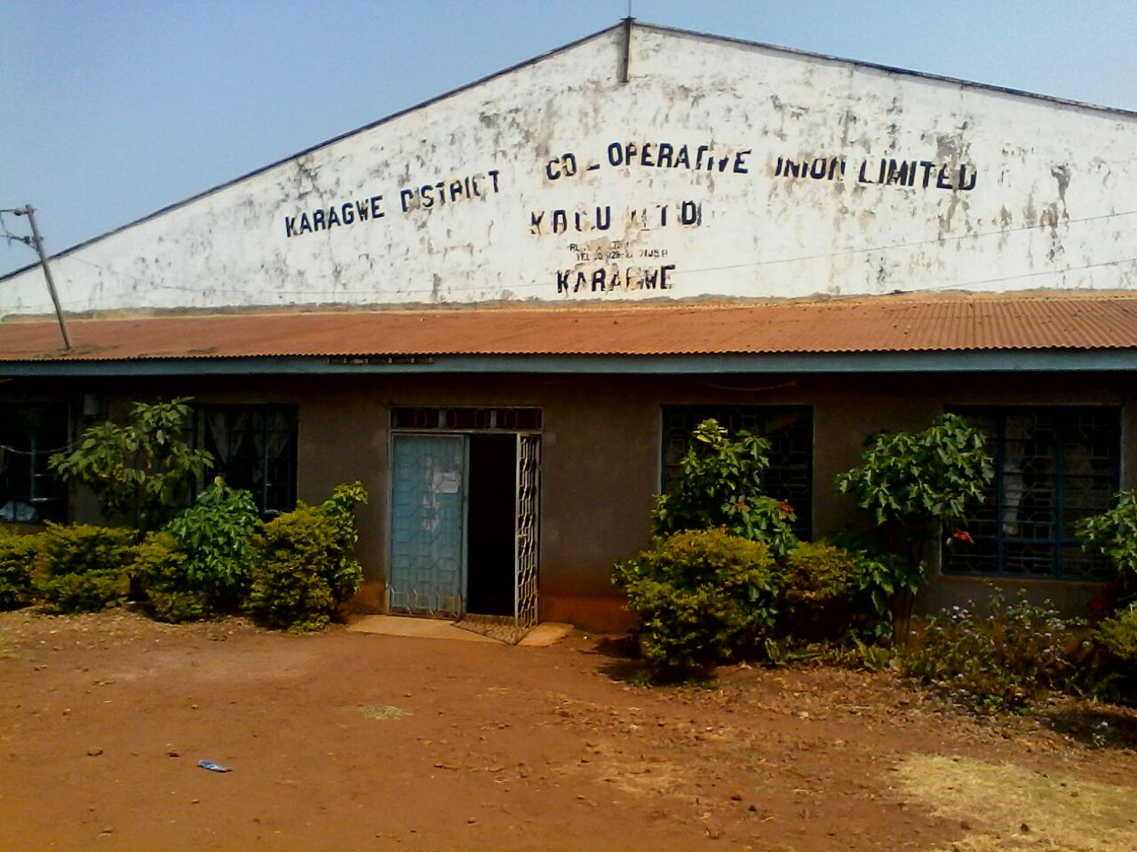
Karagwe District Cooperative Union (KDCU) is a member-based, Cooperative Union established in 1990 as a result of a split from the Kagera Cooperative Union. KDCU is located in the Karagwe District, Kagera Region of Tanzania, on the western shores of Lake Victoria, about 1000 km from Dar es Salaam. The cooperative was established for the purpose of supporting their members to access production services and markets for coffee and other commercial farm products. In addition, KDCU focusses on the implementation of grassroots development needs identified by the beneficiaries. KDCU has 81 member Rural Primary Cooperative Societies (RPCS) serving a total of 21,000 members. KDCU is registered under the cooperative act of 2004 and operates in Kyerwa and Karagwe District in Kagera region. KDCU has been granted by Lutheran World Relief to implement a three -year project named Pamoja kwa Mafanikio “Together for Development” that will benefit a total of 9,864 members of 36 member RPCS in Kyerwa and Karagwe district s. The objective of the project is to support KDCU and its RPCs members to operate viable businesses, also support farmers to diversify their income sources.

KDCU has three major 3 operations: 1). Collecting 2). Processing and 3). Marketing and selling coffee beans from its members

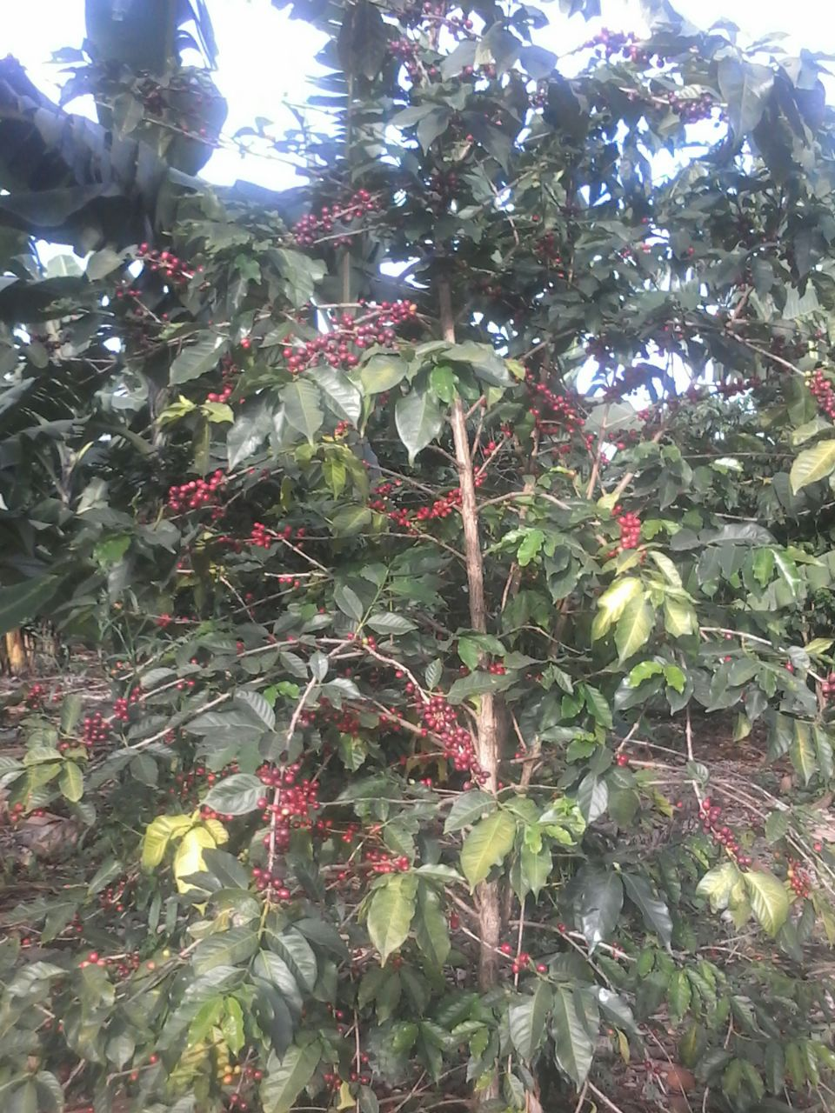
Collection of cherry coffee from farmers who are members of Cooperative: Farmers of Karagwe and Kyerwa District produce organic Arabica and Robusta coffee even though 90% of the farmers produce Rob usta and only produce 10% Arabica coffee. Framers don’t use inorganic chemicals, instead they use mulching and cow dung manure as fertilizer. At harvest time, farmers pick the ripe cherries and spread these on plastic sheeting on the ground for drying, a process which takes around 14 days. The dried cherries are packed in 70kg bags for delivery to the primary cooperative society which purchases the cherries using a cash advance from KDCU. The bulked coffee is then transported by rented trucks to the main warehouse where it is stored before being delivered to the processing factory. In order to purchase the cherries KDCU borrow capital from local banks to repay after selling coffee beans to the market. For the past three years KDCU has managed to collect a total of 8,470MT cherry coffee while the highest collection was in the 2014/2015 season whereby they collected 4,238MT
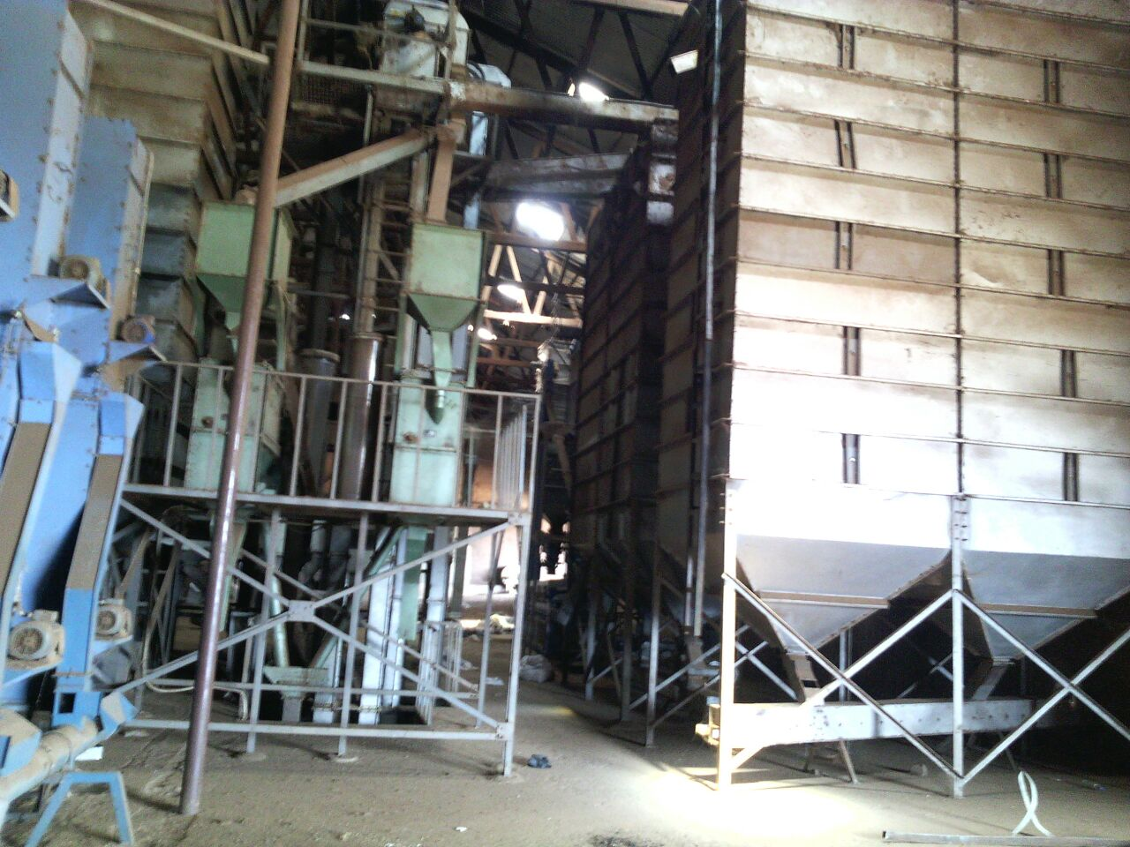
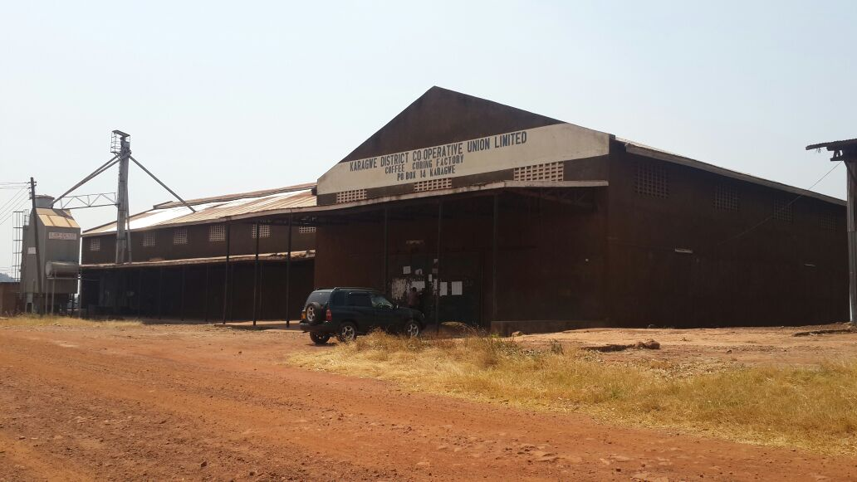
Processing of cherry coffee. KDCU owns and operates a coffee processing factory. At the Factory, dried cherries are stored in bulk awaiting hulling, sorting, grading and bagging. Hulling machines removes the outer cover of the coffee leaving the beans. The hulling machine also polishes the beans to remove any other unwanted material which both improves the appearance and quality of coffee. After polishing, the machine shakes the beans thru a series of sieves, sorting them by size ready for packing based on size. KDCU does not have a color sorting machine therefore sorting is done manually. In the 2014/ 2015 season, efficiencyciency of the factory was improved by 60% due to the numerous training provided by the LWR project. A consultant was hired to study the processing and thereafter advise on improvement. From 2014 backwards the factory was employing more than 600 staff in a season to run the factory but after training, KDCU is now employing less than 200 staff in a season. The improvement in efficiency has even allowed KDCU to contract its hulling services to a private buyer and hulled a total 500MT substantially increasing its revenue. At the height of the harvest season, 540 workers are employed in the dry coffee curing process in which the coffee beans are cleaned, hulled, polished, graded and packed.

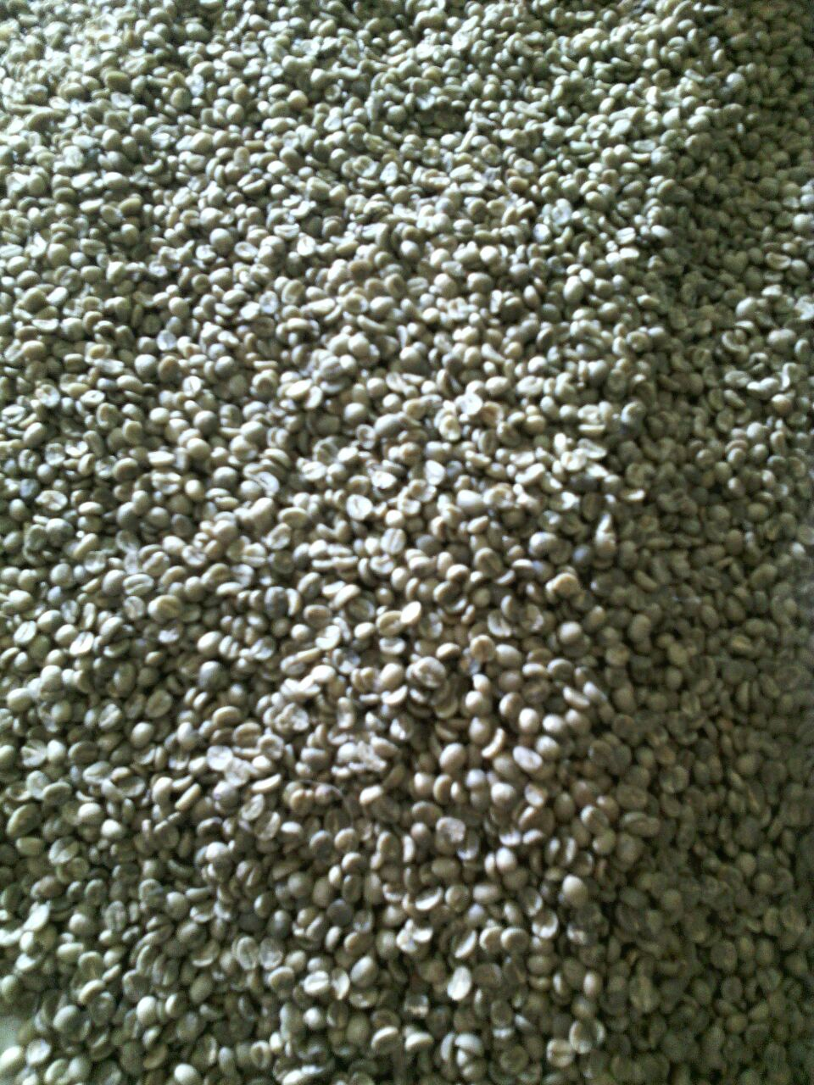
Marketing and selling coffee beans. KDCU has a responsibility of marketing and selling its members coffee within and outside the country. Within the country, KDCU has been selling coffee through auction markets. Additionally, KDCU has a license of exporting coffee outside the country, and has been selling coffee to different companies like ECOM, SUCCADEC, Olam International etc. KDCU has managed to sell a total of 4,635 MT of clean/ bean coffee while the highest selling was 2014/2015 whereby they sold a total of 2,248MT. The increase in sales especially for last year was due to higher confidence by the farmers in the cooperative marketing process. Farmers discovered that the other buyers are not honest with the weighing process even when there was a slight marginal increase in their prices and this was as a result of the LWR interventions.

B: ISSUE DESCRIPTION:

In spite of the LWR support, KDCU, which represents about 20,000 coffee farmers in Karagwe and Kyerwa districts, and its’ 81 rural primary cooperative societies (RPCS) is not self-sustaining. While KDCU and the RPCS are potentially viable entities for delivering business services required by their members in the coffee value chain, they are weak and operate in an unsustainable manner. KDCU has a weak governance that impedes growth. The board and management are not in good terms, management complaining that the board interferes too much with the work of management while the board is not clear of its functions. In March 2016 the board was suspended by the District Commissioner due to misunderstandings between themselves. As per the LWR analysis the KDCU potential is not fully utilized due to the following key issue related to management.

- KDCU board members face a number of challenges including misunderstandings among themselves, no clear board plans to lead KDCU, no transparency among board members, and misunderstandings between the Board and Management.
- The board does not understand their roles and responsibilities which results in conflict of interest especially for some members who were also serving as board members of other coffee companies that are competitors of KDCU in the coffee market.
- Generally, there is poor governance of the board which translates into major challenges that impedes growth of KDCU.
- KDCU board lacks or does not understand the strategic plan that would guide the leaders and staff to remain relevant to their respective membership and help the organizations move in a strategic, focused direction for growth.
- Though LWR has supported in developing a strategic document for sharing information, the board is not promoting transparency, accountability and cross sharing between and among members
- There is a new board in place since May 2016 since the KDCU Annual General Meeting suspended the former board on 8th April 2016 and this is an opportunity to mentor and steer the board into a new and effective direction

C: OBJECTIVE OF THE ASSIGNMENT
The new board is committed and supportive to the management. It has held two meetings in which they drew action plans that will guide them to run the KDCU management. But there are still gaps; most of board members are not trained to understand their governance roles and responsibilities, and they don’t have exposure/training on how to run a successful Cooperative union. Therefore, the KDCU is requesting the support of the F2F volunteer expertise to implement the following:

- Conduct organizational capacity assessment of the board members and management for a clear understanding of the gaps. The assessment will evaluate the board’s understanding of key components of good governance such us rule of law, transparency, accountability, responsiveness, participation, consensus, collective actions, conflict of interest.
- Using the results of the assessment the expert will design a training plan /module for the board and management to specifically address the gaps identified
- The expert will proceed to conduct the training with the board, management and the LWR support teams separately and then where appropriate joint sessions – it is expected that some of the trainings will cover such subjects as; best management practices, cooperative governance best practices, separation of roles and responsibilities for board and management, the rule of law, transparency, responsiveness, accountability, participation, consensus building among and between board and management among others.
- Facilitate the board and management to clearly understand how to implement the strategic plan already developed with the support of the LWR in order to serve as a guide that the board and management will use to guide the KDCU so as to remain relevant to their respective membership and steer the organization to the heights anticipated by its members.

D: ANTICIPATED RESULTS FROM THE ASSIGNMENT
- A training needs assessment report both for the board and management with recommendations for action
- Training modules /syllabi speaking to the gaps identified
- KDCU board, management and the LWR support team trained on the above
- KDCU board, management and LWR support staff walked through the existing strategic plan for a clear understanding and where necessary revised to align with the existing situation
- The expert will facilitate the three groups to prepare one annual action plan following the training that will inform the volunteer report that will be submitted to KDCU, the LWR and CRS F2F project

E: SCHEDULE OF VOLUNTEER ACTIVITY IN TANZANIA
The host would prefer to flesh this out once the skills and background of proposed volunteer (s) are determined to align with the period the expert will devote for the assignment. Opportunity to provide their feedback on amount of time needed for training and developing the training modules will be offered to the volunteer/s identified for the assignment. It is proposed that the expert/s identified engage very closely with both the F2F team Tanzania, KDCU and the LWR Tanzania as soon as possible once identified to clarify on the needs/ situation as he/she prepares for the assignment. Following is a very tentative schedule subject to change with the reality on the ground
Day | Activity
Day 1 | Travel from home to US international airport
Day 2 | Arrival in Dar es Salaam DAR airport. The volunteer will be picked from the airport by a designated cab and driven to the Amariah Hotel and Boutique
Day 3 | At around 09.00 am the volunteer will visit with the CRS office for logistics and briefing and then take a flight Bukoba and then about 2 hours’ drive to Karagwe
Day 4 | Upon arrival in Karagwe, the first day would be spent with Anna Mlay-KDCU General Manager and management to go over assignment objectives, determine what’s achievable, and spending time with KDCU staff to assess their knowledge and gaps.  Start developing a schedule
Day 5-6 | Assessment
Day 7 | Rest
Day 8-10 | Training
Day 11-13 | Training
Day 14 | Rest
Day 15-17 | Training
Day 18-19 | Group feed-back and action planning process by KDCU and management
Day 20 | Travel to Dar es Salaam
Day 21 | Rest
Day 22 | Volunteer will finalize his/her reporting for CRS, LWR and KDCU; provide feed-back on assignment to CRS/USAID Representatives. Depart for USA evening
TBD | Outreach event when back in the US

F. DESIRABLE VOLUNTEER SKILLS-
Essential:
Demonstrated expertise of the following:
- Board governance and management best practices for farmer cooperatives
- Organizational development/management best practices especially for farmer cooperatives
- Ability to diagnose problems and design tailor made trainings to target groups
- Some understanding of the challenges/ dynamics facing small holder coffee producers in Africa would be an advantage
- Prior travel to Africa or other developing country and understanding/familiarity with cultural differences
- High level of comfort with ambiguity and ability to adapt to quickly changing circumstances
- Patience, fortitude, and sense of humor are crucial to succeeding in this environment!

G: ACCOMODATION AND OTHER IN-COUNTRY LOGISTICS-
In Dar es Salaam the Volunteer will stay at the Amariah Boutique Hotel nearby the CRS offices, located on Dr. Kairuki Road, Mikocheni, Dar es Salaam, Tanzania, ‏‎0044 203 564 5228.
While in Karagwe the volunteer will stay in a local hostel that meets F2F’s standards for security, safety, and convenience.
There are several banks (including Barclays) with reliable ATMs in Dar es Salaam and Bukoba that the expert will use if required.
KDCU will provide local ground transportation to/from office and to field sites.

H: RECOMMENDED ASSIGNEMENT PREPARATION-
As part of preparation for the work ahead the volunteer should familiarize with USAID Feed the Future program, the EARO and Tanzania F2F horticultural program proposal and scope of work for this particular assignment. It is highly recommended that the volunteer link up and engage with the LWR and KDCU as much as possible for a very clear understanding of the assignment and the working environment prior to travel. It is also advisable that the volunteer read and familiarize with Tanzania, the coffee industry and how the cooperative movement in Tanzania operates. The KDCU and LWR will ensure supply of any required stationary for the assignment and so the expert can inform prior to travel or while on site what will be needed to successfully accomplish the assignment.

I: KEY CONTACTS

CRS Baltimore | CRS EA Regional Office
Maria Figueroa  Volunteer Coordinator  Farmer-to-Farmer East Africa  228 W. Lexington Street  Baltimore, MD 21201  410-951-7366  Email: maria.figueroa@crs.org | Nyambura Theuri  Deputy Project Director  EA Farmer-to-Farmer Program  P.O. Box 49675 – 00100  Nairobi, Kenya  St. Augustine Court Karuna Close Road  Email: nyambura.theuri@crs.org
CRS Tanzania
Mary Kabatange  Farmer-to-Farmer Program Country Director  Plot # Migombani Street, Regent Estate, Mikocheni  P. O. Box 34701 Dar es Salaam  Tanzania  Office Tel: +255 22 2773141  Mobile cell phone +255 758 820025  Email: mary.kabatange@crs.org | Brian Gleeson  Country Representative  CRS Tanzania  Plot # Migombani Street, Regent Estate, Mikocheni  P. O. Box 34701 Dar es Salaam  Tanzania  Office Tel +255 22 2773141  Mob: +255 754 930966  Email: brian.gleeson@crs.org
Moses Kabogo  Country Program Manager  Lutheran World Relief  Tanzania  Phone:+255718576045  Email: mkabogo@lwrearo.org  Skype: lwr_moseskabogo | Anna Mlay  General Manager KDCU  P. O. Box---  Email: anna55tz@gmail.com

