
Farmer to Farmer East Africa
Volunteer Assignment Scope of Work
NOTE: SCOPE OF WORK AWAITING FINAL EDITS
Assignment Summary
Assignment Code | TZ91
Country | Tanzania
Country Project | Grains
Host Organization | International TanFeeds Ltd.
Assignment Title | Efficient operation and maintenance of animal feed machinery
Assignment objective | Training to TanFeeds staff on proper operation and maintenance of feed meal machinery.
Desired skills | Animal Feed/Soya Processing Plant management
Assignment preferred dates | Anytime from August 2016

- Background
The grains sector is targeted for the CRS F2F technical assistance because grains are key staple food for the majority of Tanzanians. Strategic interventions in these value chains also have great potential to contribute to the USAID goal of sustainably reducing poverty and food insecurity by increasing productivity and profitability of grain crops. The key challenges experienced by small scale farmers involved in the grains chains include limited access to markets, poor pricing, limited access to agricultural credit for farm inputs and overall poorly organized farmer associations/ cooperatives. Value addition and processing are poorly developed and the current practice of selling unprocessed grains exacerbates the problem of low prices. Agro-processing companies provide market outlets for the farmer produce, and their business growth and development are directly linked to farmers’ welfare, especially when these agro-processors are competitive because then they have an assured market for the farmers’ produce.
This scope of work is for providing volunteer technical assistance to the International Tanfeeds Limited, a private company that manufactures and sells various types of animal feeds (chicken, pigs, dairy). The business is located in Morogoro Urban district at Kihonda ward S/industry (some 200 km from Dar es Salaam). The area is easily accessible with all amenities. The company was registered in 2008 with a mission to process animal feeds and soya bean oil for human consumption and the resultant cake for animal feed. Its vision is to become a leading agro-processing Company in Tanzania based on efficient utilization of locally produced materials. Initially the company relied heavily on sardine as the key protein source for the animal feeds but has switched to soy bean due to many challenges with the use of sardines. Some of the challenges with sardine include; heavy adulteration with sand (to cheat on weight), dwindling supplies due to overfishing in the lakes (Victoria and Tanganyika), poor animal products as a result of fishmeal consumption (fishy smell with eggs and meat) and wastage due to poor drying practices and other losses. Increasingly prices for sardines have been unpredictable and climbing higher due to high demand and competition as human food within the country and across to the neighboring countries like DRC, Zambia and Malawi.

TanFeeds is a progressive company. In order to explore the still untapped demand for animal feed the company has an ambitious plan of scaling up and processing 100 tons of feed per day. Currently they manage 10 tons per day.

- Issue Description
TanFeeds company has technicians and operators who need more training on operation and maintenance of animal feed processing plants. The company has so far received 2 F2f volunteers who worked with the company from November 28th to December 19th, 2015; Ralph Stonerock (ralph@flyinaballoon.com) provided training on chicken feed formulation. As part of his assignment he made a tour of the plant and observed low milling efficiency and lack of repair for the machines.

The lack of repair is partly due to the fact that the Chinese manufacturers of the machines do not follow up with their customers to provide maintenance training and support after installation. Hence the need for another assignment for training TanFeeds technicians on efficient operation and maintenance of animal feed machinery.

Another volunteer, Bill Clapham (wclapham@gmail.com) worked with the company on strategic market plan development. His recommendations included maintenance of product quality and exploring a niche market for soy oil.

As per recommendations by previous volunteers TanFeeds has improved immensely on quality control and feed formulation. Also, they have started to use digitized weighing machines and have started to package chicken feeds in small amounts (1- 10kg) suitable for small scale poultry keepers. Recently they have installed 2 soy bean driers so as to scale up production of soy oil.

- Objectives of the Assignment
- To train TanFeeds management and 16 TanFeeds employees on efficient operation and maintenance of feed processing machinery. The machines include soy oil extruder, fish feed and animal feed pelletizer which are made in China; and feed milling and mixer which is made in Tanzania.
- To prepare and elaborate maintenance for these machines

- Anticipated Results from the Assignment
- A manual on all machinery maintenance
- Trained technicians who can efficiently run the different plants The company has plans to acquire a new soya bean oil expeller from Insta Pro (an American company) with capacity to process 10tons of soy bean per day. This calls for a good capacity to operate the machinery

- Schedule of volunteer Activity in Tanzania
N.B: This schedule is only indicative. A firm schedule will be prepared by the volunteer once they are with the host in Tanzania.
Day | Activity
Day 1 | Travel from home to US international airport
Day 2 | Arrival at Tanzania Julius Nyerere International Airport picked by CRS vehicle and check in at Amariah Hotel
Day 3 | At 10.00 am, the Volunteer picked from the by CRS driver to the CRS office for introductions and briefings including host brief, logistics and expectations and anticipated outcomes. In the afternoon proceed to Morogoro where he/she will stay at the company residential house
Day 4 | Visit with TanFeeds for familiarization and briefing
Day 5- 6 | Study the current operations and consult with management for a clear understanding of the current situation
Day 7 | Resting day
Day 8-13 | Work with management and technicians on proper operation and maintenance of the machinery
Day 14 | Assignment finalization and travel to Dar
Day 15 | Volunteer travels back to USA
TBD | Outreach event when back in the US

- Desirable Volunteer Skills
TanFeeds is looking for a volunteer with knowledge and proven experience in operation and maintenance of livestock feed machinery, capable of imparting the skills to the company technicians.
- Accommodation and other In-Country Logistics
On arrival in Dar es Salaam the volunteer will be accommodated at the Amariah Boutique Hotel; Tel: +255 22 2701787/ +255 22 2774970 Mobile: +255 789 471461 /+255 712 471461 Email: info@amariah.co.tz / reservations@amariah.co.tz http://www.3star.co.tz/AMARIAH/MIKOCHENI/index.html; Dr. Kariuki Road Mikocheni. The hotel has all basic amenities including water, electricity and internet access.

In Morogoro the volunteer will stay at TanFeeds accommodation facility in the factory compound. It is a modest house with basic amenities. Bill and Ralph were treated very kindly by TanFeeds company, and they enjoyed their stay at the house. The house does not have internet connection, but the volunteer will be given an internet dongle.

- Recommended Assignment Preparation
In order to prepare well for the assignment, the volunteer is advised to familiarize with the company very well and its processes and procedures through directly engaging with the management using the contacts and website provided below, prior to the trip to Tanzania. It is also advisable that the volunteer reads and familiarizes with Tanzania, its development challenges and opportunities

For any printed material these will be printed at CRS office in Dar es Salaam before commencement of the assignment. Flip charts, markers, masking tapes will be provided by CRS. Volunteers are not advised to rely on LCD projections as the main method of training because full time electricity is not guaranteed in most venues where such trainings take place.

- Key Contacts
CRS Baltimore | CRS EA Regional Office
Maria Figueroa  Volunteer Coordinator  EA Farmer-to-Farmer Program  228 W. Lexington Street  Baltimore, MD 21201  410-951-7366  Email: maria.figueora@crs.org | Nyambura Theuri  Deputy Project Director  EA Farmer-to-Farmer Program  P.O. Box 49675 – 00100  Nairobi, Kenya  St. Augustine Court Karuna Close Road  Email: nyambura.theuri@crs.org
CRS Tanzania
Brian Gleeson  Country Representative  CRS Tanzania  Plot # Migombani Street, Regent Estate, Mikocheni  P. O. Box 34701 Dar es Salaam  Tanzania  Office Tel +255 22 2773141  Mob: +255 754 930966  Email: brian.gleeson@crs.org | Mary Kabatange  Farmer-to-Farmer Program Country Director  Plot # Migombani Street, Regent Estate, Mikocheni  P. O. Box 34701 Dar es Salaam  Tanzania  Office Tel: +255 22 2773141  Mobile cell phone +255 758 820025  Email: mary.kabatange@crs.org
Prof. F. P. Lekule
Managing Director
International TanFeeds Ltd.
P. O. Box 1752
Morogoro
Email: TanFeeds@yahoo.com
www.TanFeeds.com; lekulefp@yahoo.com
Mobile phone: +255 754 690 023, +255 715 690 023

- Useful references.
- Bill Clapham and Ralph Stonerock volunteer reports
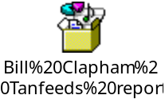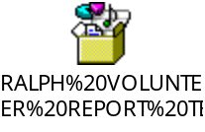

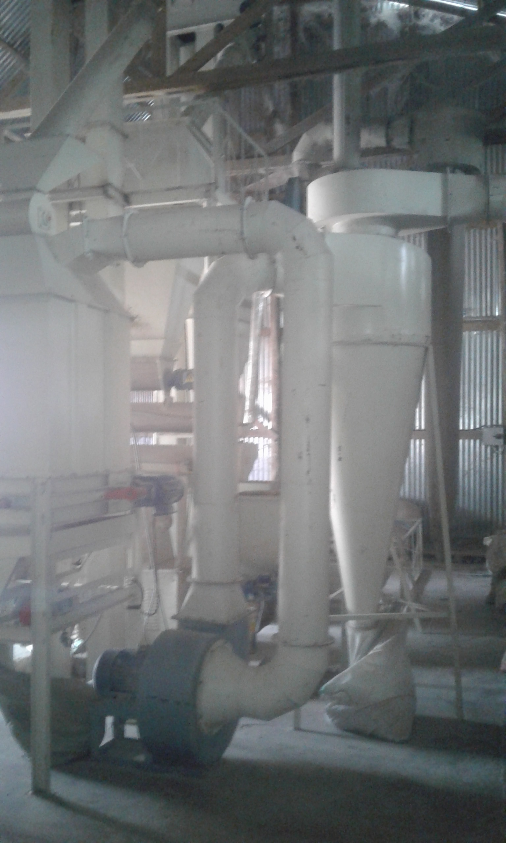
- Photos of machinery at Tanfeeds
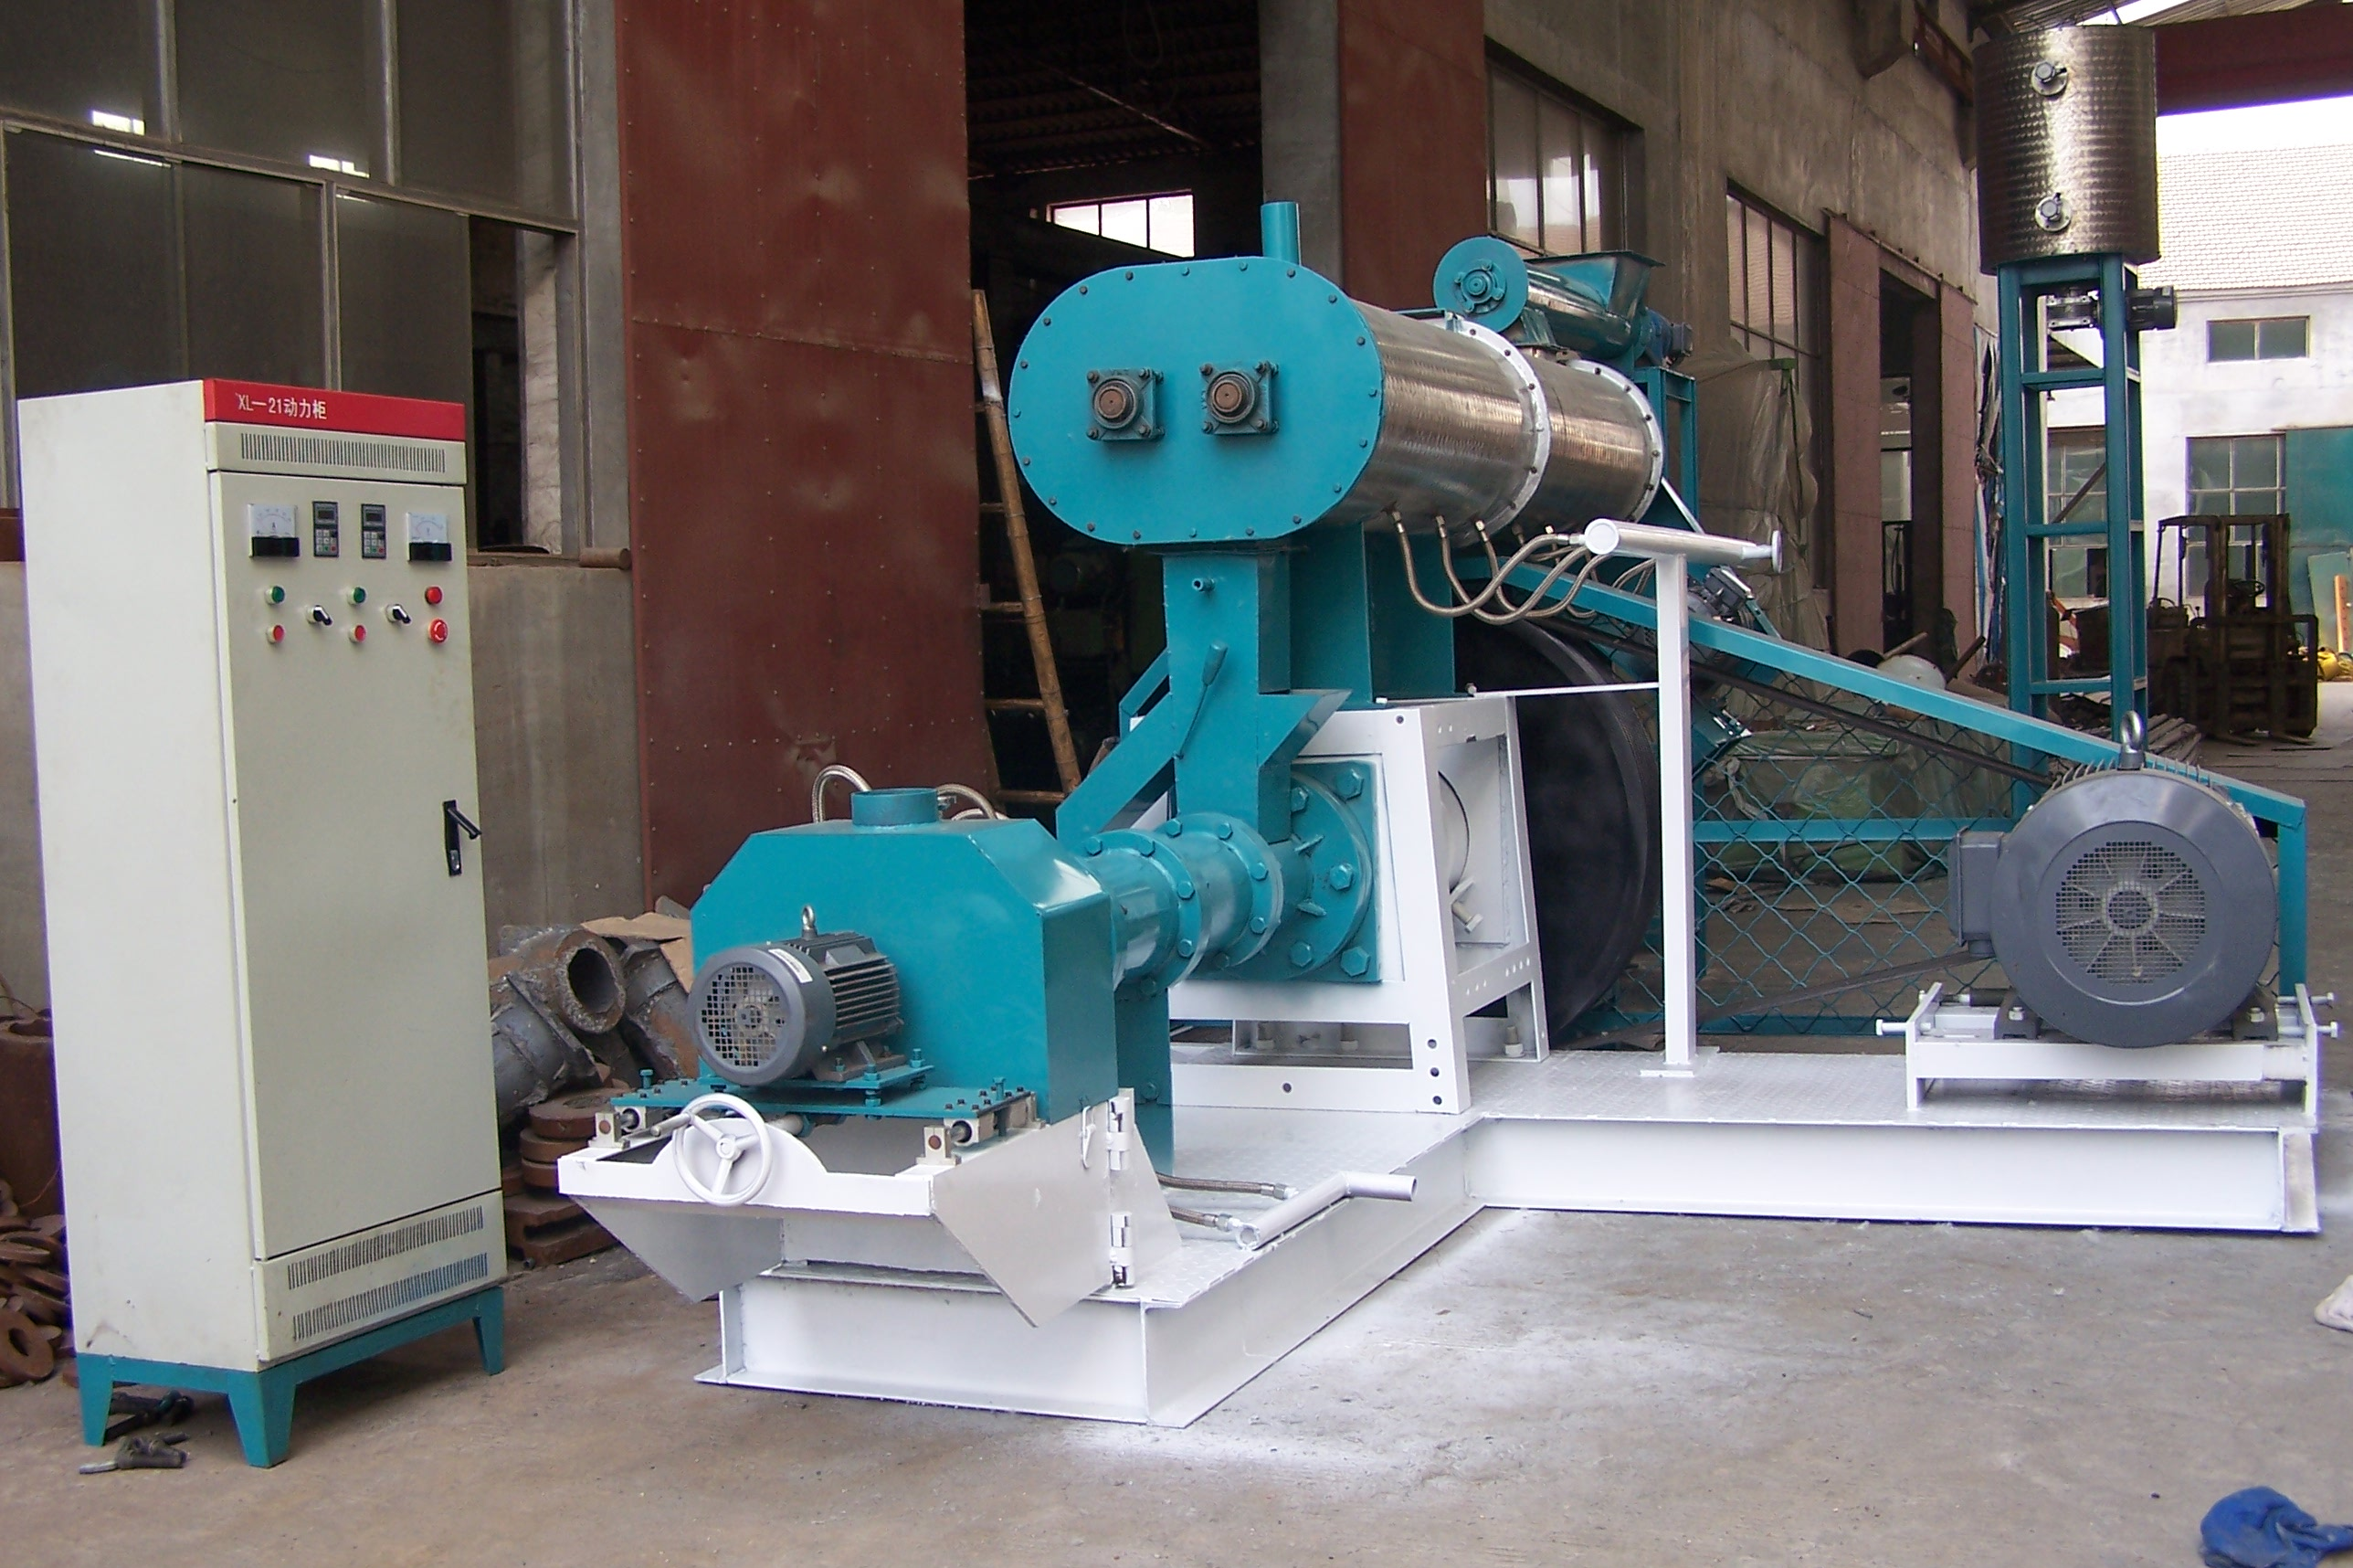
Figure 1: Fish pellet machine

Figure 2: Animal feed pellet machine
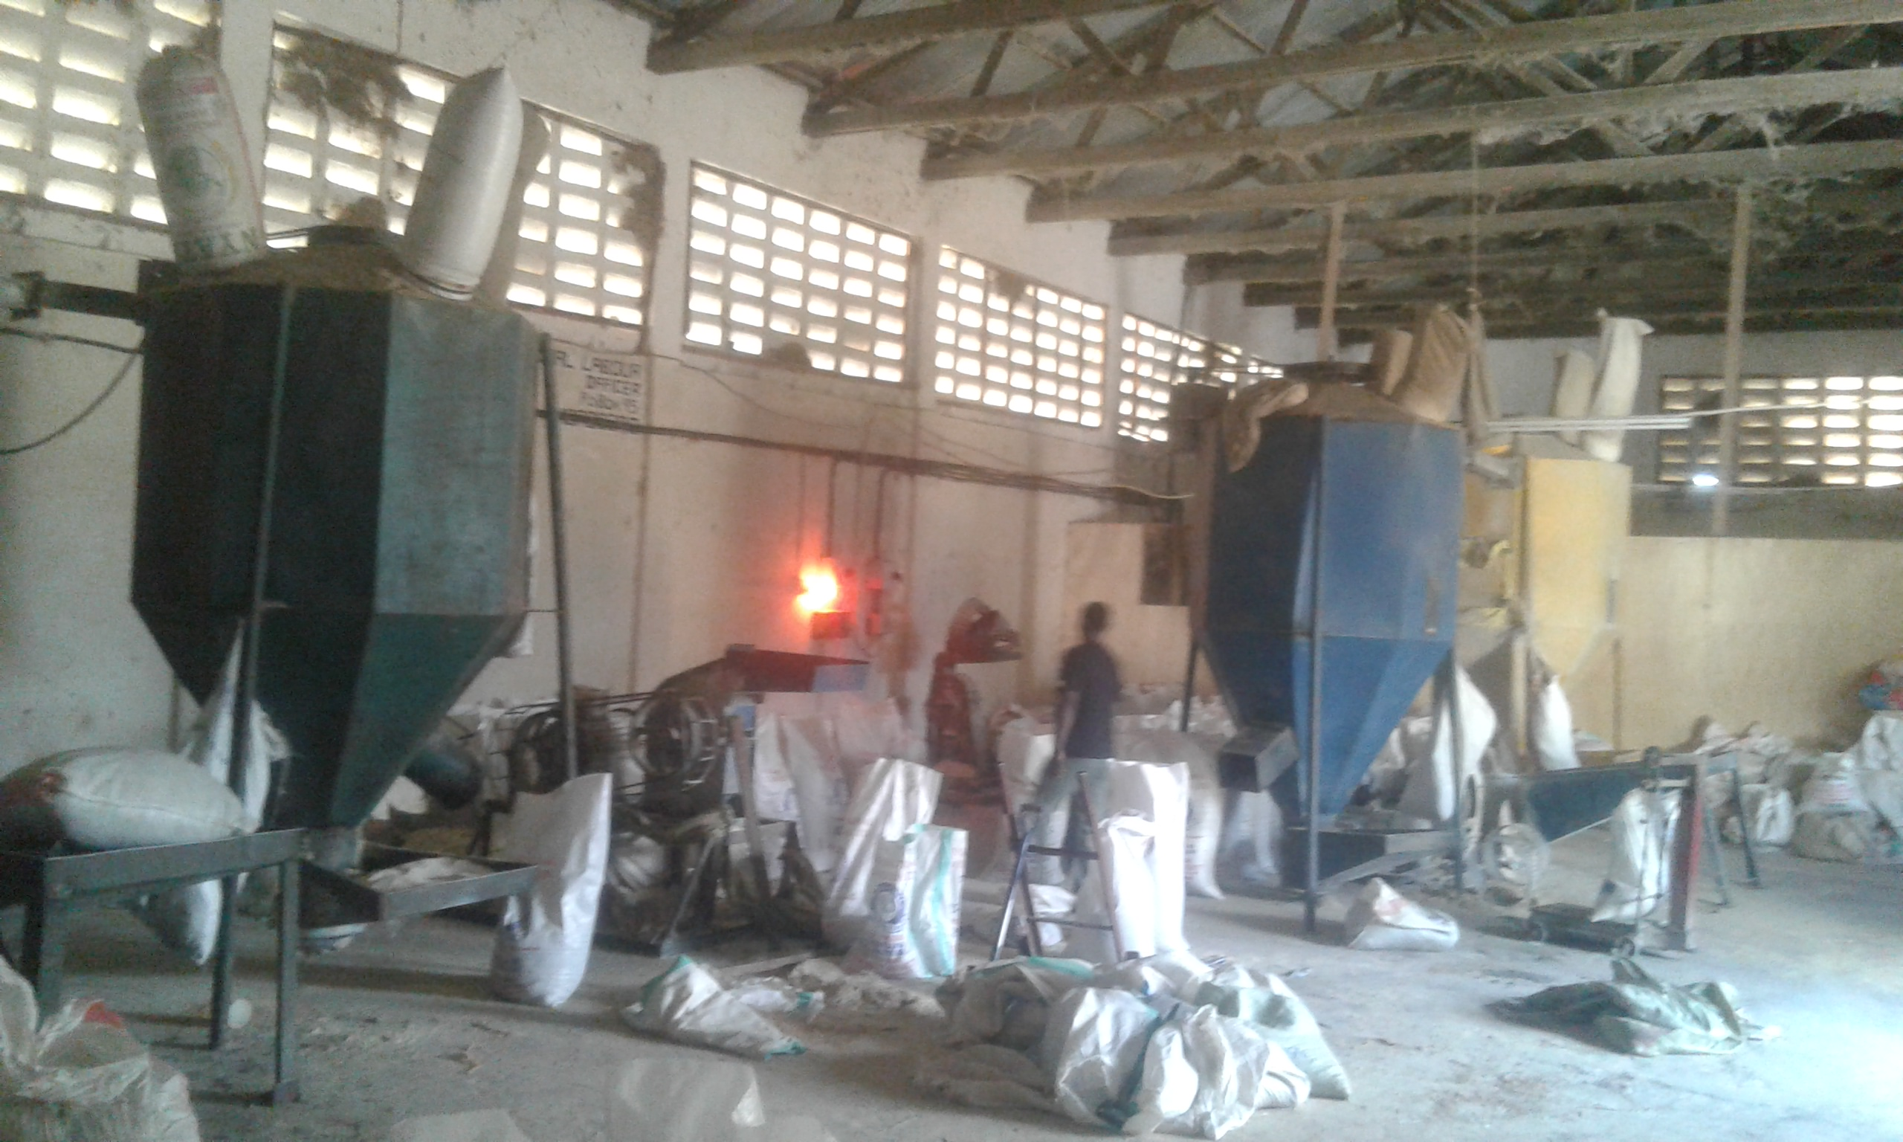
Figure 3: Animal feed plant (mash)
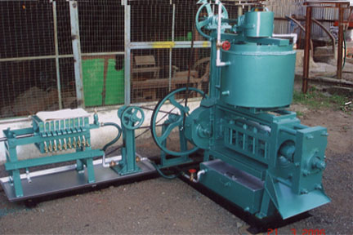
Figure 4: Soy oil expeller

