Farmer-to-Farmer East Africa
Volunteer Assignment Scope of Work

Summary Information
Assignment Code | TZ 131
Country | Tanzania
Country Project | Horticulture
Host Organization | Same District Council/Umoja wa wafugaji wa ng’ombe wa kisasa
Assignment Title | Soil and water conservation training for smallholder farmers in Chome
Assignment Preferred Dates | January – March 2018
Objectives of the Assignment | To provide farmers with practical knowledge in soil and water conservation techniques appropriate to the environment in Chome so that they can mitigate factors affecting their output, increase productivity, and improve farming conditions in the long run.
Desired Volunteer Skill/Expertise | Field agronomist/soil and water management specialist

*FINAL EDITS PENDING*

BACKGROUND
The Farmer-to-Farmer (F2F) East Africa program is one that uses short-term US volunteer expertise to assist smallholder farmers and small-scale processors in East Africa to improve their business practices through volunteer assignments conducted with host organizations. In Tanzania, the objective of Catholic Relief Services’ (CRS) F2F project is to support smallholder farmers by improving access to and utilization of markets and credit so they can broaden their participation in the grain and horticulture value chains as producers and service providers. By extension, the program also aims to improve livelihoods and nutritional status, resilience to adverse events, and preservation of natural resources.
In Tanzania, horticulture makes a significant contribution to food security and economic growth. Horticulture is practiced in large part by female smallholder farmers as well as a limited number of large-scale operators. Commercial horticulture is endowed with local and foreign investors, particularly in floriculture and export vegetables, and has production and market growth potential. Tanzania’s favorable socio-political environment offers an opportunity for the horticulture sector to thrive. Thus, horticulture in Tanzania has the potential to increase incomes through meeting demand in domestic, regional, and international markets, while simultaneously improving household nutrition through improving dietary diversity.
The key challenges that the horticulture industry faces in Tanzania include low productivity of horticultural crops, limited processing of horticultural products, and poor access to markets. Some key opportunities that favor the growth of the industry and the success of the F2F project in Tanzania include the various participants along horticulture value chains, including the USAID programs Feed the Future (FTF) and Tanzania Agriculture Productivity Program (TAPP), both in partnership with Tanzania Horticulture Association (TAHA). Through on-going programs and partnerships such as these, specific interventions allow volunteers to reach smallholder farmers, and production and processing companies.
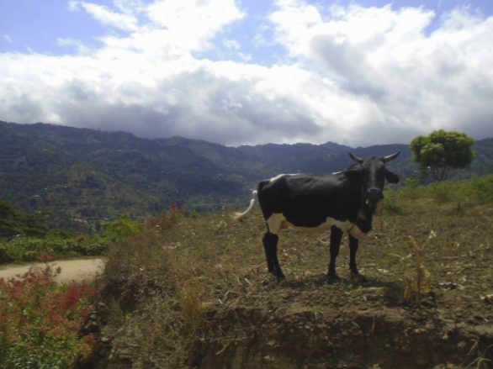
This Scope of Work (SOW) is for providing technical assistance to a group of farmers from Marieni, Gwanga, and Mhero villages in Chome Ward (Same District, Kilimanjaro Region), about 30 miles from Same Town. The group’s name, Umoja wa wafugaji wa ng’ombe wa kisasa (hereafter, Umoja), means “Association of modern cattle farmers”. The group was formed in 2009 to facilitate the writing of a grant proposal to a German NGO for cow husbandry equipment. Since then, their membership and organization have remained strong; the group currently comprises 20 members, with women representing just under half of that membership. These farmers practice mixed farming, cultivating bananas, coffee, maize, vegetables, and rearing cows and goats. Individual farms range from 1 to 2 acres in size.
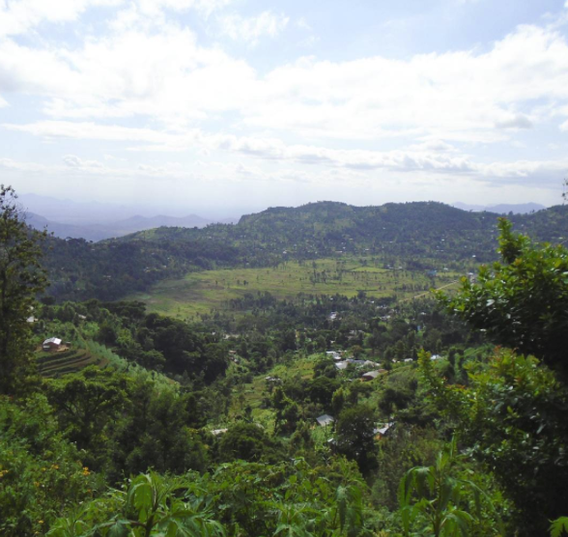
Chome is situated at over 5000 feet above sea level in the Pare Mountains, part of the Eastern Arc Mountains. It is located 30 miles from Same town along a steep dirt road. The landscape is montane and verdant. The steep cliffs and forested slopes are home to many rare flora and fauna. This area is inhabited by the Wapare tribe. Having lived there for countless generations, they enjoy a deep connection to the land. The area is densely populated, but villages are scattered throughout, connected by a system of footpaths and roads. The area is very remote, with minimal electricity and plumbing.
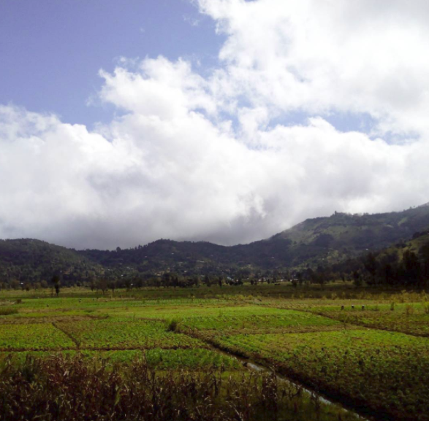
Water feeds into the Chome valley from the Shengena forest, located higher up the mountain. It serves as a water sink that disperses water down the mountain, providing a source of water even during most of the dry season. At present, villagers manage this water through a network of artificial swales, redirecting it onto farms with dams.
Soil conditions in Chome vary greatly by location.
Chome farmers primarily grow maize, beans, and bananas. Onions, tomatoes, cabbages, potatoes, and leafy greens are cultivated to a lesser extent. At present, the majority of crops are grown for subsistence. Whenever a surplus is produced, villagers are able to sell to nearby villages. Farmers hope to eventually achieve enough surplus to meet the high demands in markets of larger towns, such as Same, located over 60 km away. In addition to crops, farmers also keep cows, goats, pigs, and some sheep.
Chome farmers are progressive and the local government leadership is supportive and cooperative. The community has hosted Peace Corps Volunteers (PCVs) for the past four years. The current PCV will be available during this assignment to offer logistical and cultural support to the F2F Volunteer. Furthermore, the PCV is uniquely positioned to continue follow-up work and monitoring after the volunteer’s departure.
In January 2016, F2F Volunteer Anna Mae Glenn (amaeglenn@gmail.com) trained farmers in improved agricultural practices, focusing on soil fertility, crop rotation, and organic methods. Ms. Glenn recommended further training in soil fertility/testing, seed saving, and soil conservation techniques appropriate to Chome’s mountainous terrain. Since hosting Ms. Glenn, farmers have successfully adopted improved practices, such as crop rotation, scrutinizing labels of chemical fertilizers, and targeted fertilizer application. During the subsequent growing season, farmers began to enjoy increased yields thanks to implementing those practices. Specifically, farmers rotate plots of the main staple crops, maize and beans. The have also recently introduced fallow fields into their rotation schemes, further increasing their yields thanks to the regenerative effects of that practice.
Farmers have also been exposed to other techniques, but only in theory, due to time constraints during Ms. Glenn’s assignments. They discussed mulching, applications of animal manure, and composting.
In September 2016, the farmers hosted F2F Volunteer Todd Flynn (tflynnlaw@threeriver.net), who trained them in business skills, record keeping, accounting, and cost-benefit analyses. Since then, farmers have been maintaining their own personal financial records, in addition to monitoring and recording group finances; they also monitor and record patterns in rainfall, thanks to the rain gauges that were gifted to them by Mr. Flynn. Furthermore, in collaboration with the PCV, Umoja created and regularly maintains a group budget for collaborative activities. Farmers are also actively exploring alternative markets and products in the hopes of improving returns on their activities.

ISSUE DESCRIPTION
The processes of human-induced land erosion have their origin in social, economic, and cultural factors resulting in overexploitation of natural resources, especially inadequate management of soil and water. The consequences of this are damage to agricultural land and a decrease in food production. Despite there being many technological solutions for soil and water management, the majority are ill-adapted for smallholder, rural contexts where resources are limited.
One of the main causes of soil degradation is the practice of inappropriate methods of soil preparation and tillage. This results in rapid physical, chemical, and biological deterioration of soils. Consequently, declines in agricultural productivity and deterioration of the environment occurs. Various compensatory measures can significantly improve affected areas in the short-term, for example complementing the use of selected tillage methods with soil management and conservation techniques.
Umoja farmers are eager to learn how to improve their methods with respect to soil management and conservation. Specifically, within the context of the montane environment in which they live. This assignment has the potential for creating a far-reaching ripple effect of knowledge transfer, since Umoja farmers are progressive and have a good track record for implementing new ideas. Despite their readiness and success in implementing past volunteer recommendations, Umoja farmers continue to struggle with optimizing yields and mitigating soil erosion.

OBJECTIVES OF THE ASSIGNMENT
The objective of this assignment is to provide farmers with practical knowledge in soil and water conservation techniques appropriate to the environment in Chome so that they can mitigate factors affecting their output, increase productivity, and improve farming conditions in the long run. Though some formal, classroom sessions might be used, the volunteer should rely mostly on farm visits and practical training. Furthermore, the Volunteer should tailor their message and recommendations to the local situation and resources.
- To survey/visit a sample of farms to assess the extent of soil degradation and current practices addressing that issue
- To design a training that addresses the gaps and issues identified in (i)
- To provide theoretical and practical training to farmers in relevant soil and water conservation techniques
- To work with farmers on a demonstration plot to illustrate soil and water conservation best practices
- To facilitate individual or collective farmer strategies/plans for implementing relevant practices on their plots

HOST CONTRIBUTION
Umoja group leadership will identify a house, for which CRS will pay for the duration of the assignment. Also, the volunteer, with the help of the PCV, will arrange and pay for prepared meals as needed. The volunteer will most likely be lodged in the same house Anna and Todd stayed in, a small, modest house, with a western toilet. Additionally, group leadership will mobilize group members and other villagers to attend trainings and avail key personnel to work with the volunteer and prepare training venues.
A translator, well-versed in this SOW’s subject, will be provided by CRS. They will accompany the volunteer throughout the duration of the assignment and provide any further logistical support.

ANTICIPATED RESULTS FROM THE ASSIGNMENT
- Chome farmers will increase their understanding of environmental and human factors affecting their land, and how to mitigate these
- Through mitigation of issues affecting current output, farmers will increase their productivity.
- Through improved water management practices, farmers will mitigate water supply issues, extending the duration of productivity, in addition to output
- Through applied soil conservation practices, farmers will improve soil health, ensuring improved farming conditions and productivity in the long run

DELIVERABLES
- Trainings conducted and attendance registers
- Photos taken during assignment
- Training manual or communication tools (e.g. guidelines, flyers, brochures), to facilitate knowledge transfer following the assignment
- Action plan drafted in collaboration with beneficiaries
- Volunteer presentation
- Volunteer report and press release
- Outreach activity (press release or media event) in US

SCHEDULE OF VOLUNTEER ACTIVITIES IN TANZANIA
The schedule below is tentative. A detailed schedule will be drafted upon volunteer arrival in country.
Day | Activity
1 | Travel from home to U.S. international airport
2 | Arrive in Tanzania, at Kilimanjaro International Airport, travel to Moshi Town, spend night at X
3 | Travel to Chome, meet with Umoja group for orientation, discussion of expectations and objectives, scheduling
4-12 | Farm visits and trainings
13 | Wrap-up and action planning with host
14 | Return to US via Kilimanjaro International Airport

DESIRABLE VOLUNTEERS SKILLS
- Formal qualification or qualifying experience in agronomy, soil and conservation/management
- Facilitation, mobilization, and training skills within the context of adult learning; good interpersonal skills
- Ability to adapt to new working environments, e.g. work through an interpreter in a rural, foreign environment
- Flexibility to work with people of varying literacy levels
- Resilient, in good health, and able to walk on steep, uneven (possibly muddy) terrain at high altitudes

ACCOMMODATION AND OTHER IN-COUNTRY LOGISTICS
In Same, the volunteer will be lodged at Amani Lutheran Center (0784 894 140). In Chome, the volunteer will be lodged at a local house.
All logistics will be organized by CRS and the host organization. All proposed accommodations will have the basic amenities of running water, electricity, self-contained rooms. CRS will provide the Volunteer with per diem allowances to cover meals and other incidentals.
A cell phone and modem will be provided by CRS. In Chome, there may be power outages and challenges with internet and phone connectivity.

RECOMMENDED ASSIGNMENT PREPARATIONS
The Volunteer should familiarize themselves with the USAID Feed the Future program, the East Africa Regional Office (EARO) and Tanzania F2F Horticulture Project Description, this SOW, and the reports produced by the preview two volunteers. It is also advisable that the volunteer read and familiarize themselves with Tanzania and its development history, challenges, and opportunities.
Additionally, the FAO publications listed below may prove useful for further background and local, contextual information on the issue.
Integrated soil management for sustainable agriculture and food security in southern and East Africa | ftp://ftp.fao.org/agl/agll/docs/misc23.pdf
Manual on integrated soil management and conservation practices | ftp://ftp.fao.org/agl/agll/docs/lw8e.pdf

KEY CONTACTS
CRS Baltimore | CRS East Africa Regional Office
Maria Figueroa  Recruitment Manager  EA Farmer-to-Farmer Program  228 W. Lexington Street  Baltimore, MD 21201  Office: 410-951-7366  Email: maria.figueroa@crs.org | Nyambura Theuri  Deputy Project Director  EA Farmer-to-Farmer Program  P.O. Box 49675 – 00100  Nairobi, Kenya  St. Augustine Court Karuna Close Road  Email: nyambura.theuri@crs.org
CRS Tanzania
Mary Kabatange  Farmer-to-Farmer Program Country Director  P. O. Box 34701 Dar es Salaam  Office: +255 222 773 141  Cell: +255 758 820 025  Email: mary.kabatange@crs.org | Brian Gleeson  Country Representative  CRS Tanzania  Office: +255 222 773 141  Cell: +255 754 930 966  Email: brian.gleeson@crs.org
Host Organization: Umoja Farmers Group
Kashanga Mndeme  Group Chairperson  Cell: +255 659 476 130 | Charles Makee Cross  Peace Corps Volunteer  Cell: +255 752 335 845  Email: charlesmakeecross@gmail.com

