To express interest in this assignment please email priyanka.subba@crs.org

CRS Farmer to Farmer Program
Volunteer Assignment Scope of Work

Notice for potential volunteers:
Some assignment details are subject to change.

Summary Information
Assignment Code | TL221
Country |  | Timor-Leste
Country Project |  | Modernizing Agriculture
Host Organization |  | Arcamaten Ltda.
Assignment Title |  | Food dehydration equipment design and fabrication?
Assignment preferred dates |  | January-February 2020
Objectives of the assignment |  | -Training the staff oh how design and develop one dehydration unit  - Weld and assembling heat components
Desired volunteer skill/expertise |  | - Practical experience in the design and installation of food dehydration equipment  - Experience in food dehydration and food processing
Type of Volunteer Assistance |  | Technology Transfer(T)
Type of Value Chain Activity |  | Processing (P)
PERSUAP Classification |  | Type III

- BACKGROUND
CRS Farmer-to-Farmer (F2F) Program is a USAID funded 5-year program (July 2018 – June 2023) that will provide technical assistance from United States (U.S.) volunteers to farmers, farmer groups (cooperatives and associations), agribusinesses and other agriculture sector institutions. The program objectives are to facilitate economic growth within targeted agriculture sub-sectors, enhance sub-sector inclusiveness to expand participation to a broader range of individuals and communities, and to increase the American public’s understanding of international development issues and US international development programs. Volunteers, recruited from all States and the District of Columbia, are individuals who have domestic careers, farms and agribusinesses, or are retirees who want to participate in development efforts. F2F program will assist in agriculture development, commodity value chain competitiveness and firm upgrading by providing technical assistance to introduce new technologies, innovations and development of local capacity for more productive, profitable, sustainable and equitable agriculture systems.
The Timor-Leste Ministry of Agriculture and Fisheries Strategic Plan recognizes the fundamental importance of agriculture to Timor-Leste’s economy and the impact of agriculture on poverty reduction, food and nutrition security, economic growth, and income and employment generation through its linkages to other sectors of the economy. The agriculture sector in Timor-Leste accounted for 19% of Gross Domestic Product (GDP), or over $253 million in 2013. However, there is a considerable net deficit in agricultural trade as imports in 2014 were valued at approximately $60 million. Major imports include rice, sugar, meat (chicken, beef, pork), vegetable oil, fish, milk, and vegetables (potato, onion). In rural communities, 57% of women and 60% of men are actively involved in agriculture. Agriculture consists primarily of subsistence farming with limited access to inputs, technical knowledge, and market linkages. There is a heavy reliance on traditional agricultural practices such as slash-and-burn cultivation. Most smallholdings are mixed rainfed farms growing maize, cassava, red kidney beans, sweet potato, rice, groundnut, and vegetables. Coffee, coconut and candlenut are the most common tree crops. Livestock, such as poultry, pigs, cattle, buffalo, goats and sheep are raised on a small-scale.
In 2016, Arcamaten Ltda was legally registered by the Ministry of Finance and started operating with only one employee. By 2017, the company had grown to employ four additional employees and started food processing on part-time basis. Local companies and farmers were contracted to supply raw materials to meet the food processing needs. There are 100 rural farmer members who are contracted to produce various agricultural commodities to ensure a steady supply to the company. The company has conducted successful experiment to dehydrate fruit, cassava, spices and leaves into flour for cuisines and bakery. Currently, they have two dehydrators, one that is too small to dry the high volume of produce, and another that has a higher capacity but is not cost efficient due to the higher consumption of electricity.
Arcamaten Ltda is located is centrally located in Dili. It aims to produce and distribute a wide range of processed food products across Timor-Leste. This company has developed business contracts with farmers from several municipalities to supply raw materials to the processing plant.
- ISSUE DESCRIPTION

According to the Timor-Leste Population and Housing Census conducted in 2015, most of the population of 1,300,000 rely on agriculture for their livelihoods. The greatest and most prevalent issue for farmers is their inability to market their surplus agricultural produce into markets, especially due to the low processing capacity in the country. There is a general lack of skills, knowledge and resources to establish and operate agri-processing industries. Arcamanten Ltda has been bridging this gap, through availing a ready market for the farmers’ produce, which it in turn processes for the domestic and international markets. Most importantly and specifically, they have installed two dehydrators, a small and fairly large units to dry fruit and other food items for the domestic market. The small unit has a capacity to dry about 5kgs of products while the large one is electrical and dehydrates 500 kg per cycle. The small unit cannot meet the demand for dried products, while the large unit is not energy efficient, and is not cost effective.
This host now plans to install a medium dehydration unit with a capacity of 100kg-250kg. They management and staff lack the capacity to fabricate and install this dehydration unit. It is for this reason that the host has requested for volunteer technical assistance to train relevant staff on the design and installation of all the dehydrator components and conduct a trial dehydration of available produce.
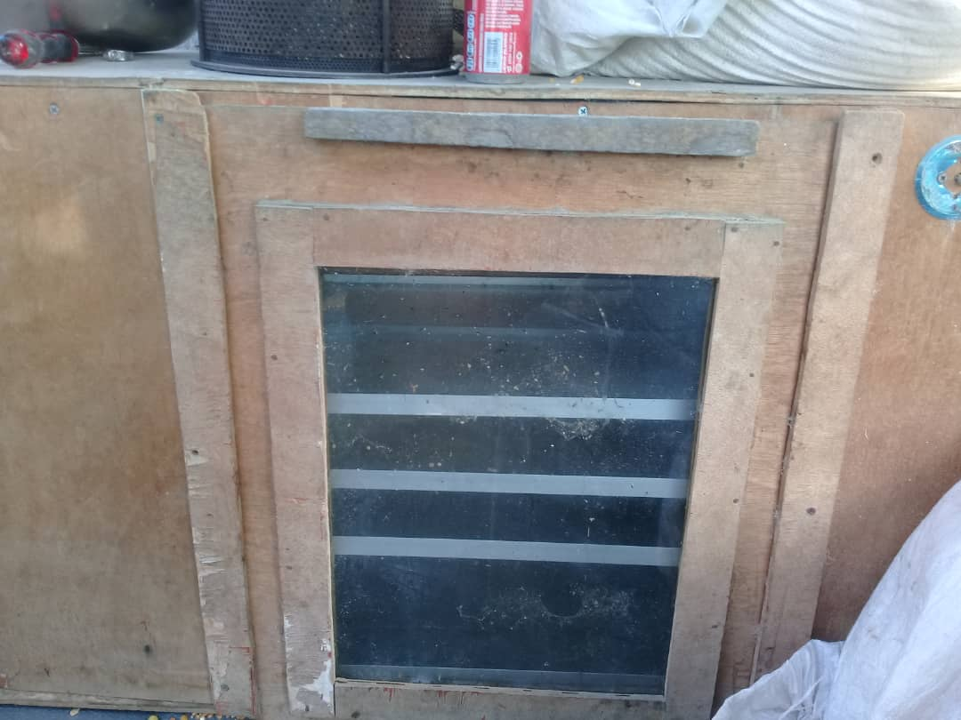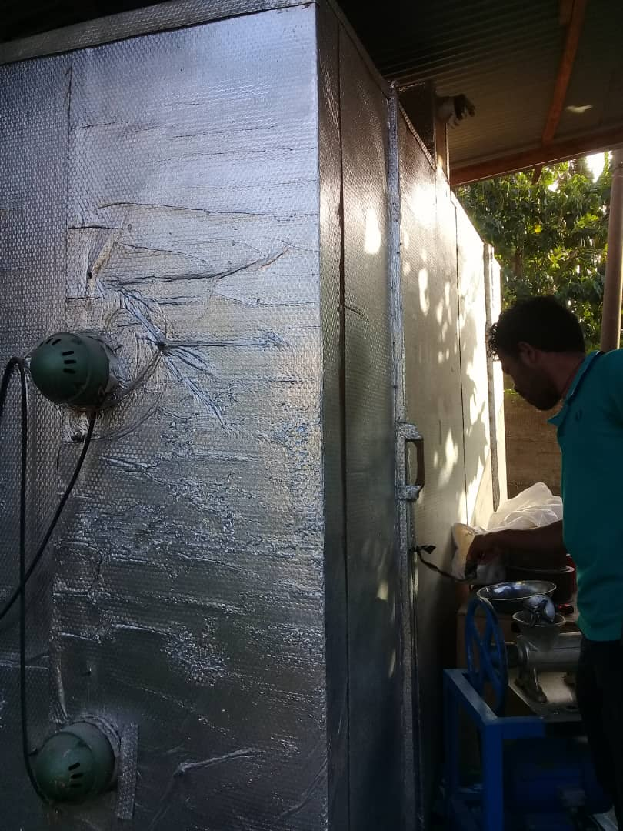
Photo Credit CRS-TL: Big dehydration machine has dried products over 500 kg with huge electricity consumption
Photo Credit CRS-TL: small dehydration machine has dried products below 5 kg

- OBJECTIVES OF THE ASSIGNMENT

The main objective is to facilitate the installation of a dehydrator, through building the capacity of the Arcamanten Ltda management and staff in the design and installation of an appropriate and cost-efficient dehydrator, while utilizing mostly locally available materials. The volunteer will transfer knowledge and skills in assembling dehydrating machine components. In addition to the first unit designed, assembled and installed, the volunteer will also support the host in designing another four units of medium dehydrators located in the central heart of Dili. The major activities include;
- Assist in designing/planning dehydration facilities
- Assembly the components for the dehydrator
- Conducting a pre-trial and
- Recommend other viable options for energy efficient dehydrators that meet host needs for capacity, dried products quality, efficiency and cost-effectiveness

- HOST CONTRIBUTION
Arcamaten Ltda will provide the volunteer with accommodation, meals, translation training hall and all materials needed for installation. Prior to volunteer arrival in country, the host will also be available to respond to any questions that the volunteer may have as they prepare for the assignment.

- ANTICIPATED RESULTS FROM THE ASSIGNMENT
It is expected that the volunteer’s efforts contribute to the following results:
- Design of a medium dehydrating unit utilizing locally available resources
- Install one dehydration unit and pretest
- Recommend and or guide staff on installing other dehydrators in Dili
- Develop dehydrator user and maintenance guidelines

- DELIVERABLES
- Initial presentation (outlines/list of activities, plan, approach, etc.)
- Final report with results, recommendations, and proposed next steps
- Presentation summarizing results for local stakeholders and CRS staff
- Attendant list

- VOLUNTEER ASSIGNMENT SCHEDULE
Please note that this is a tentative schedule and will be finalized post-volunteer selection and consultation.

Day | Activity
Day 1 | Arrive in Timor-Leste. The volunteer will be picked up by a car provided through CRS’ client hotel with a placard bearing the CRS logo and the volunteer’s name.
Day 2 | Volunteer will be escorted to CRS office to meet CRS F2F staff and receive briefing on security, logistics, and assignment itinerary. Travel to host organization site. CRS will facilitate in meeting with host company. Short briefing with company staff.
Day 3 | Volunteer and local company staff will review itinerary, staff responsibilities, required resources, objectives, expected results, any other logistic concerns and Initial observation existing dehydration machine and conduct visit to see dehydration components in the shops.
Day 4-6 | Provide initial design and complete volunteer assignment based on SOW objectives and guidelines discussed during briefings.
Day 7-8 | Reporting preparation
Day 9-11 | Provide initial design and complete volunteer assignment based on SOW objectives and guidelines discussed during briefings.
Day 13 | Finish compiling data and any information required for the final report. Provide short briefing with staff of the company on the recommendation for future improvement
Day 14 | Last presentation to CRS Ag. Staff, Students and Out brief meeting with Ambassador and USAID mission
Day 18 | Departed to USA

- ACCOMMODATION AND ANOTHER IN-COUNTRY LOGISTICS
- Before travelling to the assignment place, the volunteer will stay in Plaza Hotel at one of the CRS’s client hotels that will be booked and confirmed before the arrival date.
- In Dili, the hotel usually has rooms that include services such as airport pickup and drop-off, breakfast, wireless internet, etc.
- The hotel or CRS will arrange a vehicle for short travel from the hotel to CRS or using Taxi
- CRS Timor Leste will provide the volunteer with a laptop computer (if s/he needs), local internet dongle (modem/EVDO) and mobile phone with charged local SIM-card. Any other required logistics and facilities can also be requested by the volunteer during her/his stay in Timor-Leste.
- CRS will provide a vehicle and accompany the volunteer to the place of assignment.
- During her/his assignment period on the field, the volunteer will be stay in the host guesthouse or in the hotel that cost below $ 50 with no Wi-Fi conditions
- CRS Timor-Leste will arrange hotel accommodation and cover the lodging bills against receipts.
- CRS HQ will provide the volunteer with a per-diem advance to cater meals and incidences.
- Before departing to US, the volunteer will also liquidate advances (if any) at CRS Timor-Leste
- For more information, please refer to country information that will be provided

- RECOMMENDED ASSIGNMENT PREPARATIONS
- Training materials, demonstration aids, any other documentation should be completed prior to arriving in Timor-Leste. Soft copies can be printed for immediate use at the CRS office in Dili.
- Please prepare a brief initial presentation outlining your skills/qualifications and an overview of your anticipated approach for accomplishing assignment objectives.
- Company may request a call prior to your arrival to confirm details and discuss approach in order to maximum your time in country.
- Timor-Leste’s official currency is the US Dollar so there is no need to exchange money. Use ATM visa to withdraw the Money and no longer using Master Card.
- You may want to familiarize yourself with the history and current status of Timor-Leste. Irena Cristalis’ A Nation’s Bitter Dawn details Timor’s fight for independence and the aftermath. Timor-Leste’s Strategic Development Plan, previously referenced as a footnote, provides a more technical analysis of the current conditions and outlines a path to prosperity.
- You can subscribe to the ETAN listserv which provides daily news and analysis on events occurring in Timor-Leste.

- KEY CONTACTS

CRS Baltimore | F2F Program Manager
Priyanka Subba  Volunteer Recruiter  Farmer to Farmer Program  228 W. Lexington Street  Baltimore, MD 21201  Telephone: 410-955-7194  Email: priyanka.subba@crs.org | Jose Maria Alves Ornai  Farmer-to Farmer Project Manager  Catholic Relief Services Timor-Leste  Rua Dom Boaventura No. 12, Motael Vera Cruz, Dili, Timor-Leste  Email: josemaria.alves@crs.org  Celestina Ramos Cristo  Farmer to Farmer Project Assistant  Email: celestinaramos.cristo@crs.org  Telephone: +670 526421s
Host Organization:
Carlito Alves  Arcamaten Ltda, Director  Telephone: +670 77289495  erani.bimali@yahoo.com | Natalino Ximenes  Acamaten Ltda. Manager  Telephone: +670 76196432

USAID precisely classifies PERSUAP in four categories; PERSUAP Type I assignments directly related to pesticides recommendations, Type II as assignments with indirectly related with pesticides, Type III assignments related to curriculum review and designing, business plan development and strategies development and Type IV as assignments associated with other USAID projects and collaborators.

