Farmer to Farmer East Africa
Volunteer Assignment Scope of Work
Summary Information
Country | South Sudan SS04
Country Project | Flexible assignment
Host Organization | Jonglei Food Security Program
Assignment Title | Good agronomic practices for vegetable production
Assignment preferred dates | March – May 2016
Assignment objective | Increase the productivity of the vegetables, improve food security, dietary diversity and increased incomes for the vegetable producer groups
Desired volunteer skills/ expertise | Agronomist

- Background

Jonglei Food Security Project, JFSP, was designed as a development program with the goal to improve food security of conflict-affected households in Jonglei State and aimed to achieve three strategic objectives namely (i) resilience to cope with shocks and hazards affecting food security, (ii) production to strengthen Jonglei State Government capacity to address food insecurity, and to support private sector services that enhance crop and livestock production and (iii) Market Linkages to link a sub-set of producer groups to markets to facilitate both staple and diversified production for localized or commercial sale.
Following the crisis of December 2013, the program implementation modality was modified to ensure that conflict-affected households meet immediate life-saving needs, supporting them to recover their livelihoods and strengthen resilience to future shocks. JFSP Results Framework was equally modified maintaining the same goal to improve food security of conflict-affected households in Jonglei State with only two strategic objectives, that is (i) to help conflict-affected households meet immediate and acute food and non-food needs and (ii) to help Conflict affected households adopt improved livelihood (crop and livestock) practices.

To support conflict affected subsistence farmers to recover their livelihoods through production of their own food, JFSP maintained its original strategy to work with farmer producer groups (FPGs) and individual farmers and to support the expansion of cultivation by internally displaced persons (IDPs), returnees and host communities. The program supported vulnerable households through provision of agricultural inputs (seeds and tools) as well as technical advice and supervision and support to develop value chains and market linkages. During rainy seasons, JFSP continued to support FPGs to grow sorghum, maize and groundnuts and supported vegetable production during the dry season for farmers with access to irrigation water. To stimulate local markets and link farmers to input suppliers, JFSP adopted the use of seed fairs in areas where markets are functional and quality seeds were produced by local farmers while in places where no seed vendors could be identified the program locally procured seeds and distributed them to the farmers. JFSP also mainstreamed the savings and internal lending communities (SILC) approach as a methodology that would help finance the rural agro-enterprise development.
- Issue Description
South Sudan is naturally endowed with agricultural potential given its favorable soil, water, and climatic conditions. It is estimated that about 70 percent of total land area is suitable for producing a wide range of field and horticultural crops; annual crops such as grains, vegetables, tree crops and various forest products. Despite this great potential, only a small portion of this land has been converted to crop land. Efforts by the government of South Sudan complemented by development partners like CRS are geared towards expanding the underutilized land into productive land while also increasing land productivity. South Sudan is rated lowest in terms of yield per unit area in the region.

In line with its mandate, JFSP continues to work with farmer producer groups and individual farmers and provides them with agricultural inputs (seeds and tools) as well as technical advice for improved productivity of the target value chains. Even with these efforts, the farmers require additional support in improving their production technologies so that they can transform from subsistence to commercial oriented food secure communities. Lack of improved production technologies for vegetables and cereal production by both the farmers and the extension agents undermine the efforts of the farmers in realizing optimum yields from their farms;

Most of the soils observed during the assignment assessment are black cotton soils- vertisols. It takes a lot of time and effort to prepare the land, plant and weed for the crops. During the wet season and in irrigated plots, the soils are sticky and easily get water-logged while during the dry season they become very hard forming deep cracks. The farmers have been trained on use of farm-yard manure and compost to improve the workability of the soils. The adoption of this is not very good as some farmers use un-decomposed cow-dung that scorches the plants leading to low plant densities.
There are notable skills gaps even for the agriculture extension staff in all aspects of production, from land preparation, nursery establishment and management, planting methods and plant density for the different crops, weeding, pest and disease control, harvesting and-post harvest handling of vegetables. Bridging this gap is critical to improving the productivity of the area under cultivation.
Although there is need to address cereals and vegetable production agronomic practices, this assignment will focus on good agronomic practices for vegetables. The volunteer will train pre-selected agriculture extension staff and selected farmer groups members.

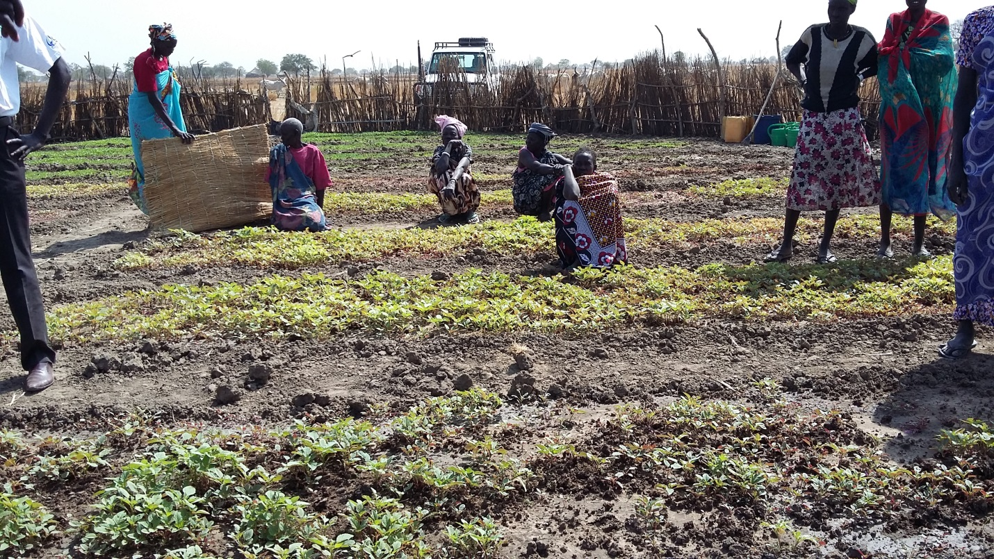
Figure 1 vegetable farmer group tending their garden in Twic East
- Objectives of the Assignment
This assignment will focus on vegetable production, and will address the entire production process, from seedbed preparation, seeding rates (for various seed types), transplanting, weeding, mulching, soil conditioning, soil fertility management, integrated pest management etc. to increase the productivity of the vegetable farmers, improved food security and dietary diversity and increased incomes. This will be completed mostly through practical demonstration and theory using illustrations where appropriate. The target groups for this volunteer assistance are CRS and government agriculture extension staff. The volunteer is expected to develop simple training guidelines to be used by the agriculture extension staff for scaling up to other groups that the volunteer is not able to reach.
The volunteer will provide training direct assistance on all production aspects as described in the SOW and confirmed while in country. The specific tasks for this volunteer assignment are:
    - Train on land preparation
    - Nursery preparation and management
    - Seed handling, preparation use of clean seeds, seeding rate and seed planting (spacing, depth, etc);
    - Organic soil fertility management: compositing, mulching, manure application, crop rotation etc
    - Use of preventive and early season pest control practices including integrated pest management (IPM), biological, cultural and physical methods of controlling pests such as weeds and other pests
    - Develop training guidelines

- Schedule of Volunteer Activities

A detailed schedule of planned activities will be developed with MOAF and JFSP personnel. Once a volunteer is identified, s/he will work closely with the JFSP team to develop a clear schedule. The assignment duration is however estimated at 3 weeks.

At the end of the assignment, the volunteer will conduct assignment debriefing with JFSP and the local USAID mission in Juba

- Desirable Volunteer Skills
An agronomist/horticulturalist with the following;
- Practical experience in production of vegetables – management of black cotton soils is highly desirable
- Extensive experience in development of training materials
- Excellent- hands-on training skills to an adult audience
- Good writing and analytical skill as well as good communication skills
- Availability for assignment timing

- Accommodation and Other In-Country Logistics

Upon arrival at Juba Airport, the volunteer will be picked by a CRS designated driver for an initial assignment briefing. Thereafter, the volunteer will travel to Bor (by air or by road) where s/he will spend a significant part completing the assignment.

CRS will make all arrangements for hotels, transport and perdiems to cater for meals and incidental expenses to cater for the duration of assignment in South Sudan. For more information, please refer to country information provided.

- Recommended Assignment Preparations

CRS-F2F designs assignments with the assumption of some pre-departure preparation by the volunteer. Actual preparation time will vary based on the experience of the volunteer, as well as informational or training resources the volunteer has readily available. CRS relies on the volunteer to assess the tasks outlined in this SOW and to make his or her own judgment about how much and what kind of preparation is needed prior to arriving in South Sudan.

CRS strongly recommends that the volunteer become familiar with CRS programs in South Sudan, and specifically the Jonglei Food Security Program.

- Key Contacts

CRS Baltimore | CRS EA Regional Office
Maria Figueroa  Volunteer Coordinator  EA Farmer to Farmer Program  228 W. Lexington Street  Baltimore, MD 21201  410-951-7366  Email: maria.figueroa@crs.org | Nyambura Theuri  Deputy Project Director  EA Farmer to Farmer Program  P.O. Box 49675 – 00100  Nairobi, Kenya  St. Augustine Court Karuna Close Road  Email: nyambura.theuri@crs.org
CRS South Sudan
Zemede Abebe | Deputy Chief of Party|JFSP | Bor, Jonglei State|SOUTH SUDAN| +211(0)956 915808 - +211(0)927422507|Skype ID:zemedeabebe  South Sudan/Bor  Email: zemede.zewdie@crs.org | Nkurunziza, Francis  Livelihood Team Leader  Email: francis.nkurunziza@crs.org  Vedaste Gatebuka  Agriculture Program Manager  Email: vedaste.gatebuka@crs.org

