CRS Uganda
International Agriculture Education Fellowship Program (IAEFP)
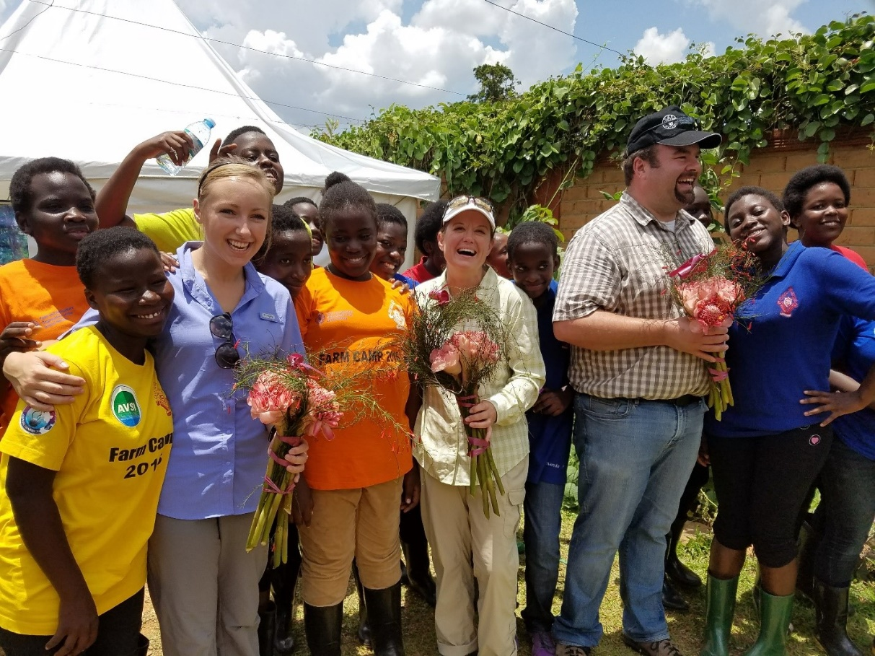

Fellow onboarding & orientation schedule
May-July 2021
Orientation– the important details

Orientation Schedule for IAEFP Fellows (May 10 – July 15, 2021)
Date | Description | Orientation medium | Resources | Person Responsible
May 13 | Fellows’ cohort introduction  Advanced prep for next session:  Fellowship prep  - Review sections 1, 2 & 3 on the IAEFP fellows page | MS Teams meeting  Self-learning | IAEFP fellows page | Priyanka  45 mins  Time varies
May 19 | US logistics Overview and Q&A  - Required CRS Documents  - Medical insurance, vaccinations, and pre -travel medical requirements  Travel & Visa  - Booking your flight  - How to obtain your Uganda visa  - Type of visa, requirements, application process  - Work permit process: Requirements (documents to obtain before travel to Uganda)  Healthcare in Uganda  - Quick overview on Medical access while in Uganda, CRS Uganda contract with Jubilee insurance  - Recommended list of hospitals per host site, process of accessing medical care  Advanced prep for next session:  Intro to CRS (use your CRS email and password to log in)  - Vision 2020: CRS History Mission Values  - CRS code of conduct and ethics  - CRS programming in Uganda: here  - Watch video about CRS’ work in Uganda: Previous work on Vanilla growing in Uganda. Foundation for current VINES project  - Watch the IAEFP launch recording | Recording Online Course  YouTube | IAEFP fellows page | Priyanka & Maria  90 mins
May 25 | A brief introduction to CRS and the Uganda country program  - Brief overview on CRS strategy, guiding principles, mission, vision), relief and development programs, mode of operation  - Detailed overview on the Uganda CP  - Special virtual welcome of IAEFP fellows to CRS family  IAEFP Program brief:  Goals and objectives of the program, geographical coverage  - Uganda school system/structure  - SOW objectives/Expectations from IAEFP Fellows  - School host sites  - Fellowship timelines (Gantt chart for key activities)  Advanced prep for next session:  - Read an article, watch a movie or watch few reliable YouTube videos about Uganda. |  | CRS agency and country strategies  Program brief, SOW, Uganda Map, areas of IAEFP coverage | CR (Niek de Goeij)  45 mins  Maria  45 mins
May 26 | Life in Uganda  Chat with a CRS International Development fellow in Uganda  Advanced prep for next session:  Security  - IFRC security training on CRS Learns  Please use your CRS email and password to log in  Safeguarding  - Read the CRS Safeguarding Policy and Code of Conduct  - Ethical Do’s and Don’ts  - Policy on general workplace conduct  - PSEA: It’s everyone’s responsibility- https://www.youtube.com/watch?v=tpUEbZ7sPX4 | Online Course | Safety and Security  IAEFP fellows page  Section 7: Orientation resources Safeguarding section | Edwin Wong  240 mins estimated time.
June 2 | Getting to know Uganda  - Uganda perspective - History, culture (acceptable behaviors /dress code), diversity, religion, and politics  Health, Safety, and Security  - COVID 19 status (Pandemic spread and vaccination status)  - SOPs/Guidelines/requirements for travelers  - Guidelines and rules for travel  - Tips for travelers to Uganda  - Security protocols for various types of emergency incidents: medical emergency, road emergency etc.  - gender-specific issues related to safety and security  - Communication protocols: Constant companion  Medical Safety  - Staying safe and healthy while in Uganda  Safeguarding  - CRS compliance  Advanced prep for next session:  - Begin to work on your Visa application and work permit requirements |  | IAEFP fellows page Section 4  - CP Visitors guide  - security manual  - constant companion  - Uganda CP Visitors’ guide: | CP Security focal person (Patrick)  Abdoul Aziz
Week of June 10 | Donor Engagement  Engagement session with USDA & FAS: POST  - Further security briefing and requirements for US citizens  - Keeping in touch with US Embassy in Kampala, registering on STEP  Advanced prep for next session:  - Review CRS Social media Policy
TBD | Social Media  CRS guidelines/policies/protocols on social media communication,  - Platforms, Dos and Don’ts, best practices  - Creativity for program advocacy and outreach  Outreach  - IAEFP outreach  - Review outreach guide  - Bio and profile sheet  Advanced prep for next session:  - Headington Institute Stress and Resilience Training  - Review resources on the Headington site  - Visit the Global Staff care page on MYCRS |  | Policy documents/ guidelines (CRS) | Melissa Stevens & Jim Stipe  Tom Cox (PSO)  Priyanka/Maria
TBD | Fellow Care and Well-being:  - Stress management, living in a new environment  Medical Access:  - Medical access while in Uganda  - CRS Uganda contract with Jubilee insurance,  - Recommended list of hospitals per host site  - process of accessing medical care  Other support services: Interior formation (counselling, psychosocial services, self-care, work-life balance, vacation, personal development planning)  Advanced prep for next session: | In person | Link to CDC website: CDC.  Jubilee insurance list  How to access jubilee hospitals using SOS medical cards | HR  60 mins
TBD | Getting to know your school  Virtual connection to individual school hosts  Advanced prep for next session:  Watch video about CRS’ work in Uganda: CRRF in Uganda: Dignified, Durable Support for South Sudanese Refugees |  | School baseline information, profiles (as available)  Links/MyCRS  F2F library link | Maria  1.5 hrs.
Week of June 22 | Preparing for departure  - Discussion of Fellowship Expectations  - Winter break TDY opportunities  - Introduction to VINES
Week of June 28 | Open Session
July | Open session Q&A final prep  - Recommended Reading List  - Recommended packing list (clothing, toiletries, medicine, electronics, school supplies) |  | Link to recommended materials | Adamaah/ Maria/ Priyanka/ Bruce

Additional sessions to be added:
- Curriculum materials (depending on status of materials approval, this will be done virtually)

