To express interest in this assignment please email priyanka.subba@crs.org
CRS Farmer to Farmer Program
Volunteer Assignment Scope of Work
Summary Information
Assignment Code | NE239
Country | Nepal
Country Project | Crops Country Project
Host Organization | Mush Nepal Pvt. Ltd
Assignment Title | Low cost Mushroom Production Technique
Assignment preferred dates | April 2020 Onwards
Objectives of the assignment | To strengthen knowledge of mushroom production
Desired volunteer skill/expertise | Mushroom Production Technique  Hands on experience on oysters Mushroom Farming
Type of Volunteer Assistance | Technology Transfer = T
Type of Value Chain Activity | Information and Input Support Services (S) on Mushroom Seed Production
PERSUAP Classification | PERSUAP Type II

- BACKGROUND
Nepal is predominantly depending upon agriculture for their livelihood. The agriculture is traditional; subsistence based producing mostly food security crop and very less amount of high value cash crop. Nepal Government emphasize poverty alleviation and economic growth through agriculture especially promoting the geographically suitable high value commodity crops. Climatic condition of the country varies from tropical in Terai region via alpine in Hills to Himalayan regions. Due to this rich diversity, the potential for mushroom production is immense can cultivated across the country.
Mush Nepal is one of the leading private company supplying quality spawan produced in its own laboratories. It was established in 2015 in Balambu, Chandragi Municipality, ward no.12 Kathamndu, Nepal. The aim of the company is to supply Nepali farmers with mushroom spawns on an industrial scale. The company had invested three million dollars to build its infrastructure. The company has more than 200 clients all over Nepal. Since its establishment, it has produced mushroom seed. The company is committed to enhance capacity of existing mushroom growers and training new mushroom growers.
The company has expanded its mushroom farm to nearby district Makwanpur. The company is cultivating mushrooms like sitake and oysters. In its farms pink oyster mushroom is also cultivated. The company is growing mushroom in new kind of dome and is planning to automatize the farm.

- ISSUE DESCRIPTION
Many of the small holders engaged in the crops sub sector are shifting towards modern farming methods but are struggling with access to knowledge and techniques prerequisite to increase production and productivity by adopting low cost mushroom production. Furthermore, disease and pests, poor farm management practices, lack of efficient water use practices, limited knowledge on maintaining quality of produced seed, limited knowledge on soil nutrition management, limited access to farm mechanization technologies and limited access to farm extension services are aggravating low productivity. Mushroom is also facing the above stated challenges. Despite all the challenges, mushroom farming is gaining momentum among smallholders and urban farmers.
The cost of production of mushroom farming is growing. Farmers are selling mushroom in lower price than cost of production. Mush Nepal Pvt. Ltd. is conducting research on reducing cost of production. Mush Nepal Pvt. Ltd is currently selling straw based production bags to produce oysters mushroom and log to produce sitake mushroom. The existing bag size are big and farmers are looking for smaller bags to produce same amount of mushroom or farmers are vying for techniques to come up with larger yield on existing bag.
The company is struggling with knowledge on lower production techniques and looking for mushroom production specialist to support the company in identifying lower production techniques or increasing the yield in the same bag.
- OBJECTIVES OF THE ASSIGNMENT
Mushroom production technology will be provided to company staffs and farmers related to Mush Nepal Pvt. Ltd. The specific objective of this volunteer assignment is to provide training on quality mushroom production. The general objective will be:
- Introduce and demonstrate handful techniques to produce mushroom by identifying low cost production techniques.
- Improve mushroom production guideline/protocol for local technicians.

- HOST CONTRIBUTION
The assignment will be conducted closely with the mushroom production facility of Mush Nepal. The host will also arrange training for their laboratory staffs. Host will also provide the volunteer with office space, training hall and daily tea/snacks for participants.
- ANTICIPATED RESULTS (Outcome/impact) FROM THE ASSIGNMENT
It is anticipated that this volunteer assignment will contribute to lowering cost of production of mushroom directly contribute to the following;
  - Company laboratory will adopt the improved mushroom production techniques
  - Company will adopt the improved cultivation techniques
  - Increased incomes of all round the year
  - Outreach events conducted upon return to the US

- DELIVERABLES
The anticipated deliverables accomplished by the volunteer also include:
  - One simple mushroom production guideline/protocol for the local technicians will be developed
  - Appropriate and relevant technologies on mushroom cultivation will be transferred
  - Host recommendations action plan developed
  - Trip Report should be submitted before exit meeting

- SCHEDULE OF VOLUNTEER ACTIVITIES IN COUNTRY (DRAFT)
Day | Activity
Days 1 | Arrival Nepal, Tribhuvan International Airport. The volunteer will be picked by Greenwich Hotel with a placard bearing “CRS logo and volunteer name”.
Day 2 | Introduction and meeting with CRS management and briefing meeting (Security, general orientation, logistic, reporting formats, etc.) at CRS office. Discuss anticipated outcomes and work plan.
Day 3 | Travel to assignment site. Introduction and assignment briefing with host representatives
Days 4 – 15 | Complete assignment related activities at the host location
Day 16 | Report revision, submission,
Day 17 | Debriefing including CRS country Office and USAID Local mission and fly back to USA

- DESIRABLE VOLUNTEERS SKILLS
The volunteer will have the following qualifications and competencies:
- Experience on Mushroom seed production
- Hands on experience on oysters mushroom production

- ACCOMMODATION AND OTHER IN-COUNTRY LOGISTICS
- Before travelling to the assignment place, the volunteer will stay in Kathmandu at one of the CRS’s client hotels, Hotel Kutumba https://www.orbitz.com/Lalitpur-Hotels-Hotel-Kutumba.h33780567.Hotel-Information or another hotel that will be booked and confirmed before the arrival date. In Kathmandu, the hotel usually has rooms that include services such as airport pickup and drop-off, breakfast, wireless internet, etc. The hotel or CRS will arrange a vehicle for short travel from the hotel to CRS and vice versa while in Kathmandu.
- All required materials will be prepared ahead of time and will be provided to the volunteer. CRS Nepal will provide the volunteer with a laptop computer (if s/he needs),and mobile phone with charged local SIM-card. Any other required logistics and facilities can also be requested by the volunteer during her/his stay in Kathmandu. CRS will provide a vehicle and accompany the volunteer to the place of assignment.
- During the assignment period, the volunteer will be booked in a hotel at the project site, to be confirmed prior to volunteer arrival. CRS Nepal will arrange hotel accommodation and cover the lodging bills against receipts. CRS HQ will provide the volunteer with a per-diem advance to cater meals and incidences.
- Security information will be provided by CRS Nepal Security focal person at Kathmandu CRS Country office.

- RECOMMENDED ASSIGNMENT PREPARATIONS
- Prior to travel, the volunteer is advised to prepare necessary training and demonstration aids and written handouts. Electronic copies of these handouts and any other printed materials can be printed for immediate use at the CRS office in Kathmandu on request by the volunteer.
- If the volunteer requires use of simple training aids like flip charts, markers or tape s/he should make the request and collect from the CRS office in Kathmandu prior to travel to the assignment place.
- Translation of handouts to the local language can be done at the assignment location if required.
- Depending on the meeting places and availability of electric power and LCD projector, the volunteer may use a laptop and projector for power point presentations.
- Weather Appropriate Clothing: https://www.accuweather.com/en/np/nepal-weather
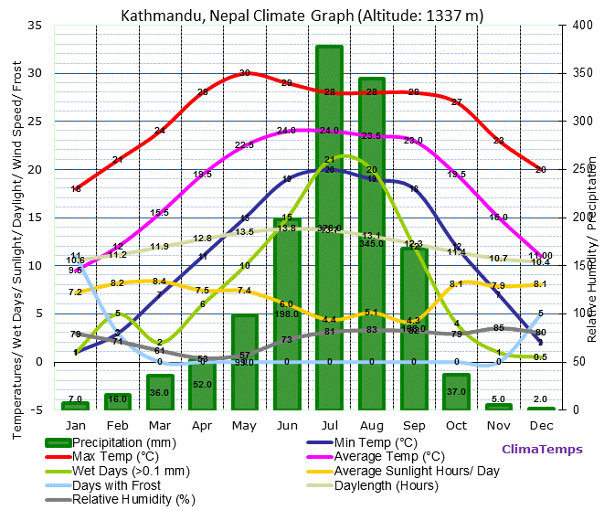

- KEY CONTACTS
CRS Baltimore, US | CRS Nepal Country Program
Priyanka Subba  Volunteer Recruiter  Farmer to Farmer Program  228 W. Lexington Street  Baltimore, MD 21201  410-955-7194  Email: priyanka.subba@crs.org | Phaindra Raj Pandey  Project Director, CRS F2F Nepal Country Office  Maitri Marg - Bakhundole, Lalitpur Metropolitan City Ward No.1, Province 3, Nepal  Cell: +977-98141205763, 9808028903  Email: phaindra.pandey@crs.org
CRS Nepal Country Program
Prachanda Kattel  Project Coordinator, CRS F2F Nepal Country Office  Maitri Marg - Bakhundole, Lalitpur Metropolitan City Ward No.1, Province 3, Nepal  Cell: +977-98141205763, 9808028903  Email: prachanda.kattel@crs.org | Chhan Bahadur Bhattachan  MEAL Coordinator  CRS F2F Nepal Country Office  Maitri Marg - Bakhundole, Lalitpur Metropolitan City Ward No.1, Province 3, Nepal  Cell: +977-9841390786  Email: chhan.bhattachan@crs.org
Host Organization:
Suman Maharjan
Founder
Mush Nepal Pvt. Ltd
Balambu, Chndragiri Municipality #12 Kathmandu District, Province #3
Cell: 977-9841526744/9851033898
Email: sumankone@gmail.com

