Farmer-to-Farmer

Expenses & Reimbursements
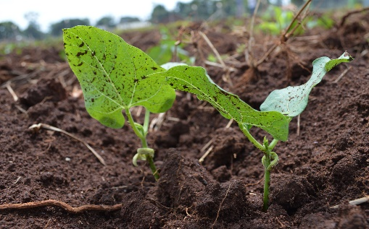
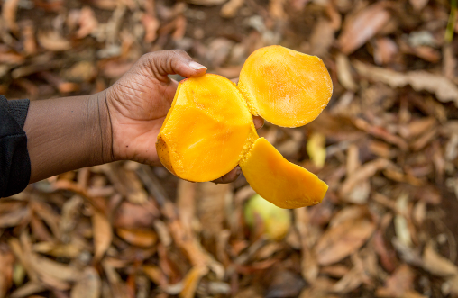

YOUR EXPENSE CHECKLIST
To receive your advance and reimbursements, submit the following items to your CRS contact.
*Receipts scans submitted via e-mail are preferred. Mailed receipts should be copied in case of lost mail.

Prior to departure…
☐ Submit Banking Form (at least 3 weeks before departure)
When you return…
☐ Receipts (US transportation/parking, medical, etc.)
☐ Volunteer Reimbursement Form (see page 6)

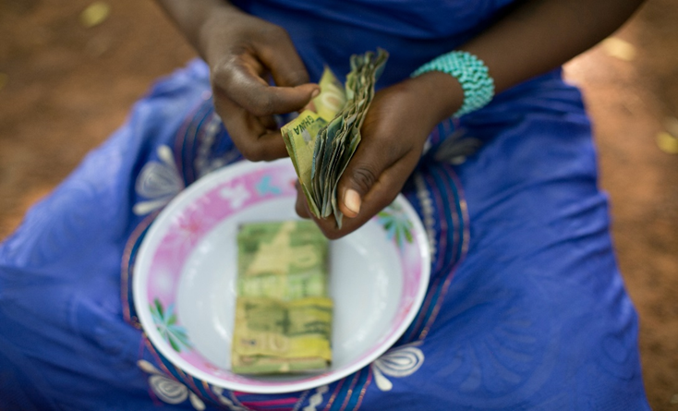
YOUR CRS CONTACT
Maria Figueroa
maria.figueroa@crs.org
Phone: (410) 951-7366
Catholic Relief Services
Attn: Maria Figueroa
228 W. Lexington Street, 6th Floor
Baltimore, MD 21201

EXPENSES AT A GLANCE
Expense | Payment method | Timing
Medical preparation | CRS reimburses | Post assignment
International airfare | CRS pays directly | At time of purchase
Visa | Direct deposit to volunteer | Before departure
Emergency Insurance | CRS has prepaid | NA
Training materials | CRS reimburses | Post assignment, w/preauthorization
Airport transportation in US | CRS reimburses | Post assignment
Layover meals/incidentals | CRS reimburses | Post assignment, using flat rates
Layover hotels | Depends on location | Depends on location
In-country meal funds | Direct deposit to volunteer | Before departure
In-country meal funds | Direct deposit to volunteer | Before departure
In-country meal funds | CRS pay directly | Varies
In-country meal funds | CRS pays directly | Varies

MEDICAL PREPARATION EXPENSES
- CRS pays for travel vaccinations recommended by the CDC for volunteers to Uganda; however, volunteer are responsible for routine vaccines & flu shots. Keep all receipts.
- Note: Uganda requires proof of the Yellow Fever shot to exit the airport.

Reimbursable w/receipt | Non-reimbursable
- Travel vaccines  - Malaria pills, when recommended  - Travel checkup fee | - Routine vaccines (MMR, chickenpox, polio, tetanus, flu, etc.)  - Medical supplies (bed nets, water filters, etc.)  - Personal medications, annual physical fee
*CRS does not give medical advice; travelers should consult a doctor and CDC.
TRAVEL TO/FROM AIRPORT
We appreciate volunteers who help CRS stretch funds farther by finding economic airport transportation!

- CRS reimburses volunteers $0.58 per mile (subject to change).
- If you anticipate total transport/parking expenses to exceed $150.00, please advise us beforehand.
- Receipts required for airport parking reimbursements.
MEAL PER DIEM
While Traveling
- CRS provides preestablished, flat rate amounts for meals, regardless of the actual amount spent. Receipts only needed for meals taken in Zurich, Switzerland and Tokyo, Japan.
- Request travel meals post-assignment using the form on page 4.
- The “incidentals” category covers laundry, service charges, tips, and miscellaneous expenses.

Breakdown of Daily Per Diem--Layover Cities
City | Daily Total | Breakfast | Lunch | Dinner | Incidentals
Berlin, Munich, Incheon | $50 | $8 | $12 | $20 | $10
Dublin, Wellington | $65 | $10 | $16 | $26 | $13
Brussels, Rome, Bali,  Amsterdam, Canberra, London, Frankfurt | $70 | $11 | $17 | $28 | $14
Paris | $75 | $11 | $19 | $30 | $15

While in Uganda
- Volunteers will receive per diem meal funds via direct deposit. Submit the Banking Form at least 3 weeks before departure. Let your CRS contact know if you prefer a mailed check.
- You are not required to provide meal receipts or account for per diem usage.
Breakdown of Daily Per Diem Rates in Uganda
Daily Total | Breakfast | Lunch | Dinner | Incidentals
$45.00 | $7.00 | $11.00 | $18.00 | $9

Carrying and withdrawing cash:
- You may carry money to exchange or withdraw it from an ATM in Addis Ababa. Daily maximum withdraws may apply. Email George.Ntibarikure@crs.org and Maria.Nakayiza@crs.org for more information.
- When exchanging dollars, ensure bills are crisp, free of markings, and less than 10 years old. Exchange rates vary by location. Higher value bills bring a better rate.
- Speak to your bank about international fees and to flag your account for international travel.

ASSIGNMENT SUPPLIES
- If you need training supplies, consult Maria.Figueroa@crs.org for approval before purchasing and to inquire if supplies are best purchased in the US or Uganda. $100 limit, receipts required.

EXPENSES IN COUNTRY
CRS pays directly for assignment-related, in-country travel, hotel, translators, etc.

CRS Farmer to Farmer
Volunteer Reimbursement Form
Email completed form and receipt scans to Maria.Figueroa@crs.org
Name:
Assignment Code:
Assignment Dates:
Please list expenses in chronological order.
Do not include any expenses that CRS has already reimbursed.
Date | Description of Expense | Location | Cost
 |  | TOTAL:
Mileage Only *
Date | Address Traveled To / From | # of Miles

- Please include a route map from Google Maps or MapQuest showing your mileage, if possible.
- Emailed forms are encouraged. If you prefer to mail them, please retain copies in case your mail is lost, and send to the address on page 1 of this document.

