Farmer to Farmer East Africa
Volunteer Assignment Scope of Work
NOTE: THIS SCOPE OF WORK AWAITING FINAL EDITS
Assignment Summary
Assignment Code | TZ98 -SOW
Country | Tanzania
Country Project | Horticulture
Host Organization | Karagwe Development Cooperative Union (KDCU)
Assignment Title | Financial and accounting best practices training for KDCU
Assignment objective | - Enhance the capacity of staff to manage KDCU funds by training the accounting staff on the best book keeping and accounting practices  - Introduce and install appropriate and user-friendly accounting software for KDCU  - Conduct the appropriate training for the accounting staff to fully understand and use the software for accounting purposes
Desired skills | A financial expert with accounting and ICT experience
Assignment preferred dates | Mid October 2017

- Background:

The Farmer-to-Farmer (F2F) East Africa program is a program that uses short-term US volunteer expertise to assist small holder farmers and small scale processors in East Africa to improve their business practices through volunteer assignments conducted with host organizations. The goal of the (F2F) grains project is to increase incomes and improve nutritional status of Tanzanian smallholder farmers through; smallholder farmers increased productivity of agricultural crops, improved access to and utilization of markets and credit and preservation and enhanced natural resources upon which target communities depend. The program reaches out and establishes partnership with like- minded organizations, the latest been Cheetah Development.

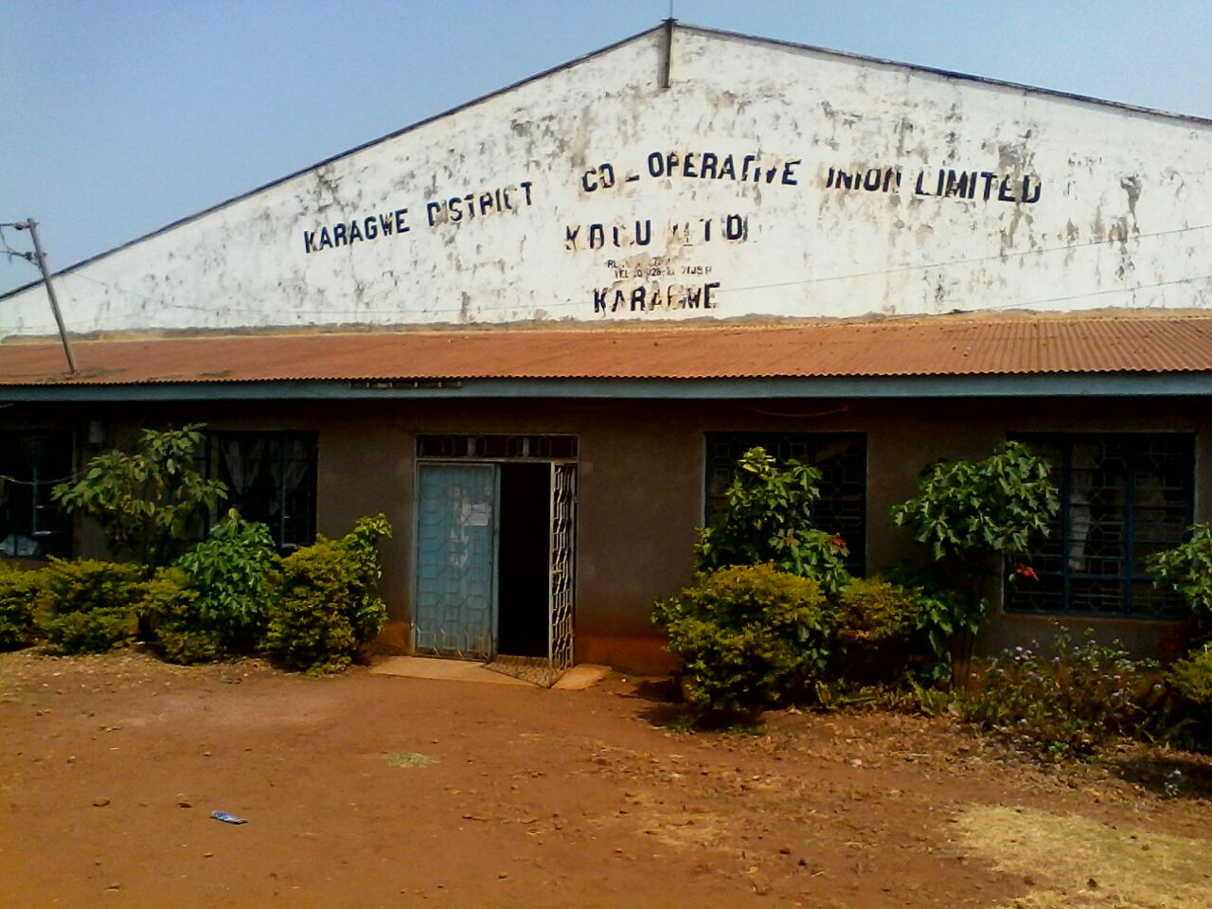
Karagwe District Cooperative Union (KDCU) is a member-based, Cooperative Union established in 1990 as a result of a split from the Kagera Cooperative Union. KDCU is located in the Karagwe District, Kagera Region of Tanzania, on the western shores of Lake Victoria, about 1500 km from Dar es Salaam. The cooperative was established for the purpose of supporting their members to access production services and markets for coffee and other commercial farm products. In addition, KDCU focusses on the implementation of grassroots development needs identified by the beneficiaries. KDCU has 81 member Rural Primary Cooperative Societies (RPCS) serving a total of 21,000 members. KDCU is registered under the cooperative act of 2004 and operates in Kyerwa and Karagwe District in Kagera region. KDCU has been granted by Lutheran World Relief to implement a three years’ project named Pamoja kwa Mafanikio (together for development) that will benefit a total of 9,864 members of 36 member RPCS in Kyerwa and Karagwe districts. The objective of the project is to support KDCU and its RPCs members to operate viable businesses, also support farmers to have diversified their income sources.

KDCU has a major 3 operations: 1). Collecting 2). Processing and 3). Marketing and selling coffee from its’ members

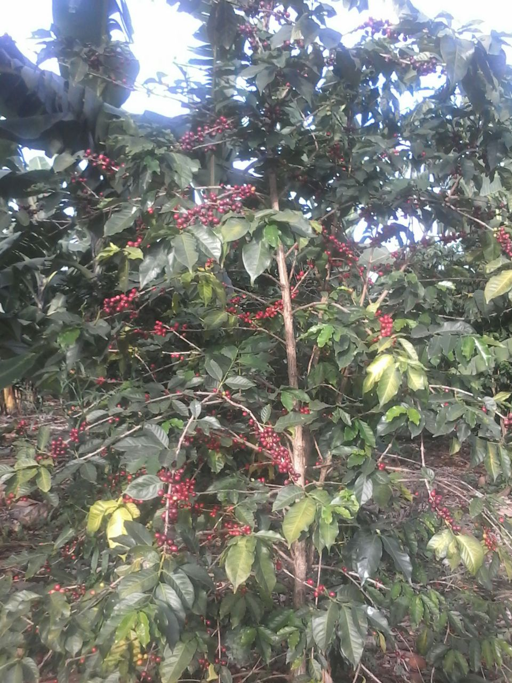
Collection of cherry coffee from farmers who are members of Cooperative: Farmers of Karagwe and Kyerwa District produce natural Arabica and Robusta coffees however 90% they produce Robusta and 10% is Arabica. They grow coffee in natural a way, mulching and using cow manure as fertilizer. At harvest time, farmers pick the ripe cherries and lay them out on plastic sheeting on the ground for drying, a process which takes around 14 days. The dried cherries are packed in 70kg bags for delivery to the primary society which purchases them using a cash advance from KDCU. The accumulated coffee is then transported by rented truck to the main warehouse where it is stored before being delivered to processing factory. KDCU borrow capital from banks for buying coffee from members, loaned is returned after selling coffee bean to market. For the past three years KDCU has managed to collect a total of 8,470MT cherry coffee while the highest collection was 2014/2015 whereby they collected 4,238MT

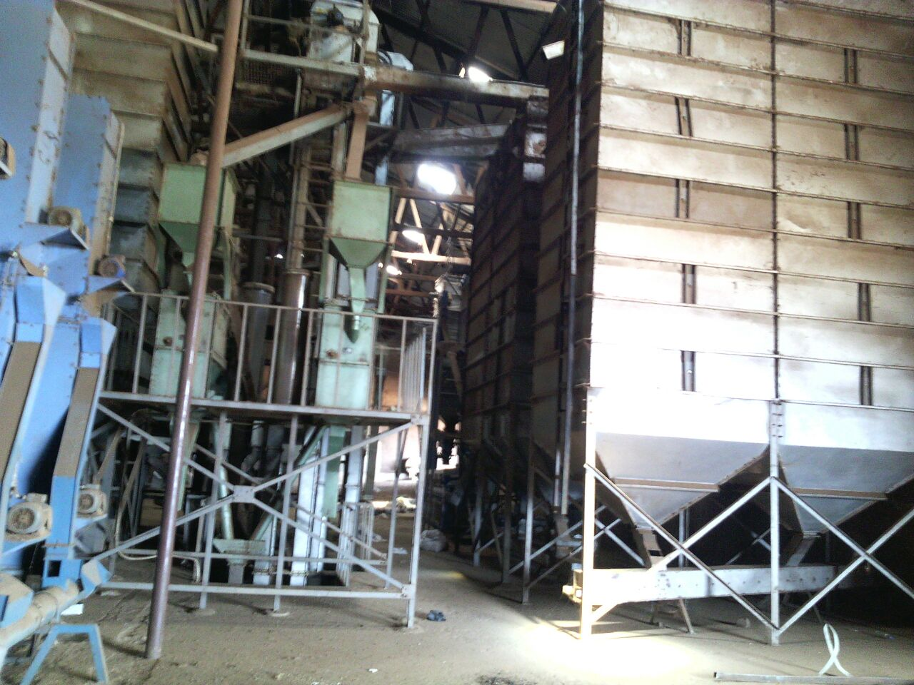
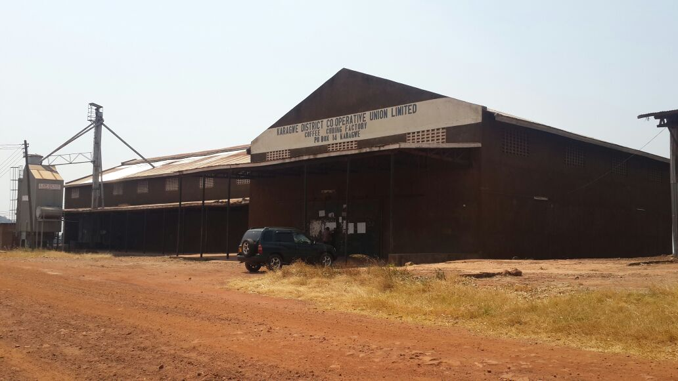
Processing of cherry coffee. KDCU is owning and operating processing factory. At the Factory, dried cherries are stored in bulk waiting for hulling, sorting, grading and bagging. Hulling machine removing the outer cover of the coffee and left with bean. The hulling machine is also polishing to improve the appearance of coffee beans and eliminate a byproduct of roasting. After polishing, machine shake the beans through a series of sieves, sorting them by size ready for packing based on size. KDCU do not have color sorter machine therefore sorting is done hired labor. In the season of 2014/2015 efficiency of the factory was improved by 60% due to numerous training provided by LWR project. From 2014 backwards the factory was employing more than 600 staff in a season to run the factory after training KDCU is now employing less than 200 staff in a season. In order to increase the income of KDCU the same season KDCU hulled coffee of the private buyer a total 500MT. At the height of the harvest season, 540 workers are employed in the dry coffee curing process in which the coffee beans are cleaned, hulled, polished, graded and packed.

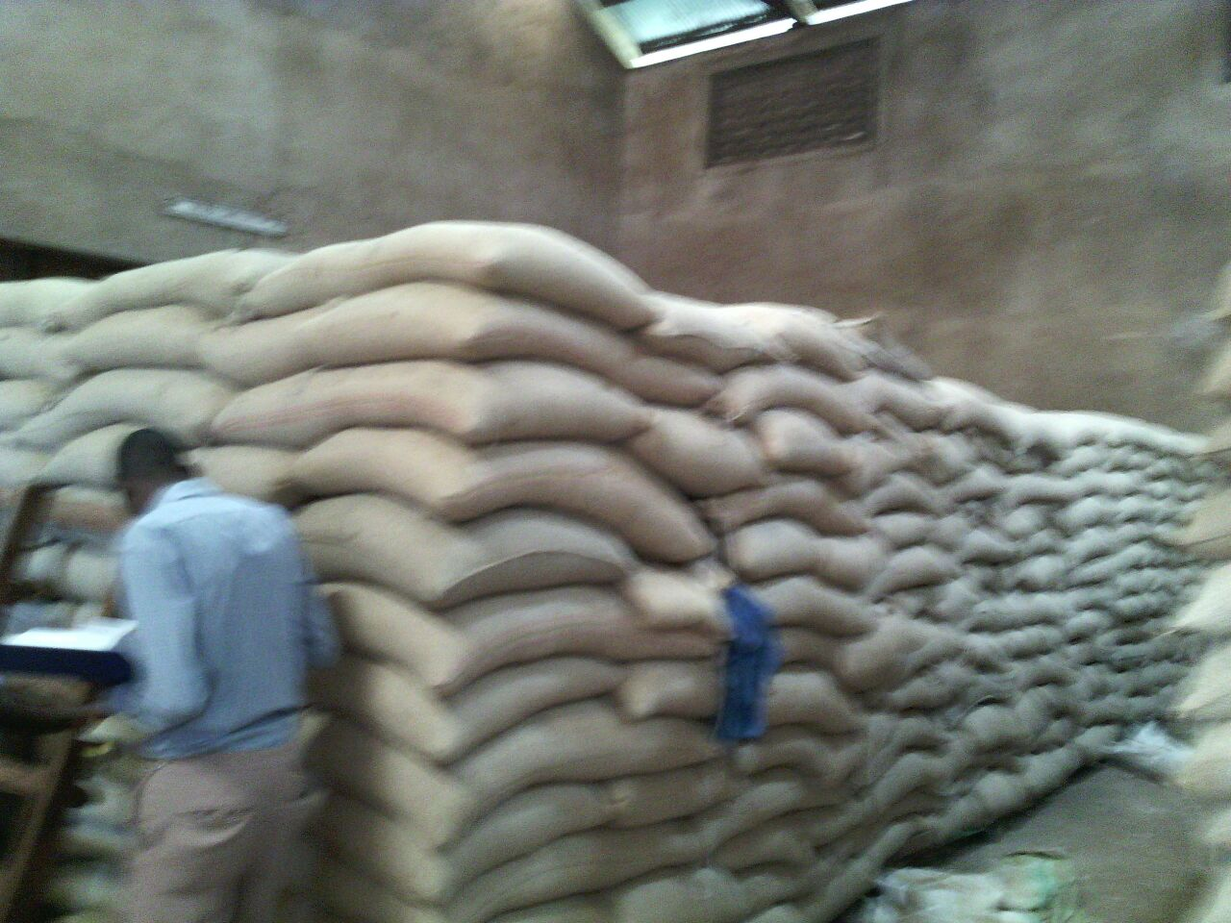
Marketing and selling coffee bean. KDCU has a responsibility of marketing and selling coffee bean inside and outside the country of its members. Within a country KCU has been selling coffee though action market. KDCU has a license of exporting coffee outside the country, the cooperative has been selling coffee to different companies like ECOM, SUCCADEC, Olam International etc. KDCU has managed to sell a total of 4,635 MT of clean/ bean coffee while the highest selling was 2014/2015 whereby they sold a total of 2,248MT

B: ISSUE DESCRIPTION:

Kagera District Cooperative Union (KDCU), which represents about 21,000 coffee farmers in Karagwe and Kyerwa, and its member 81 rural primary cooperative societies (RPCS) are not self-sustaining. While KDCU and the RPCS are potentially viable entities for delivering business services required by their members in the coffee value chain, they are weak and operate in an unsustainable manner. Over the past 3 years, KDCU's operational costs are higher than the income the organization generates. For example, for 2012/2013 the gross income earned from coffee trading and other investments was Tsh. 294,838,082 while board meeting, staff and board travelling expenses exceeded the income. The RPCS are completely dependent on KDCU to finance their operations when they receive payment for the bulked coffee from their members. This is caused by:
- Low knowledge on the application of accounting system. KDCU has a software package (Pastel) but finance staff do not use it because poor skills of applying it. All financial work is coded manually or in excel which makes it hard to track many transactions
- The financial manual been used has not been revised since 1990 even though KDCU is not using it at moment. This has let some of the financial procedures to be skipped
- Over the past three years KDCU has received a Qualified Opinion audit report which has resulted in poor internal procedures of accounts. In recognition of this, the LWR trained finance staff on accounting in 2014 but the staff did not quite get the skills and hence more training is required.
- KDCU has a pattern of taking loans without sufficient plans on where, when and at what price to sell their coffee so as to repay the loans.
- KDCU has not been able to negotiate favorable interest rates for loans taken for the RPCS when they deliver coffee, leading to low profit from the sale of the coffee beans. Compounding this problem is the fact that KDCU has held on to the bulked coffee for a long period due to challenges of finding optimal prices, prolonging the loan period and hence more accrued interest.
- KDCU has no clear plan on the direction it wants to take to increase revenue, and the needed investments to do so.
- About 40% of member RPCS failed to submit their accounting books for the annual audit process.

To sum up, the KDCU and RPCS have weak financial management systems as demonstrated by poor internal controls, poor cost management, limited capacities among accounting staff and poor management of bank loans. The above situation has prompted the KDCU and its supporting partner LWR to request the support of the CRS F2F program to provide expertise to address the financial and accounting management weaknesses of the organization so as to function as profitable and sustainable farmer cooperative.
C: OBJECTIVE OF THE ASSIGNMENT

The overall objective of this assignment is to enhance the capacity of management and accounting staff on accounting/ book keeping best practices and the installation of a recommended accounting software for KDCU for use by the cooperative. The accounting software used should make storage, analysis and retrieval of financial information easier and more accurate. Following the installation and training the staff should up-load all the existing manual data into the software as the first learning exercise. Depending on the skills and experience mix of the volunteer, the following are the potential steps towards the objectives:
- Study the current book keeping and financial accounting practices by KDCU and sample RPCSs to identify gaps/ weaknesses
- Based on the above findings design the training and plan for conducting the exercise
- Conduct the training as planned for various groups including a session with the board and management to emphasize key areas of management and governance
- Install the appropriate software and train accounting staff on use – by uploading current financial data
- Review and/or update financial manual to suit the current needs
- Advice board and management on the proper management of finance department
- Train board and management on financial governance, loans negotiation skills, financial audits and the board responsibility on financials

D: ANTICIPATED RESULTS FROM THE ASSIGNMENT
- Financial and accounts book keeping needs assessment report
- Training curricular /module developed
- Training conducted to key staff involved with accounts and book keeping
- Accounting software installed and staff trained on use -by up-loading current accounting data
- KDCU management and staff receive practical and classroom training on financial management best practices
- Updated/Developed financial manual
- Board and management trained on financial governance best practices

E: SCHEDULE OF VOLUNTEER ACTIVITY IN TANZANIA
The host would prefer to flesh this out once the skills and background of proposed volunteer (s) are determined. Opportunity to provide their feedback on amount of time needed for all the activities will be offered to the volunteer/s identified for the assignment. Below is an indicative schedule that gives some guidance
Day | Activity
Day 1 | Travel from home to US international airport
Day 2 | Arrival in Dar es Salaam JNIA airport. The volunteer will be picked from the airport by a designated cab and driven to the Amariah Hotel and Boutique
Day 3 | At around 09.00 am the volunteer will visit with the CRS office for logistics and briefing and then take a flight to Bukoba and some 2 hors drive to Karagwe
Day 4 | Upon arrival in Karagwe, the first day would be spent with Anna Mlay-KDCU General Manager to go over assignment objectives, determine what’s achievable, and spending time with KDCU staff to assess their knowledge and gaps.
Day 5-6 | Assessment to cover KDCU and RPCSs
Day 7 | Rest
Day 8-13 | Training
Day 14 | Rest
Day 15- 19 | Installation and training on appropriate accounting software
Day 19 | Board and Management Training
Day 21 | Rest
Day 22 | Volunteer will wrap up with KDCU and facilitate at least one-year action plan to implement the learnings
Day 23 | Travel to Dar es Salaam – finalize report for CRS
Day 24 | Debriefing at CRS /USAID mission in Tanzania (if possible) and flight back to the USA

F. DESIRABLE VOLUNTEER SKILLS-

The right expert for this assignment will have accounting and financial management skills with experience setting up and training on accounting software. In addition, the expert should have:
- Prior experience travelling to Africa or other developing country and has some understanding/familiarity with cooperative movements in Africa
- Apart from the core skills the expert should be a good trainer/ facilitator with adult training skills
- High level of comfort with ambiguity and ability to adapt to quickly changing circumstances- able to use a translator in some cases
- Patience, fortitude, and sense of humor are crucial to succeeding in this environment!

G: ACCOMODATION AND OTHER IN-COUNTRY LOGISTICS-
In Dar es Salaam the Volunteer will stay at the Amariah Boutique Hotel nearby the CRS offices, located on Dr. Kairuki Road, Mikocheni, Dar es Salaam, Tanzania, ‏‎0044 203 564 5228.
While in Karagwe the volunteer will stay in a local hostel that meets F2F’s standards for security, safety, and convenience.
There are several banks (including Barclays) with reliable ATMs.
KDCU will provide local ground transportation to/from office and to field sites.

H: RECOMMENDED ASSIGNEMENT PREPARATION-
As part of preparation for the work ahead the volunteer should familiarize with USAID Feed the Future program, the EARO and Tanzania F2F horticultural program proposal and scope of work for this particular assignment. It is highly recommended that the volunteer link up and engage with the LWR and KDCU as much as possible for a very clear understanding of the assignment and the working environment prior to travel. It is also advisable that the volunteer read and familiarize with Tanzania, the coffee industry and how the cooperative movement in Tanzania operates. The KDCU and LWR will ensure supply of any required stationary for the assignment and so the expert can inform prior to travel or while on site what will be needed to successfully accomplish the assignment.

I: KEY CONTACTS

CRS Baltimore | CRS EA Regional Office
Maria Figueroa  Volunteer Coordinator  Farmer-to-Farmer East Africa  228 W. Lexington Street  Baltimore, MD 21201  410-951-7366  Email: maria.figueroa@crs.org | Nyambura Theuri  Deputy Project Director  EA Farmer-to-Farmer Program  P.O. Box 49675 – 00100  Nairobi, Kenya  St. Augustine Court Karuna Close Road  Email: nyambura.theuri@crs.org
CRS Tanzania
Mary Kabatange  Farmer-to-Farmer Program Country Director  Plot # Migombani Street, Regent Estate, Mikocheni  P. O. Box 34701 Dar es Salaam  Tanzania  Office Tel: +255 22 2773141  Mobile cell phone +255 758 820025  Email: mary.kabatange@crs.org | Brian Gleeson  Country Representative  CRS Tanzania  Plot # Migombani Street, Regent Estate, Mikocheni  P. O. Box 34701 Dar es Salaam  Tanzania  Office Tel +255 22 2773141  Mob: +255 754 930966  Email: brian.gleeson@crs.org
Moses Kabogo  Country Program Manager  Lutheran World Relief  Tanzania  Phone:+255718576045  Email: mkabogo@lwrearo.org  Skype: lwr_moseskabogo | Anna Mlay  General Manager KDCU  P. O. Box---  Email: anna55tz@gmail.com

