Farmer to Farmer East Africa
Volunteer Assignment Scope of Work
Assignment Summary
Assignment Code | TZ87
Country | Tanzania
Country Project | Horticulture project
Host Organization | Reservoir Ltd
Assignment Title | Dried Food Specialist in Iringa for Cheetah Development Company
Assignment objective | Study Reservoir’s current dried food systems and make recommendations that will result in the increased shelf life of packaged products and advice on the most effective packaging (bulk and small) targeting the local and international market.
Desired skills | Drying, processing, packaging and storage of dried foods, preferably with experience in distributing to retail business.
Assignment preferred dates | June-September 2016

- Background:

The Farmer-to-Farmer (F2F) East Africa program is a program that uses short-term US volunteer expertise to assist small holder farmers and small scale processors in East Africa to improve their business practices through volunteer assignments conducted with host organizations. The goal of the (F2F) grains project is to increase incomes and improve nutritional status of Tanzanian smallholder farmers through; smallholder farmers increased productivity of agricultural crops, improved access to and utilization of markets and credit and preservation and enhanced natural resources upon which target communities depend. The program reaches out and establishes partnership with like- minded organizations, the latest being Cheetah Development.

Cheetah Development is a US-based impact investor headquartered in the US with a registered entity – Cheetah Development of Tanzania – based in Iringa, TZ. Cheetah funds the establishment of agricultural companies using a micro-venture capital model. Established companies are launched that target specific weaknesses in agricultural value chains that are not being addressed by other companies. Cheetah Development of TZ provides all the back office services to portfolio companies, including finance & accounting, HR, property management, etc. This safeguards quality provision of services to the start-up/early stage companies and is crucial for ensuring compliance with international standards and mitigates corruption. This back office service provision is just one of the innovative approaches that Cheetah employs to ensure success of portfolio companies. Cheetah Development USA manages two funds: one is an equity fund for starting up new value chain companies, and the second is a collateral fund used as a guarantee fund when working with lending organizations (banks and MFIs).

One of the two currently established/operating portfolio companies that Cheetah established is Reservoir Ltd, a company that operates in two separate value chains: provision of solar dryers for fruit and vegetables, and collection, packing, and distribution of dried foods. Reservoir lifts smallholder farmers out of poverty by guaranteeing a market for the food dried by farmers, and our approach is unique in that we are pushing the value-added process of drying down to the village level where the smallholders can capitalize on the increased value of dried food, instead of a company earning the benefits from drying. With dried food, farmers can earn many times the market price of fresh produce. At the same time, dryer owners can improve their food security by keeping some of the dried produce to last through the lean dry season and also improve nutrition by making available more fruits and vegetables during the dry season.

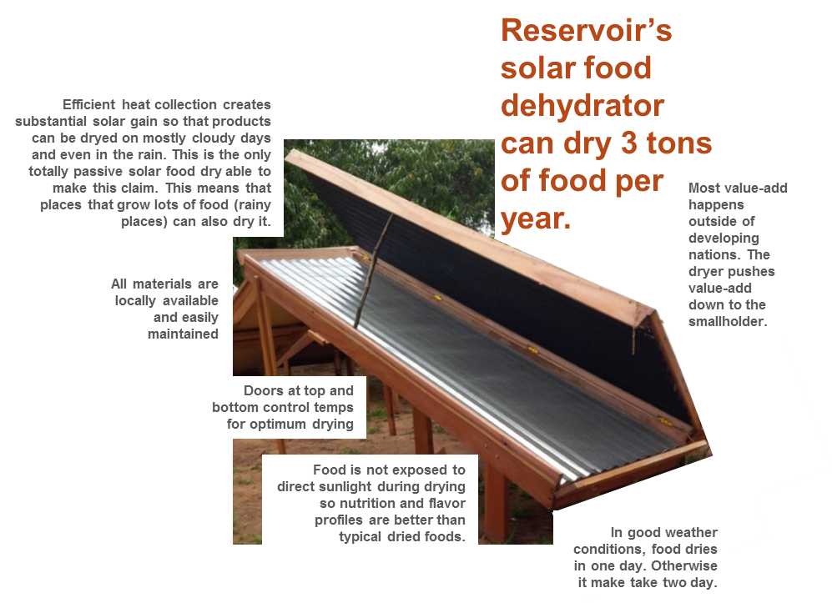
Solar Dryers: our completely passive solar dryer is manufactured locally and designed to be maintained and repaired in the village. Despite its seemingly simple design, our dryer performs better than any other known dryer for drying produce in cloudy and drizzly weather (conditions that exist for nearly half the year in the southern highlands of Tanzania). Farmers or others who purchase the dryer receive training from Reservoir staff on dryer instruction, food safety and sanitation, using the dryer to generate income, etc. Dryer customers (usually smallholder farmers in rural settings but also some entrepreneurs and groups such as student groups in rural areas) generally buy the dryer on credit (from a lending institution arranged by Cheetah) and use proceeds from the sale of dried food to service the loan payments. The cost of the dryer to customers is approximately $350-400 (with interest payments, $300-350 for a cash purchase).

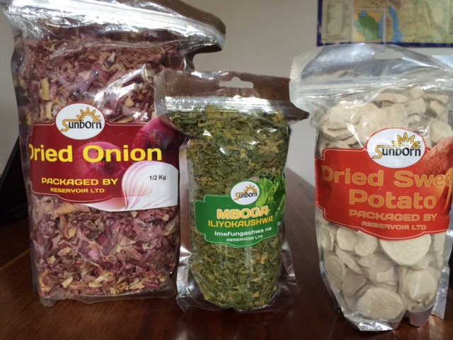
Dried Food: Reservoir guarantees the market for the dried products that the farmers produce as long as it meets quality and cleanliness standards. Dried produce includes bananas, mangoes, pineapples, onions, tomatoes, sweet potatoes, and leafy greens. Reservoir is open to buying and reselling other produce as long as we can find a suitable market with adequate demand to be profitable. Farmers deliver dried produce to the Reservoir office in Iringa where it is inspected and weighed and the farmer is given a receipt indicating the volume delivered and the value of the food; farmers are paid via mobile money system (MPESA, etc.) within 5 days of delivery. After intake, Reservoir staff sort the product by hand and move it to the packaging area to be put into bags ranging from 50 grams to 1 kilo, depending on the product. The food is then stored in cargo containers (converted into temporary storage space) until it is sold to retail shops.

The dried foods are marketed under a trademarked brand called Sunborn. Currently the dried produce is sold locally in and around Iringa town, but we are in the process of finishing the registration of products with the Tanzanian Food and Drug Agency (TFDA) that will allow us to sell domestically country-wide. After we have sufficient number of dryers in the field, the end goal is to produce enough dried food for export, meaning that we should be collecting enough to fill one 40-foot cargo container per month per product (around 20 metric tons, depending on the product). The goal is to eventually turn the brand into a certification that other brands can use that will let consumers know that products with the Sunborn label are fairly and sustainably sourced directly from smallholder farmers.

There are currently around 200 dryers in the field but Reservoir is pursuing a rapid growth strategy to increase dryers in the field and thus generate the volumes needed for export. We have proved the concept and now we are ready to scale. To reach the scale necessary to provide reliable and steady supply to international buyers, we need at a minimum 1,000 dryers in the field for each product. Our goal is to have at least 3,000 dryers in the field within the next 12 months.

We are currently searching for funds to capitalize an in-house lease-to-own division that would allow the customer to acquire the dryer and earn ownership over time by selling crops back to Reservoir over an 18 month period. Leasing is preferable to credit because it reduces the risk for the farmer on a purchase that requires a massive cash outlay for them. Risk is reduced because the dryer can be returned at any time by the customer with no further costs, and Reservoir can quickly refurbish and re-lease the dryer. Our leasing terms ensure that payments leave some cash in the pocket of farmers while part goes to dryer payments. This relationship also helps ensure that farmers sell most of the dried food back to Reservoir instead of any other party who wishes to purchase from them.

- Issue Description

As an early stage company, Reservoir has generated and sold roughly 200 dryers and only modest amounts of dried food since its inception in 2014. Our innovative dryer performs well but we are anxious to discover other innovative ways for it to be more effective to farmers so that they can maximize their efforts resulting in larger volume of dried produce with minimum effort and generate income. On the flip side, Reservoir is looking to generate more income through the reliable and regular delivery of dried food from farmers. It is also imperative that we ensure maximum shelf life for the products we sell (we are shooting for 1 year shelf life).

Replicability and scalability are inherent to our growth strategy. We intend to expand Reservoir throughout different regions of TZ while also expanding into other countries. We have already established a presence in Malawi and anticipate starting up activities in fall 2016. Other countries in East Africa are targeted for 2017 and beyond. In order for us to scale rapidly and effectively, it is imperative that we have highly detailed manuals that we can use to train staff and then farmers, so a big part of the assignment will be committing procedures and lessons learned into manuals.

From a dried food product marketing standpoint, we are pursuing a 3-phase approach:
- Our current phase where we are selling locally in and around Iringa town in shops and markets. We are using a direct sales approach for this channel.
- Scaling up to service the domestic Tanzanian market. For this channel we hope to sell to food distributors who can get our products into shops and markets all over the country. We will be able to do this once our TFDA license is approved.
- Reaching high volumes for export where we are filling and shipping 20 metric tons per product per month (most likely for 1-3 products initially). We have LOIs from 2 food distributors in the US that are interested in dried tomatoes, among other crops, once we achieve volume.

This information is relevant to understand the types of packaging we will need for each phase. For our direct marketing in Iringa we package the food by hand into ziplock type bags (not vacuum sealed). Bags range from 50g to 1.5kg (see photos above). We are experiencing some food spoilage and/or presence of insects in as little as 1 month after packaging. We have to constantly monitor our inventory on site and around town to ensure products are in condition to sell. We would like to identify packaging that is not so expensive and yet still retains desired freshness and shelf life.

When we reach sufficient volume to sell nationally (and upon receiving certification from TFDA) we hope to sell through distributors. Depending on the distributor, some food may be sold in bags while some may be sold loose in bulk bins. For the former we may still need some sort of Reservoir/ Sunborn branded packaging; for the latter we will need packages to transport dried food to distributors. We anticipate bags up to 25kg.

For export, we will need some type of packaging to fill cargo containers. Again, we anticipate transporting the food in large bags, perhaps the same bags used for distributors. We have also considered the use of cubic buckets as seen in the photo below.
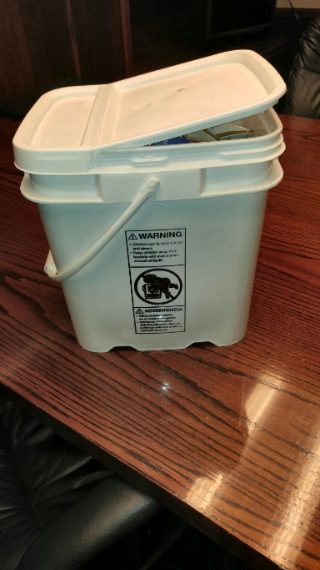
Traceability is a key aspect: we need to be able to trace dryers from the manufacturer to customers in the field; we also need to be able to trace dried food back to specific farmers. We have recently adopted a farmer management software platform called FarmForce that will help with traceability in the field, but this software is not designed to perform as an inventory tracking/management system, so we are looking for appropriate solutions.

- Assignment Objectives

Depending on the skills and experience mix of the volunteer, we will from the following potential objectives.

Drying the food:
- Use of natural preservatives (sugar, salt, etc.) to increase shelf life
- Sanitation and food safety techniques to improve quality/taste and shelf life, by farmers and at central collection point
- Ideas on new types of produce to dry and new products to offer based on abilities of dryer and availability of food in the region

Packaging and storage: Once the dried food is delivered to our premises, it needs to be packaged and stored. We are also searching for guidance on:
- The most effective process for short-term storage of dried produce before it is packaged
- How to measure quality, e.g. dryness, lack of sand/ dirt
- Ideas on the most effective packing options (including research on various hand operated and automated packaging machines) taking into consideration price to buy and operate, speed/capacity, and effectiveness
- Packaging options (types of bags) for each of our 3 sales channels that strike the balance between price, prolonging shelf life, and minimizing weight for long distance cargo shipping.
- Improvements to the storage facility

Distribution: We want to work through distributors to penetrate the retail market in Tanzania. We would like advice about pricing, contracting, and management.
- Anticipated Results from the Assignment
- Detailed recommendations and instructions
- Reservoir staff receive practical and classroom training on improved practices, food safety recommendations (for farmers and for staff doing packaging)
- Narrow down options for package machine options and packaging for dried food
- Advice on next steps for furthering our efforts on the objectives of the assignment

- Schedule of Volunteer Activities in Tanzania

The host would prefer to flesh this out once the skills and background of proposed volunteer (s) are determined. Opportunity to provide their feedback on amount of time needed for training and developing the manual will be offered to the volunteer/s identified for the assignment. Below is an indicative schedule that gives some guidance
Day | Activity
Day 1 | Travel from home to US international airport
Day 2 | Arrival in Dar es Salaam DAR airport. The volunteer will be picked from the airport by a designated cab and driven to the Amariah Hotel and Boutique
Day 3 | At around 09.00 am the volunteer will visit with the CRS office for logistics and briefing and then travel to Iringa by CRS transport
Day 4 | Upon arrival in Iringa, the first day would be spent with Marco and Patricia (Director of Reservoir in TZ) to go over assignment objectives, determine what’s achievable, and spending time with Reservoir field staff to assess their knowledge and gaps.  Start developing a schedule
Day 5-6 | Field visits to dryer owners to understand local context produce drying in the southern highlands and/or dried food retailers, depending on main focus of assignment.  Deeper dive into current receiving, packaging, storage, inventory, and distribution practices.  Begin documenting processes into manual
Day 7 | Rest
Day 8-9 | Continue outline of manual and preparation of training program
Day 10-11 | Implement office training for topic 1
Day 12-13 | Implement office training for topic 2
Day 14 | Rest
Day 15 | Testing of Reservoir staff on what they learned
Day 16-18 | Continue progress on manuals and other training material
Day 19 | Wrap-up with staff and work on assignment related docs
Day 20 | Travel back to Dar es Salaam from Iringa by CRS Transport, check in Amariah Hotel and Boutique
Day 21 | Rest
Day 22 | Volunteer will finalize his/her reporting for CRS office; provide feed-back on assignment and Present to CRS/USAID Representatives and clear financial advances. Depart for USA evening
TBD | Outreach event when back in the US  Finish the rest of the deliverables

- Desirable volunteer Skills
Essential:
- Demonstrated expertise in two of the following:
  - various types of food packaging, including small scale automated packaging machines, for direct to retail and food distributors, bulk and small packaged
  - working with distributors to retail
  - dried food quality and safety
- Prior travel to Africa or other developing country and understanding/familiarity with cultural differences
- High level of comfort with ambiguity and ability to adapt to quickly changing circumstances
- Patience, fortitude, and sense of humor are crucial to succeeding in this environment!

- Accommodation and Other in-country Logistics

In Dar es Salaam the Volunteer will stay at the Amariah Boutique Hotel nearby the CRS offices, located on Dr. Kairuki Road, Mikocheni, Dar es Salaam, Tanzania, ‏‎0044 203 564 5228.
While in Iringa, the volunteer will stay in a local hostel that meets F2F’s standards for security, safety, and convenience. One likely destination is the Rucu Hostel on the main road close to the center of town, where previous F2F volunteers have stayed.
There are 3-4 Western style restaurants within a 10-minute walk of Rucu Hostel, which are frequented by the local expat community and tourists.
There are several banks (including Barclays) with reliable ATMs. Cheetah will provide local ground transportation to/from office and to field sites.

- Recommended Assignment Preparations
As part of preparation for the work ahead the volunteer should familiarize with USAID Feed the Future program, the EARO and Tanzania F2F horticultural program proposal and scope of work for this particular assignment. It is also advisable that the volunteer read and familiarize with Tanzania, its development challenges and opportunities. For any printed material these will be printed at CRS office prior to commencement of the assignment.

Flip charts stand, charts, markers, masking tapes will be provided by CRS office for volunteer use during the training. Use of LCD projector for training is discouraged due to electricity power challenge in the villages where host farmers are located. Hence, the volunteer will be expected to prepare training materials and have handouts printed at CRS offices for distribution to the participants if required.

I: Key Contacts

CRS Baltimore | CRS EA Regional Office
Maria Figueroa  Volunteer Coordinator  Farmer-to-Farmer East Africa  228 W. Lexington Street  Baltimore, MD 21201  410-951-7366  Email: maria.figueroa@crs.org | Nyambura Theuri  Deputy Project Director  EA Farmer-to-Farmer Program  P.O. Box 49675 – 00100  Nairobi, Kenya  St. Augustine Court Karuna Close Road  Email: nyambura.theuri@crs.org
CRS Tanzania
Mary Kabatange  Farmer-to-Farmer Program Country Director  Plot # Migombani Street, Regent Estate, Mikocheni  P. O. Box 34701 Dar es Salaam  Tanzania  Office Tel: +255 22 2773141  Mobile cell phone +255 758 820025  Email: mary.kabatange@crs.org | Brian Gleeson  Country Representative  CRS Tanzania  Plot # Migombani Street, Regent Estate, Mikocheni  P. O. Box 34701 Dar es Salaam  Tanzania  Office Tel +255 22 2773141  Mob: +255 754 930966  Email: brian.gleeson@crs.org
Marco Johnson
VP of Field Operations
Iringa, TZ
Phone: +255 68 463 7902
Email: marco.johnson@cheetahdevelopment.org
Skype: johnsonmarc1

