Farmer to Farmer East Africa
Volunteer Assignment Scope of Work
Assignment Summary:
Assignment Code | TZ 130 SOW
Country | Tanzania
Country Project | Tanzania F2F Horticultural Project
Host Organization | Tanzania Episcopal Conference (TEC)
Assignment Title | Strategic Business Plan Development for Oldean Integrated Grains and Dairy Farm; Karatu
Assignment objective | To provide a business plan that will lead to a profitable dairy and grain agri-business for Oldean Farm
Desired skills | Dairy and/or integrated dairy grains production and management skills in the tropics
Assignment preferred dates | From December 2017 to March 2018

- Background
The Farmer-to-Farmer (F2F) East Africa program is a program that uses short-term US Volunteer expertise to assist small holder farmers and small-scale processors in East Africa to improve their business practices conducted with host organizations. The goal of the F2F Cereals project is to increase incomes, improve access to and utilization of markets, credit and preservation, and enhance natural resources upon which target communities depend.
In Tanzania, one of Catholic Relief Services’ (CRS) F2F project objectives is to support cereals production along the entire value chain. F2F works on the entire spectrum: at the origin, with small scale producers, and higher up, with processors, millers, exporters, trainers and the like.
Channeling technical assistance toward the grains value chain is a main target for the CRS F2F project because grains are key food staples for most Tanzanians. Strategic interventions in these value chains also have great potential to contribute to USAID goals; in this case, the goal of sustainably reducing poverty and food insecurity by increasing productivity and profitability of the grain crops that form the staple food for most Tanzanians.
The host for this assignment is the Tanzania Episcopal Conference (TEC) which is the permanent institution of the Assembly of the Bishops of Tanzania. TEC is the official national organization of the Catholic hierarchy in Tanzania, which aims by joint action to adopt the most suitable means of promoting the interests and welfare of the Church, not only in matters of religion but also in the development, and social programs. TEC was founded in 1956 and registered with the Government in 1957 and has twenty-nine (29) dioceses.

The Directorate of Economic Sustainability is one of the six Directorates of the Secretariat of the Tanzania Episcopal Conference, which has the mandate to oversee and guide the Secretariat’s income generating units, with the goal of improving the economic sustainability of the Secretariat, as well as supporting TEC’s core business. It is this directorate that oversees such economic projects as the Oldean Farm in Karatu; Dakawa Farm in Morogoro and the Kurasini Center in Dar es Salaam. The focus of the Directorate is on rationalizing and professionalizing the existing three income generating units, thereby realizing increased profit margins and, consequently, higher contribution towards running the secretariat’s various activities.

This volunteer assignment is to provide technical support to TEC and Oldean farm management develop a strategic business plan for the 695-acre farm comprised of varying acreage for grains (maize, wheat, barley and beans) and the dairy unit comprised of about 100 herd and pasture farm. Another assignment has been allocated to support their coffee farm of 280 acres and advising on a strategic business plan.

Description of the Oldean Farm:

The 975-acre farm has a long history but was acquired by the TEC in 1978 from an Italian farmer (the farm had changed ownership since the first world war; first owned by a German; who died in the first world war (buried at the farm); then offered as a gift to a British farmer after the British won the war; who then sold to an Italian farmer and finally to TEC). For management; TEC consulted and got management support from the Save Code Immaculate Marie order of Catholic Brothers from Njombe who have been managing the property to-date. There are three Brothers at the farm each doing different errands. Apart from the Catholic Brothers there are 17 permanent staff though the number will increase to 38 from January 2018 and varying number of daily laborers depending on the on-going activity. Its exact location is at the Oldean village; Karatu District and Arusha Region in Northern Tanzania. It is about 180 km from the Arusha city and only 5 km from the famous Ngorongoro Conservation Area’s main gate. The Ngorongoro Conservation Area (NCA) borders the farm to the north, providing picturesque landscapes and views from the farm. Apart from coffee there are two other enterprises on the farm; grains production (maize; wheat; barley and beans) and dairy farming; a minor enterprise for now. Other minor enterprises include a piggery and a horticultural garden.

The coffee enterprise and the key priority crop is on a 280 farm with arabica coffee trees with very low production. Projections by TEC are about 250 tons per year from the farm while the actual realized is between 15-93 tons (14-33% of potential) over the last 5 years. Plans to revamp the farm into a thriving business are underway and TEC has requested the CRS F2F program to provide technical support for which a scope of work for an assignment to conduct a strategic business plan has been drafted.

This scope of work is for the rest of the land; about 695 acres that has been dedicated to growing seasonal crops of maize; barley; wheat and beans while a substantial amount of land is allocated to pasture production for the roughly 70-herd dairy farm.

B: ISSUE DESCRIPTION
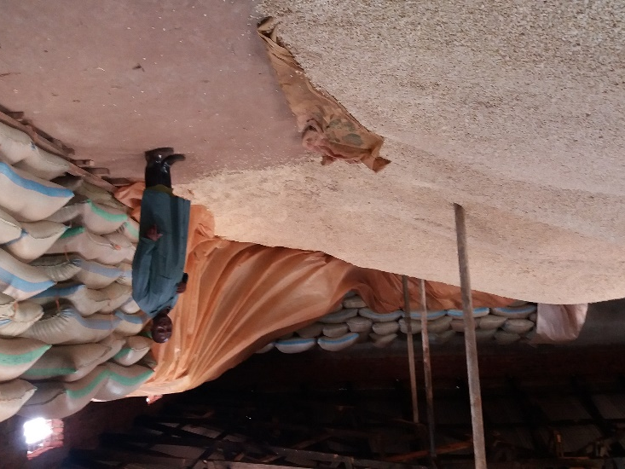
Currently grains utilize about 200 acres for maize; wheat; barley and beans production varying the acreage per crop yearly depending on the market price and fluctuating business conditions. Maize is the priority crop and last season a bag of maize fetched up to Tshs. 120,000/- (about US$ 57). Barley for beer production has been promoted by the Tanzania Breweries Limited but has not done very well because the contract buyer has not been transparent on costs and pricing and so the producers feel cheated. Currently the farm produces wheat and some barley, mostly for the dairy herd and piggery unit. When the writer of this scope visited she saw barley being boiled for the piggery unit. Challenges experienced by the grain business are like those for coffee; climate change; wildlife intrusion and fluctuating and increasing price for inputs especially seed. Markets are also a challenge for all the grain crops with prices fluctuating yearly depending on supply and demand and weather general.
The dairy unit is considered as a minor business though it has a high potential to be a key business. The current herd is 70 animals (only 14 cows being milked); with high milk demand and heifers. It was explained that in the 1990s the unit got an average of 20 liter per cow per day with average management. There is an assured market for the milk because buyers collect at the gate -so no added costs.
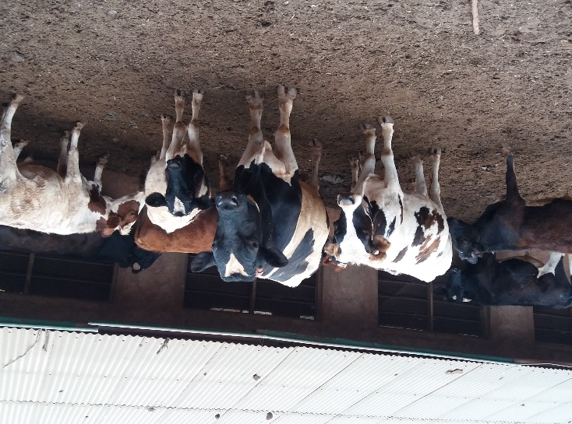
Some of the key advantages of the dairy unit as observed by the writer of the scope are as follows
- Quality breed of cattle – mostly Holstein Friesian and Ayrshire cattle known worldwide as the highest milk producers. The only problem might be in-breeding since it is not clear if new bulls have been introduced in the recent past
- Conducive environment for dairy production – the altitude of Karatu; (+/- 1500 ft. above sea level); the rainfall pattern (bi-model rains) with an average of –to –mm per year allow for pasture production for a good part of the year and fodder/ pasture conservation for the dryer parts of the year
- Land availability for intensive pasture production – a good part of the 695-acre land (left over from coffee estate) can all be managed as an integrated crop dairy production land with potentially high productivity of both the grains and dairy
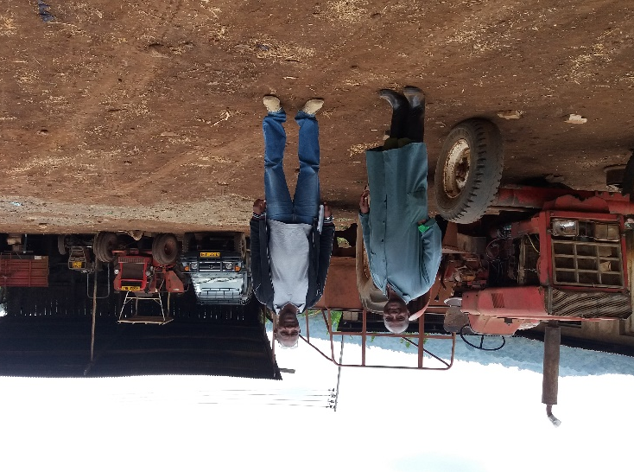
- Conducive market environment – information from the manager is that the farm cannot supply enough milk in the neighboring community and the Karatu township. The advantage is also that the buyers get the milk from the farm
- and so no marketing costs currently. This is a great advantage that should be maximized going forward.
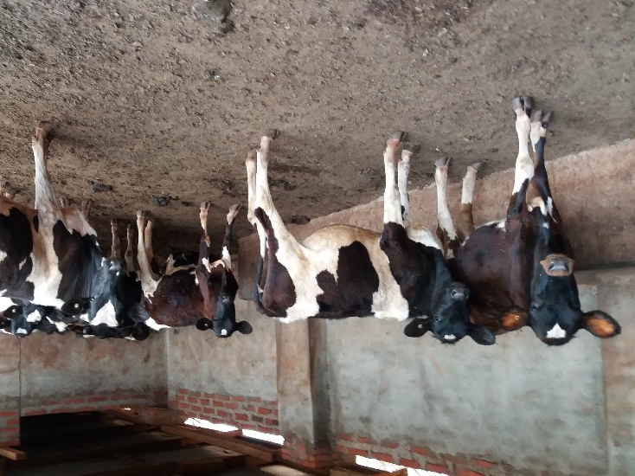
Buildings; to include the cattle barn, machinery and other infrastructure are currently very adequate for an intensive dairy management. There are some additional facilities and machinery required but not substantial. The advantage is that since the dairy and grains enterprises are part of the Oldean farm it will be possible and feasible to utilize the available farm machinery as one farm just making sure that utilization costs are properly allocated
- Dedicated staff- the Catholic Brothers running the farm are a religious order that are very dedicated to the work. These may not be the most qualified on the dairy industry but are willing and continue to learn on the job

Some constraints to be addressed:
- Currently the dairy unit is not considered a major enterprise and so not properly financed to allow for maximum production. For the potential to be realized TEC will need to make a strategic decision to identify dairy as one of the priority enterprises and allocate resources accordingly
- When the TEC has listed dairy as a second key enterprise it should hire a livestock /dairy expert well versed in the business to run the unit because currently there is no expert on dairy or livestock involved with the unit
- Currently there is no clear demarcation of the land into a clear pasture production area. Depending on the year – priority is for maize when price is good. There is need for a clear land demarcation for dairy and grains production

Taking all the above into consideration; TEC has requested for a volunteer expert to study the grains and dairy production and marketing environment and work with management and TEC to develop a 3-5-year business plan that will guide a planned and phased out investment and management activities that will lead to an integrated dairy /grains business into a thriving business utilizing all the resources as listed above.
C: OBJECTIVE OF THE ASSIGNMENT

The objective of the assignment is to undertake the following:

- Consult with TEC -the TEC Secretary General and investment director in Dar es Salaam to fully understand their vision for the dairy and grains business; commitment to invest on the project and their expectations from this assignment. The TEC should also share any reports and documentation that will later inform the business proposal
- Travel to Karatu and Oldean Farm – to spend a few days surveying the farm; the dairy unit and its infrastructure and related machinery; processing units; warehouse etc. to familiarize with the operations
- Continuously carrying out consultations with management and other personnel of the farm for information gathering
- Use all the information to draft a 3-5-year strategic business plan for dairy and grains production with prioritization and phasing as appropriate
- Present the draft to the farm management for inputs/ comments
- Travel to Dar es Salaam and visit with TEC Secretary General and Director of investment to table the report for comments and /or inputs
- Revise the document to incorporate agreed upon changes; finalize and submit final report

D. Host contribution:
- The TEC and farm management will contribute in the development of the scope of work
- Will provide transport within the farm, accommodation and translation service as may be required by the volunteer as he/she conducts the assignment.
- Will mobilize relevant staff to work with the volunteer in the process of conducting the assignment.
- Will provide prompt inputs as required during the assignment and comments /views as sought for the success of the exercise
- Will commit to and provide investments to implement the proposed plan
D: ANTICIPATED RESULTS FROM THE ASSIGNMENT
- A 3-5-year strategic business plan with budget for Oldean farm integrated dairy -grains project fully understood by TEC and management ready for implementation
- An action plan and budget for the first year that has been approved by TEC and management
- Volunteer report and presentation to both TEC and CRS

E: SCHEDULE OF VOLUNTEER ACTIVITY IN TANZANIA
It is estimated that the volunteer will use the first week to visit with TEC at Kurasini; travel to Karatu and the farm; survey and understand the farm and obtain any documentation to support the study. The second week will involve planning and documentation – followed by presentation and discussion at the farm. There will possibly be a two-day overlay in Dar es Salaam to discuss the plan and action points with TEC and wrap up with CRS. The detailed schedule will be worked out by the volunteer and TEC when in Dar es Salaam
F. DESIRABLE VOLUNTEER SKILLS.

- Experience in small scale dairy business (added advantage if also versed in grains production) in the tropics or Africa
- Practical experience in developing long range business plans and budgeting for dairy and grains farming business
- Ability to work through interpretation and adoptable to local situations in Africa
- Good writing and analytical skill as well as good communication skills

G: ACCOMODATION AND IN-COUNTRY LOGISTICS
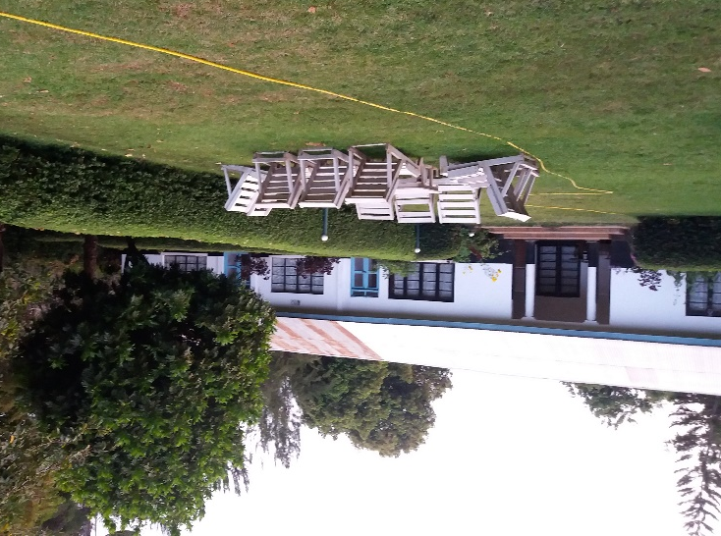
On arrival in Dar es Salaam the volunteer will be accommodated at the Amariah Boutique Hotel; Tel: +255 22 2701787/ +255 22 2774970 Mobile: +255 789 471461 /+255 712 471461 Email: info@amariah.co.tz/reservations@amariah.co.tz ; http://www.3star.co.tz/AMARIAH/MIKOCHENI/index.html; Dr. Kariuki Road Mikocheni A, where he/she will spend at least two nights. The hotel is well equipped with all necessary amenities of water, electricity and wireless internet. The volunteer, accompanied by a CRS F2F staff will then take a flight to Arusha or KIA whereupon he/she will be picked by the TEC farm vehicle for the trip to Karatu and the farm about 180 km from Arusha city. The road is paved all the way to Karatu and the turn off on a dirt farm road is only 5 kilometers. At the farm is a nice guest house where the volunteer will stay for the whole time while at the farm sharing food and other facilities with the Catholic Brothers running the farm. The only challenge with the farm is poor access to phone and internet. Capacity for research will be very limited.

H: RECOMMENDED ASSIGNEMENT PREPARATION

Would be volunteers for this assignment are recommended to familiarize with the Tanzania Episcopal Conference; and if possible contact the director of economic investment (contacts below) for clarifying any information. It is also highly recommended that the volunteer familiarizes with grains and dairy industry in Tanzania, challenges and opportunities. The volunteer should also familiarize with the CRS F2F program and Tanzania as a country general.

]: KEY CONTACTS

CRS Baltimore | CRS EA Regional Office
Maria Figueroa  Recruitment Manager  EA Farmer-to-Farmer Program  228 W. Lexington Street  Baltimore, MD 21201  410-951-7366  Email: maria.figueora@crs.org | Nyambura Theuri  Deputy Project Director  EA Farmer-to-Farmer Program  P.O. Box 49675 – 00100  Nairobi, Kenya  St. Augustine Court Karuna Close Road  Email: nyambura.theuri@crs.org
CRS Tanzania
Mary Kabatange  P. O. Box 34701 Dar es Salaam  Tanzania  Office Tel: +255 22 2773141  Mobile cell phone +255 758 820025  Email: mary.kabatange@crs.org | Brian Gleeson  Country Representative  CRS Tanzania  P. O. Box 34701 Dar es Salaam  Tanzania  Office Tel +255 22 2773141  Mob: +255 ----------------  Email: Gleeson, Brian Brian.Gleeson@crs.org.
Ms. Mecklina W. Isasi
Director for Economic Sustainability
Tanzania Episcopal Conference
P.O.Box 2133
Dar es Salaam
Tel: +255 22 2851075
Fax: +255 22 2851133
Cell: +255 763 683 015
Email: TEC DOES <does@tec.or.tz>
Dar es Salaam
Tanzania

