Farmer to Farmer East Africa
Volunteer Assignment Scope of Work
Assignment Summary:
Assignment Code | TZ 129 SOW
Country | Tanzania
Country Project | Tanzania F2F Horticultural Project
Host Organization | Tanzania Episcopal Conference (TEC)
Assignment Title | Strategic Business Plan Development for Oldean Coffee Farm; Karatu
Assignment objective | To provide a business plan that will lead to the revamping of the coffee farm into a thriving profitable business
Desired skills | Farming business management and preferably with the coffee enterprise
Assignment preferred dates | From December 2017 to March 2018

- Background
The Farmer-to-Farmer (F2F) East Africa program is a program that uses short-term US Volunteer expertise to assist small holder farmers and small-scale processors in East Africa to improve their business practices conducted with host organizations. The goal of the F2F Cereals project is to increase incomes, improve access to and utilization of markets, credit and preservation, and enhance natural resources upon which target communities depend.
In Tanzania, one of Catholic Relief Services’ (CRS) F2F project objectives is to support cereals production along the entire value chain. F2F works on the entire spectrum: at the origin, with small scale producers, and higher up, with processors, millers, exporters, trainers and the like.
Channeling technical assistance toward the grains value chain is a main target for the CRS F2F project because grains are key food staples for most Tanzanians. Strategic interventions in these value chains also have great potential to contribute to USAID goals; in this case, the goal of sustainably reducing poverty and food insecurity by increasing productivity and profitability of the grain crops that form the staple food for most Tanzanians.
The host for this assignment is the Tanzania Episcopal Conference (TEC) which is the permanent institution of the Assembly of the Bishops of Tanzania. TEC is the official national organization of the Catholic hierarchy in Tanzania, which aims by joint action to adopt the most suitable means of promoting the interests and welfare of the Church, not only in matters of religion but also in the development, and social programs. TEC was founded in 1956 and registered with the Government in 1957 and has twenty-nine (29) dioceses.

The Directorate of Economic Sustainability is one of the six Directorates of the Secretariat of the Tanzania Episcopal Conference, which has the mandate to oversee and guide the Secretariat’s income generating units, with the goal of improving the economic sustainability of the Secretariat, as well as supporting TEC’s core business. It is this directorate that oversees such economic projects as the Oldean Farm in Karatu; Dakawa Farm in Morogoro and the Kurasini Center in Dar es Salaam.

This volunteer assignment is to provide technical support to TEC and Oldean farm management to develop a strategic business plan for the 280-acre coffee farm at Karatu, Arusha region.

Description of the Oldean Coffee Farm:
The 975-acre farm has a long history but was acquired by the TEC in 1978 from an Italian farmer (the farm had changed ownership since the first world war; first owned by a German; who died in the first world war (buried at the farm); then offered as a gift to a British farmer after the British won the war; who then sold to an Italian farmer and finally to TEC). For management; TEC consulted and got management support from the Save Code Immaculate Marie order of Catholic Brothers from Njombe who have been managing the property to-date. There are three Brothers at the farm each doing different errands. Apart from the Catholic Brothers there are 17 permanent staff though the number will increase to 38 from January 2018 and varying number of daily laborers depending on the on-going activity. Its exact location is at the Oldean village; Karatu District and Arusha Region in Northern Tanzania. It is about 180 km from the Arusha city and only 5 km from the famous Ngorongoro Conservation Area’s main gate. The Ngorongoro Conservation Area (NCA) makes the northern border of the farm and such a picturesque land scape and sites from the farm. Apart from coffee there are two other enterprises on the farm; grains production (maize; wheat; barley and beans) and dairy farming; a minor enterprise for now. Other minor enterprises include a piggery and a horticultural garden.

The coffee enterprise and the key priority crop is on a 280 farm with arabica coffee trees with very low production over the last 5 years. Projections by TEC are about 250 tons per year from the farm while the actual realized is between 15-93 tons (14-33% of potential) over the last 5 years.

B: Factors contributing to low production:

Firstly, and historically, the coffee crop is potentially one of the most profitable and long-term enterprise where conditions are conducive to its production and marketing. In Tanzania, the most developed communities are found in the regions where coffee was the major cash crop to include Kilimanjaro; Kagera and Mbeya. However, over the years the situation has changed and the crop has been subjected to so many challenges that it is only the well to do that can afford to continue farming coffee and realize the benefits. It is under these conditions that the Oldean Farm is working and TEC has committed to making the necessary investments to make the coffee estate profitable by rightly investing

The key factors that have contributed to low productivity of the Oldean Farm are typical of most other coffee farms and can be described as follows:
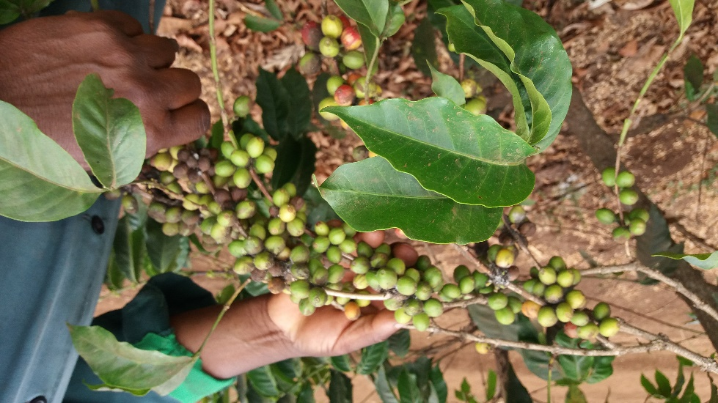
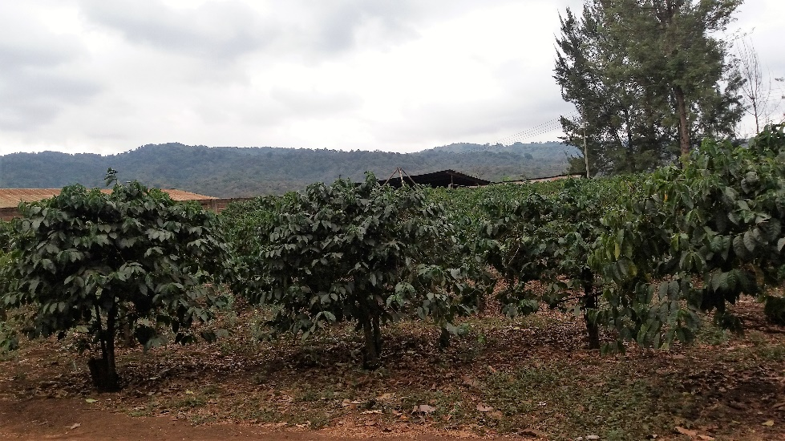
- Old and aging coffee trees: TEC bought the farm with already aging coffee trees – with some blocks of the farm planted as long ago as 1928; so are now about 90 years old. The blocks with the youngest plants were planted in the 1960s making these 65 years and above. The current practice is to fill gaps where a coffee tree has died or been destroyed one way or another; and destemming to allow new shoots.
- Chronic and endemic pests and diseases infestation some of which are long term and require constant and expensive management. The most common problem diseases are; green scale; leaf rust and to a lesser degree Coffee Berry Disease (CBD). All the diseases are transmissible and spread very fast if not quickly controlled and managed.
- Input supply and application challenges: poor capacity to access and apply the right inputs of fertilizer; pesticides; herbicides and labor is another constraint facing management; occasioned by lack of adequate and timely funds.
- Labor and timely activity- there are periods of the coffee year cycle when labor becomes scarce due to competition with neighboring farms and this forces Oldean to pay higher than projected labor costs escalating production costs. Coffee picking and pruning are such times -and failure to manage these activities can mean a lot of loss
- Wildlife destruction of coffee crops among others – the proximity to the Ngorongoro Conservation Area makes the farm very prone to stray wildlife (specifically buffalos and elephants) that find their way in the farm seeking feed, water or both. Buffaloes like coffee trees for scratching (and in the process felling the coffee bushes) while elephants follow some tree species for food. As they move along they destroy vegetation, roads and water infrastructure and this has been a constant problem
- Old farm machinery and implements - the farm has quite some machinery but some are old and some machinery and implements not serviceable.
- Low managerial capacity: the farm manager who oversees all the farm activities is a general agriculture graduate not supported by someone that has specialized on coffee. This means most decisions are made based on experience or learning from the neighboring farms. It might make sense to have a coffee farm project manager that specialized on the crop to make informed decisions on any technical activity

Factors beyond management and TEC to tackle that contribute to low farm incomes
- Fluctuating and unpredictable rains (climate change). The coffee crop’s cycle of production is delicate and if the rain pattern and amount change it influences the whole year production. There are critical times of the production cycle when rain is required like at flowering. If rains are late or too little the whole year crop may be lost. Rains also determine the pruning time -another critical operation – the importance of supplemental water cannot be over emphasized.
- Low market price due to dependence on the Tanzania Coffee Board (TCB) to auction the crop. According to the farm manager; the price they get through selling through TCB is US$3-4 per kilogram while direct export fetches US$7 upwards (about double the price). While direct export would be a good option for Oldean farm the conditions at present are not conducive.
- High input prices especially pesticides and fertilizer – most of these if not all are imported at prohibitive prices

From above it is clear that the coffee farmers are at a double disadvantage where both sales and production input prices are determined/controlled elsewhere and they are price takers all through

B: ISSUE DESCRIPTION

Having understood and considered all the above factors the TEC has determined to address the challenges the best possible to increase production and eventually price of coffee so that the objective for which the farm was bought are realized. It realizes that it is not possible to tackle all the challenges at once but will deploy a gradual process that will eventually solve most problems for a thriving coffee production business.

TEC realizes that there are several advantages already at play on the farm to include;
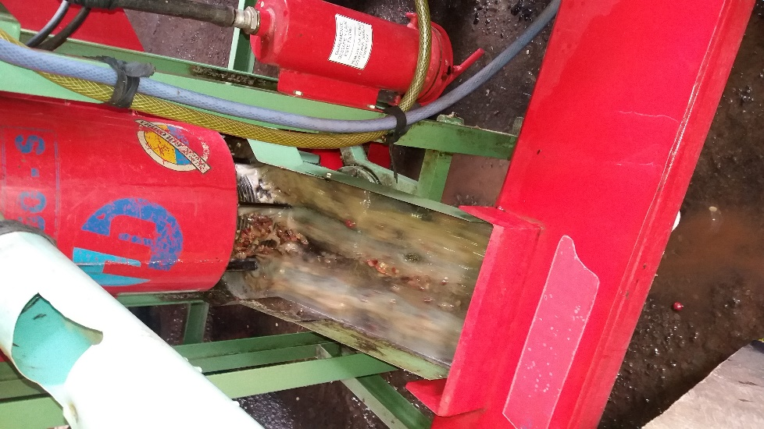
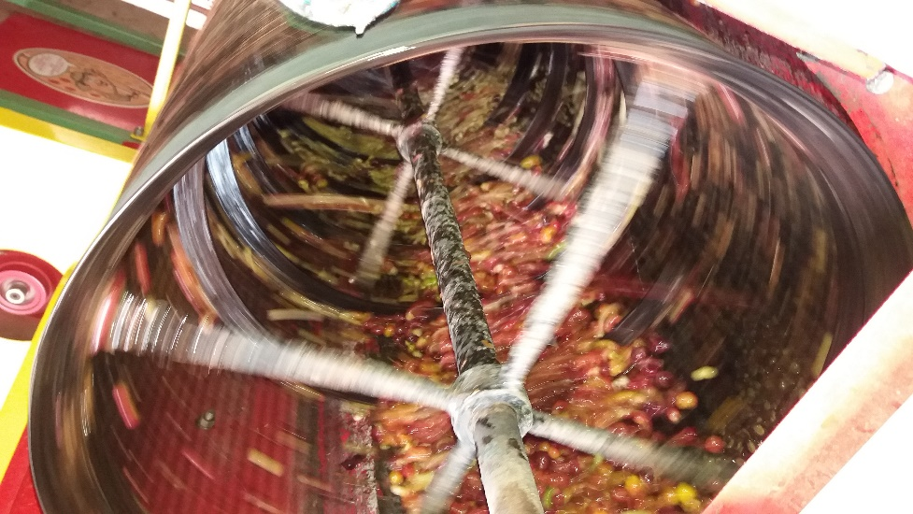
- Basic farm machinery and the infrastructure required for production. That includes a modern coffee pulper fully automated for quality coffee berries. No other farm at the proximity has such a good pulper that allows for grading during the pulping and washing process resulting in very good quality coffee. The other farm machinery of tractor and implements are either running or on various levels of repair
- To address un-predictable rains and water shortages there has been some investment on irrigation infrastructure – laying of pipes on about half the farm (140 acres) for overhead irrigation but the infrastructure was not completed. To complete the infrastructure required that a reservoir enough to supply the water was also completed and connected to the irrigation net-work. It was determined that a reservoir with 50x50x4 meter capacity would suffice and the location identified and constructed. What is now required is lining of the reservoir to seal /fill cracks and doing major repairs on the main water intake that will require some investment.
- Dedicated staff- the Catholic Brothers running the farm are a religious group that are very dedicated to the work. These may not be the most qualified on coffee expertise but are willing and continue to learn on the job

Taking all the above into consideration; TEC has requested for a volunteer expert to study the whole production and marketing environment and work with management and TEC to develop a 3-5-year business plan that will guide a planned and phased out investment and management activities that will lead to revamping the business into a thriving one beginning with the most urgent to the least urgent.
C: OBJECTIVE OF THE ASSIGNMENT

The objective of the assignment is to undertake the following:

- Consult with TEC -the TEC Secretary General and investment director in Dar es Salaam to fully understand their vision for the farm; commitment to invest on the project and their expectations from this assignment. The TEC should also share any reports and documentation that will later inform the business proposal
- Travel to Karatu and Oldean Farm – to spend a few days surveying the farm and related machinery; processing units; warehouse etc. to familiarize with the farming operations
- Continuously carrying out consultations with management and other personnel of the farm for information gathering
- Use all the information to draft a 3-5-year strategic business plan with prioritization and phasing as appropriate
- Present the draft to the farm management for inputs/ comments
- Travel to Dar es Salaam and visit with TEC Secretary General and Director of investment to table the report for comments and /or inputs
- Revise the document to incorporate agreed upon changes; finalize and submit final report

D. Host contribution:
- The TEC and farm management will contribute in the development of the scope of work
- Will provide transport within the farm, accommodation and translation service as may be required by the volunteer as he/she conducts the assignment.
- Will mobilize relevant staff to work with the volunteer in the process of conducting the assignment.
- Will provide prompt inputs as required during the assignment and comments /views as sought for the success of the exercise
- Will commit to and provide investments to implement the proposed plan
D: ANTICIPATED RESULTS FROM THE ASSIGNMENT
- A 3-5-year strategic business plan with budget for Oldean farm fully understood by TEC and management ready for implementation
- An action plan for the first year
- Volunteer report and presentation to both TEC and CRS

E: SCHEDULE OF VOLUNTEER ACTIVITY IN TANZANIA
It is estimated that the volunteer will use the first week to visit with TEC at Kurasini; travel to Karatu and the farm; survey and understand the farm and obtain any documentation to support the study. The second week will involve planning and documentation – followed by presentation and discussion at the farm. There will possibly be a two-day overlay in Dar es Salaam to discuss the plan and action points with TEC and wrap up with CRS. The detailed schedule will be worked out by the volunteer and TEC when in Dar es Salaam
F. DESIRABLE VOLUNTEER SKILLS.

- Experience in business development /business planning
- Practical experience in developing long range business plans and budgeting for farming business
- Farming experience desirable especially for perennial crops; and even more advantageous if has a coffee farming experience and knowledgeable about coffee marketing
- Ability to work through interpretation
- Good writing and analytical skill as well as good communication skills

G: ACCOMODATION AND IN-COUNTRY LOGISTICS

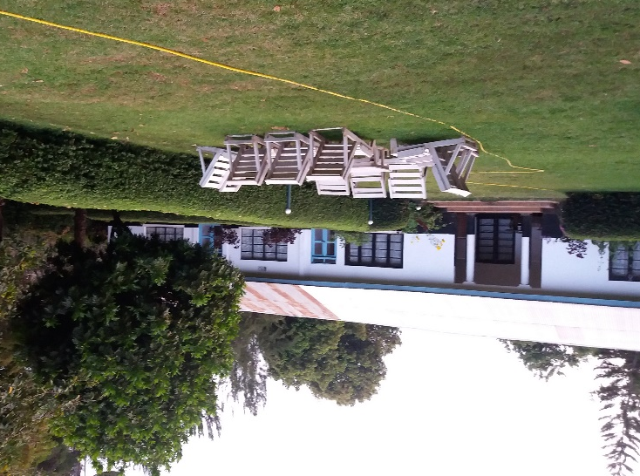
On arrival in Dar es Salaam the volunteer will be accommodated at the Amariah Boutique Hotel; Tel: +255 22 2701787/ +255 22 2774970 Mobile: +255 789 471461 /+255 712 471461 Email: info@amariah.co.tz/reservations@amariah.co.tz ; http://www.3star.co.tz/AMARIAH/MIKOCHENI/index.html; Dr. Kariuki Road Mikocheni A, where he/she will spend at least two nights. The hotel is well equipped with all necessary amenities of water, electricity and wireless internet. The volunteer, accompanied by a CRS F2F staff will then take a flight to Arusha or KIA whereupon he/she will be picked by the TEC farm vehicle for the trip to Karatu and the farm about 180 km from Arusha city. The road is paved all the way to Karatu and the turn off on a dirt farm road is only 5 kilometers. At the farm is a nice guest house where the volunteer will stay for the whole time while at the farm sharing food and other facilities with the Catholic Brothers running the farm. The only challenge with the farm is poor access to phone and internet. Capacity for research will be very limited.

H: RECOMMENDED ASSIGNEMENT PREPARATION

Would be volunteers for this assignment are recommended to familiarize with the Tanzania Episcopal Conference; and if possible contact the director of economic investment (contacts below) for clarifying any information. It is also highly recommended that the volunteer familiarizes with coffee industry in Tanzania, challenges and opportunities. The volunteer should also familiarize with the CRS F2F program and Tanzania as a country general.

I: KEY CONTACTS

CRS Baltimore | CRS EA Regional Office
Maria Figueroa  Recruitment Manager  EA Farmer-to-Farmer Program  228 W. Lexington Street  Baltimore, MD 21201  410-951-7366  Email: maria.figueora@crs.org | Nyambura Theuri  Deputy Project Director  EA Farmer-to-Farmer Program  P.O. Box 49675 – 00100  Nairobi, Kenya  St. Augustine Court Karuna Close Road  Email: nyambura.theuri@crs.org
CRS Tanzania
Mary Kabatange  P. O. Box 34701 Dar es Salaam  Tanzania  Office Tel: +255 22 2773141  Mobile cell phone +255 758 820025  Email: mary.kabatange@crs.org | Brian Gleeson  Country Representative  CRS Tanzania  P. O. Box 34701 Dar es Salaam  Tanzania  Office Tel +255 22 2773141  Mob: +255 ----------------  Email: Brian.Gleeson@crs.org.
Ms. Mecklina W. Isasi
Director for Economic Sustainability
Tanzania Episcopal Conference
P.O.Box 2133
Dar es Salaam
Tel: +255 22 2851075
Fax: +255 22 2851133
Cell: +255 763 683 015
Email: does@tec.or.tz
Dar es Salaam
Tanzania

