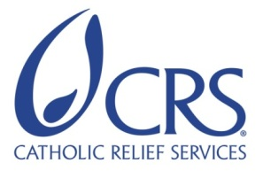
Volunteer Assignment Scope of Work

Summary Information
Assignment Code | SL 19
Country | Sierra Leone
Country Project | Horticulture Project
Host Organization | Tawopaneh & Gbampaneh Agri Business Centers (ABCs)
Assignment Title | Integrated Pest Management (IPM) for horticulture
Assignment Preferred Dates | December 2017 – February 2018
Objectives of the Assignment | To build the capacity of Tawopaneh and Gbampaneh ABCs and their associated 13 FBOs (25-30 farmers per ABC) to effectively manage horticultural pests and diseases.
Desired Volunteer Skill/Expertise | Horticultural/vegetable production, IPM, Pesticides Safety, excellent facilitator and communicator.

BACKGROUND
Catholic Relief Services Sierra Leone Country Program, in partnership with Fresh Salone and West Africa Rice Company is implementing USAID-funded Feed the Future Sierra Leone Entrepreneurial Agriculture for Improved Nutrition Activity which is scheduled to end in 2018. This Feed the Future activity is the Associate Award from the Leader with Associate award, the Farmer to Farmer East Africa Program. The goal of the five-year Feed the Future activity was to improve the agricultural and food security situation of Sierra Leone’s population by sustainably reducing rural poverty and improving nutrition through the integration of agriculture and nutrition interventions. This goal was supported by two Intermediate Results which fosters drivers of economic growth through value chain development and improved nutritional status of at least 30,000 farming households (180,000 people) across all the 11 Chiefdoms of Tonkolili District. IR 1: Increased incomes led by strategic value chain investments, and; IR2: Improved nutritional status, especially among women and children.
Now that the activity is ending in May 2018 instead of September 2021, the goals of FY18 is on one hand to ensure the return on investment made in satellite (rice and maize) and demo farms (horticulture) in FY17 is as high as possible and on the other hand to sustainably hand over demo farm operations as well as possible to the Agri-Business Centers. During FY18 the activity will focus on IR1 and not on IR2.
IR1 is supported by two components 1) improving agricultural productivity and post-harvest technologies of rice maize and horticulture crops and 2) expanding market access.
The Feed the Future activity consortium works very closely with other Feed the Future implementing partners, like Africa Lead (DAI), Feed the Future Sierra Leone Scaling up Aquaculture Production activity (World Fish), SPRING, Peace Corps, Tonkolili District council, Ministry of Agriculture, Forestry and Food Security (MAFFS) and the Ministry of Health and Sanitation at national and district levels. The collaboration will result in capacity building of government officials and extension agents, Agri-Business Center staff and leadership.

About the Host Organization-– Tawopaneh and Gbampaneh ABCs
Tawopaneh & Gbampaneh Agri-Business Centers (ABCs) were formed in 2010 by FAO and Ministry of Agriculture Forestry and Food Security (MAFFS). ABCs are a multi-purpose facility/institution providing rural communities with a place to process their agricultural produce, buy inputs and sell products, as providing an interface between farmers and rural service providers as well as serving as hub for social interaction. Each ABC is designed to deliver services like, sale of inputs, rental of agricultural tools and equipment, storage of agricultural produce, transportation of harvest to markets, access to communication and information technology. Each ABC is managed by a Board of seven members (Chairperson, Secretary, Treasurer, Public Relations Officer, two Organizers, and a Women’s Leader). This board is elected every three years during an annual general meeting which is monitored by MAFFS. All board members are selected from member Farmer Based Organizations (FBOs). Tawopaneh & Gbampaneh ABCs have each four FBOs as affiliates. The two ABCs are mandated to support their FBO member farmers with a wide range of services like input supply, storage, processing, marketing. Each ABC employed a Manager as key staff, and can add other staff positions depending on complexity and scale of their operations. The main crops for the 2 ABCs are rice, cassava and maize, but other crops especially horticulture crops are slowly being introduced by projects like Feed the Future Sierra Leone Entrepreneurial Agriculture for Improved Nutrition activity because of their high market value.
Each FBO is managed by a committee which include key positions like Chairman, Secretary and Treasurer. The FBO can add other members in the committee depending on complexity and scale of their operations. Many capacity building activities for the ABC board were conducted by FAO since 2010 in the areas of leadership, management and financial management. FAO assisted the ABC with business plan training and development in 2010 to 2013. Since then, both Tawopaneh & Gbampaneh Agri-Business Centers (ABCs) did review their business plans in the subsequent years.
FAO’s assumption was that MAFFS would mobiliz resources to continue supporting and sustaining ABC business. FAO gave Technical support and in 2014 MAFFS took over ABCs supporting restructuring and management. Since 2014 this support has been ongoing.
Fresh Salone has been working with Tawopaneh and Gbampaneh ABCs, to transfer high yielding technologies and associated good agricultural practices to improve productivity of nutritious and high value horticultural crops. Fresh Salone is linking the farmers groups in these two ABCs to irrigation kits along with agribusiness and agronomy training for improved vegetable production using Fresh Salone’s model of demonstrations plots, training and ‘open fields kits’. Fresh Salone introduced production of nutritious and locally adapted varieties of vegetables such as pepper, French beans, squash, orange fleshed sweet potatoes, zucchini, pumpkin, hot pepper, okra and papaya to raise incomes, food security and nutrition of farmers and their family.
Fresh Salone conducted an initial training to the two ABCs in Global Agriculture Practices (Global GAP) for horticultural production which included IPM, horticultural pests and diseases, safe use and handling of pesticides. There still is a knowledge and skill gap among the farmers in understanding and applying these concepts of IPM and safe use and handling of pesticides. Considering this scenario, a specialized Technical Assistance intervention on the mentioned areas will increase farmers’ knowledge allowing them to handle the myriad of challenges emanating from horticulture pests and diseases.

ISSUE DESCRIPTION
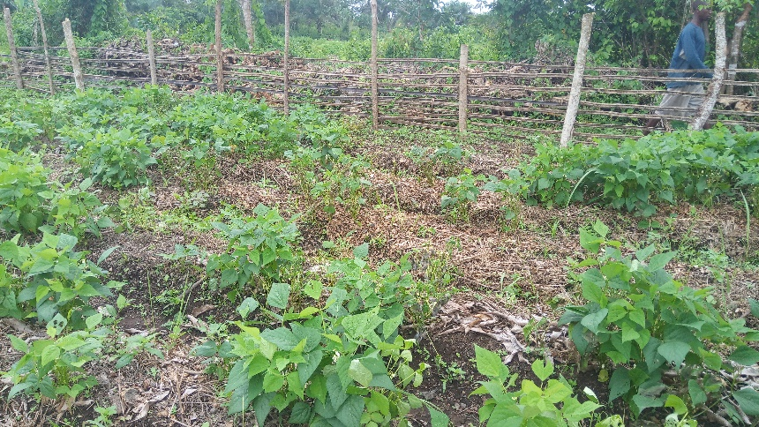
Vegetable production is a relatively new business for farmers Tawopaneh and Gbampaneh ABCs. Pests and diseases management and control has so far proved to be a key challenge which discounted yields for vegetables like french beans, squash butternuts, orange fleshed sweet potatoes, okra, pumpkin, and zucchini which were grown in the first cycle of the demonstration farms (June – October 2017). Amongst the diseases identified presenting challenges to farmers are Fusarium wilt, soft rots and blights. Since horticultural production is new, farmers still have limited knowledge on vegetable pests and diseases and most of the time they are unable to diagnose the causal agent of crop failure. The loss incurred due to pests is very high (30 – 40%). An alternative and more holistic solutions such as integrated pest management (IPM), which has proven more effective than relying on chemicals alone, and can save on input costs. IPM practices would go a long way in ensuring these farmers sustainably manage their vegetable production for improved incomes and nutrition. Additionally, farmers struggle with inappropriate and unsafe use of pesticides. The demand for proper safe use and handling of chemicals is high given that information on this field is limited and inadequate, and not easy to find. Farmers have expressed interest in receiving a broader, more holistic IPM training that would further help address safety issues with respect to pesticides, while also increasing produce yields and quality.

OBJECTIVES OF THE ASSIGNMENT
The key objective of this assignment is to build the capacity of Tawopaneh and Gbampaneh ABCs and their associated 13 FBOs (25-30 farmers per ABC) to effectively manage horticultural pests and diseases. Approximately 25 – 30 farmers per ABC and 4 MAFFS block extension officers are targeted to undergo this training.
Specifically, the Volunteer will provide farmers with hands-on, practical training in:
- Tropical pests and diseases in horticultural production;
- Integrated pest management;
- Safe use and handling of CPPs;
- Draft a reference manual in these subjects detailing the risk analysis in crop protection and possible mitigation measures to avert the identified risks.

The volunteer must notify CRS in advance of materials, equipment and other resources which should be mobilized for the training.

HOST CONTRIBUTION
Fresh Salone, a partner in the consortium, works with the two ABCs and together with the ABCs leadership, Fresh Salone will mobilize farmers to participate in trainings. They will also organize logistics, such as training venues, farmer field visits, etc.
Fresh Salone will also provide one Farmer Connector (Staff) versed in local language throughout the period of this assignment with the two ABCs. The Farmer Connector will accompany the volunteer throughout the duration of the assignment and provide any further logistical support. Tawopaneh and Gbampaneh ABCs will contribute the following:
- Development of the scope of work;
- Mobilizing relevant staff to work with the volunteer in the process of conducting the assignment;
- Providing prompt inputs as required during the assignment and comments /views as sought for the success of the exercise;
- Providing investments to implement the proposed plan;
- Providing training venues for the entire duration of the assignment.

ANTICIPATED RESULTS FROM THE ASSIGNMENT
- Farmers (248) will increase their understanding of IPM and how to apply it to their farms;
- Farmers (248) will increase their understanding of safe use and handling of pesticides;
- Reference and training manual produced in pests and diseases in vegetable production, IPM, safe use and handling of CPPs;
- Tawopaneh & Gbampaneh ABCs and key group members will continue training others using the reference manual.

DELIVERABLES
- Trainings conducted and attendance registers – 60 farmers and 4 MAFFS block extension officers
- Action plan drafted by beneficiaries;
- Volunteer presentation;
- Volunteer report and press release;
- IPM manual, later translated for use by Tawopaneh & Gbampaneh ABC and farmers;
- Outreach event in US.

SCHEDULE OF VOLUNTEER ACTIVITIES IN SIERRA LEONE
Below is the Tentative Schedule
- Travel from USA (2 days)
- Travel from Airport to (Makeni Briefing, and travelling to) Mile 91 for briefing (1 day);
- Training of Tawopaneh ABC (4 days)
- Training of Gbampaneh ABC (54Days)
- Travel to Makeni and briefing (1 day)
- Departure to Airport and USA (2 days)
- Total in country days = 10 days; travel days = (4 days)

DESIRABLE VOLUNTEERS SKILLS
- Experience in training/mentoring subsistence farmers in Africa is an advantage;
- Formal qualification in agriculture or a practicing farmer especially horticulture;
- Competency in organic farming methods;
- Understanding of safe use and handling of pesticides;
- Experience managing tropical crop pests and diseases;
- Facilitation, mobilization, and training skills within the context of adult learning; good interpersonal skills;
- Ability to adapt to new working environments, e.g. work through an interpreter in a rural, foreign environment;
- Flexibility to work with people of varying literacy levels;
- Similar volunteer assignments in Africa an added advantage;
- Good writing and analytical skill as well as good communication skills;
- Experience in natural pesticides an advantage;
- PERSUAP experience desirable.

ACCOMMODATION AND OTHER IN-COUNTRY LOGISTICS

Volunteers arriving at the airport before 4 pm will be taken by a CRS driver from airport to Magburaka town for accommodation at CRS Guest House. When the volunteer arrived after 5:00 pm, CRS will take the guest to the Lungi International Airport Hotel, E-mail: (management.lungihotel@hotmail.com) for overnight. The volunteer will have a dinner and breakfast at this hotel. In the morning around 8, the volunteer will be taken by a CRS car to Magburaka where he/she will stay at the CRS Guest House, for conducting the assignment in Tonkolili. The guest house is equipped with accommodation and cooking facilities, with breakfast food provided on self-catering. If the volunteer has special breakfast needs, he/she must let CRS in advance. For lunch and dinner CRS will provide transport to descend nearby food outlets. The volunteer has an option to buy food and prepare for him/herself in the guest house whilst staying in Magburaka.
For this assignment, the volunteer will travel to Mile 91 (still in Tonkolili district), approximately 205 km where he/she will be based for the entire period of the assignment, based at a Hotel to be booked by CRS. CRS will pay bed and breakfast every day, and will provide a vehicle and driver to assist the volunteer to look for lunch and dinner. CRS will have a vehicle and driver everyday assisting the volunteer to the different areas of assignments of this scope of work.
CRS will provide the volunteer with per diem in the form of advance which will have to be cleared before departing from Sierra Leone, to cater for meals and other incidentals during the stay. For more information, please refer to the country information that will be provided.
- RECOMMENDED ASSIGNMENT PREPARATIONS
- The volunteer should prepare materials for hand-outs in advance before travelling to Sierra Leone, which will be printed at CRS office in Magburaka before commencement of the assignment. Flip charts, markers, masking tapes can be obtained at CRS offices in case the volunteer wishes to make some illustrations, as all the trainings will be conducted in communities’ halls with no electricity. In this case the volunteer will be expected to prepare training materials and have hand-outs printed at CRS offices for distribution to the participants. CRS will also provide a laptop to the volunteer, if he/she does not have one.
CRS strongly recommends that the volunteer becomes familiar with the Sierra Leone Feed the Future Entrepreneurial Agriculture for Improved Nutrition Activity prior to arrival in the country as well as country information that will be provided.
- KEY CONTACTS
CRS Baltimore
Priyanka Subba  Volunteer Recruiter  Sierra Leone Farmer to Farmer Program  228 W. Lexington Street  Baltimore, MD 21201  410-951-7366  Email: priyanka.subba@crs.org | Bruce White  Project Director  EA Farmer to Farmer Program  228 W. Lexington Street  Baltimore, MD 21201  410-951-7249 / 410-428-4224 Cell  Skype: brucew219  Email: bruce.white@crs.org
CRS Country Program
Nikaj van Wees  Chief of Party - Feed the Future Sierra Leone Entrepreneurial Agriculture for Improved Nutrition activity  41 Riverside Drive, Brook Fields, Freetown  Email: nikaj.van@crs.org  +232 7887 4104 | Wellington Dzvene  Agro Inputs and Farm Services Advisor - Feed the Future Sierra Leone Entrepreneurial Agriculture for Improved Nutrition activity  41 Riverside Drive, Brook Fields, Freetown  Email: wellington.dzvene@crs.org  +232 769 759 38
Mohamed Kamara  Secretary General  Tawopaneh ABC  Mathombo Village, Yoni chiefdom | Ousman Sesay  Secretary General  Gbampaneh ABC  Masugbay Village, Malal Mara chiefdom

