Be REDI
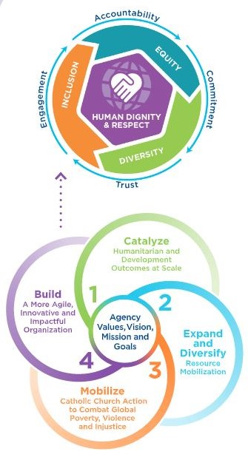
introduction to Respect, Equity, DIVERSITY, and InClusion at CRS

WHAT IS REDI?
At Catholic Relief Services, we are committed to putting our faith into action to catalyze transformational change. How we deliver our mission matters as much as what we do. CRS seeks to live out our values as an agency by creating and maintaining a workplace environment that promotes our core value of human dignity and exemplifies Respect, Equity, Diversity, and Inclusion (REDI) for all colleagues, partners, donors, and program participants. Read more about CRS’s REDI journey on our REDI MyCRS page.

Our common understanding and language around REDI: (read more about our approach to common terms in CRS’s Guidelines for Ethical Storytelling)
RESPECT is appreciation—Demonstrating high regard and appreciation for the differences and similarities in one another while living as one human family and recognizing the inherent dignity of each person.
EQUITY is about fairness—Committing to fair treatment and enabling access to opportunities and advancement for everyone. Equity differs from equality in that it addresses unbalanced conditions, enabling individuals to fully exercise their gifts and honor their inherent dignity.
DIVERSITY is a fact—Embodying the many physical, mental, and social differences that make us unique, including but not limited to gender, age, religion, race, ethnicity, nationality, socioeconomic status, education, language, and ability.
INCLUSION is an act—Creating environments where all people feel welcomed, that their expertise is optimized, and their contributions and perspectives are valued. Within an inclusive context, individuals can develop their full potential in community with others, feel respected and have a sense of belonging.

WHO IS RESPONSIBLE FOR REDI?
REDI reinforces CRS’s existing values, vision, and mission, as well as the policies, procedures and laws that govern our operations. Our guiding principles are central to CRS’ identity and to REDI.

Responsibilities as individuals:
For all colleagues to experience REDI, each of us is responsible for our own behaviors and mindsets to be inclusive and appreciative of differences that make us unique. This includes welcoming diversity dimensions such as gender, age, religion, race, ethnicity, tribe, language, ability, socioeconomic status, education, and others in the workplace. Every day we can make a choice to adopt additional ways of demonstrating respect, valuing diversity, ensuring equity, and leveraging all our colleagues’ experiences, backgrounds, and talents.

Everyone is expected to uphold our agency values in how we work and communicate with colleagues, the people we serve, our partner organizations, community stakeholders and donors. These values are also reflected in our Code of Conduct & Ethics and our Safeguarding Policy.

Responsibilities as an agency:
At the agency level, we are responsible for ensuring that our systems and structures are congruent with our agency values, vision, and mission. Some of the current methods and mechanisms for agency responsibility include:

- REDI Behaviors Leadership Assessment, in which colleagues anonymously assessed senior leaders on six key behaviors in addition to their regular performance review process. These behaviors are being integrated into our existing Agency Behavioral Competencies for all colleagues at CRS.
- Global REDI Council in which leaders come together from across the agency to advise, support, promote, and contextualize agency REDI action priorities.
- A third-party vendor Equity Assessment to look at fairness at CRS across our culture, the demographics of our workplace, as well as processes and policies.
- Specific REDI questions and responses within the agency’s all-colleague engagement surveys and pulse checks.
- A three-part onboarding experience available to CRS new hires: Mission and Values, Structure & Strategy, and REDI Orientation – to be rolled out in additional agency languages in FY22.
- Our Code of Conduct and Ethics and CRS' Safeguarding Policy outline CRS’ commitment towards personal integrity, moral conduct, ethics, and accountability to our colleagues and those we serve.

WHAT TO DO IF YOU ARE NOT EXPERIENCING REDI:
If you feel you are not experiencing REDI or if you observe something that makes you uncomfortable, you can go to your supervisor, your respective Human Resources representative, your Country Representative/Regional Team or US-based director, or depending on the issue, the Country Program safeguarding designate or Safeguarding Ethics Unit colleagues for support. If you do not feel comfortable reporting this way, you can send a confidential message about your specific incident to Candace Osunsade and Ritika Singh at REDI@crs.org

How to file a report with EthicsPoint:
All CRS Staff are obligated to report any concerns or suspicions of any forms of harassment, abuse and exploitation involving CRS colleagues, affiliates, partners, program participants, visitors, suppliers, service providers or aid workers associated with another organization. The concern may be a result of witnessing the incident, being told of it, or being the object of it.

CRS colleagues should report all concerns through the above channels or through the CRS Whistleblower Site:
- Email: alert@crs.org
- Skype: 1-866-295-2632
- Mail to Attention: Director of the Office of Legal Counsel, Catholic Relief Services, 228 W. Lexington Street, Baltimore, MD 21201

HOW TO LEARN MORE:
You can learn more about REDI and our agency wide action priorities by visiting the REDI MyCRS page. The top section entitled "Latest News & Announcements" will have the latest activities, updates, and communications about REDI. You can also submit any questions you have about REDI via the REDI Question Box.

