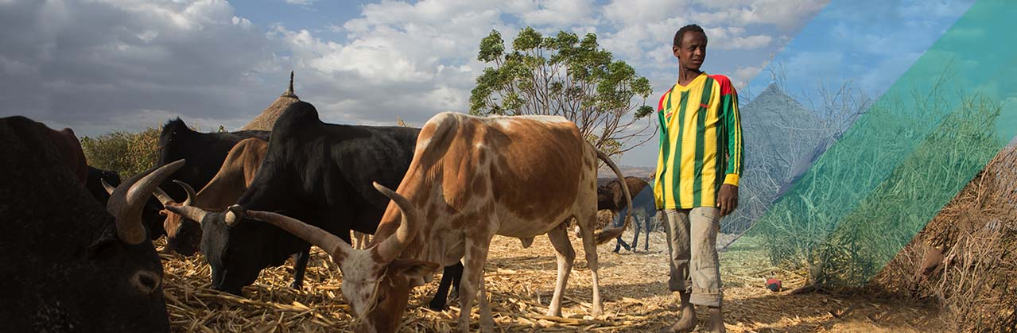

F2F Paired Remote Volunteer Model
EXPECTATIONS | Local Volunteer VVVolunteer | US VOLUNTEER
Onboarding Docs | Yes | No
Per Diem | Yes | No
Developing Report | Yes | No
Debrief | Yes | Yes
Outreach | Yes | Yes

General PROgram OVERVIEW
The Farmer-to-Farmer program promotes sustainable economic growth, food security and agricultural development worldwide. Volunteer experts help people to improve productivity, access new markets and conserve resources. Our volunteers work with farmers, producer groups, rural businesses and nonprofits to increase food production and rural incomes. Improving technical skills through people-to-people exchanges helps empower and equip people to earn better livings for their families.

REMOTE PAIRED VOLUNTEER MODEL
F2F has shifted to a Remote Paired Volunteer (RPV) model – a local volunteer paired with a U.S. based volunteer to allow program implementation during COVID related travel restrictions.

volunteer responsibilities
The local volunteer is responsible for assignment design, preparation, sharing documents pre implementation with the U.S volunteer, engaging and collaborating with the US volunteer, training, developing assignment reports, conducting action planning with hosts and outreach in country, and achieving the assignment objectives. The local volunteer works directly with the host with assistance/input from the US volunteer.
Virtual support from a paired US volunteer helps provide supplementary training resources, fill in the gaps for technical areas, and share creative ideas and solutions. Two specific responsibilities are to: (i) complete the outreach component of the assignment and (ii) support the in-country volunteer as needed.

COLLABORATION IDEAS
- Utilize messaging and video platforms such as WhatsApp, Zoom, Google Hangouts etc. to increase frequency of communication.
- Design training documents together using share tools like Google Docs
- Explore joint facilitation. US volunteer pre-records a short training module and/or virtually trains attendees if possible.
- Hold end of day Q&A sessions. U.S volunteer can respond to questions via email and/or recorded videos.
- Virtual Office hours. Volunteers schedule time for participants to contact them to discuss subject specific issues. Tools: WhatsApp, Zoom, Google Hangouts.

RPV COLLABORATION process
- The collaboration and level of support between the volunteers is unique to each assignment. Some volunteers require minimal support from their US counterpart, while some are more collaborative.
- Both volunteers participate in a call to discuss objectives and collaboration approach at the start of the assignment. Collaboration platforms vary depending on the assignment and connectivity. The most frequently used platforms are MS Teams and WhatsApp.
- Volunteers collaborate as needed to complete the assignment, with the local volunteer reaching out to the US volunteer for support.

Level of effort
- Local Volunteers: Assignments usually last up to 2 weeks; Sometimes extending beyond two weeks due to pending follow up visits, emails etc. Local Volunteers are asked to track assignment hours per day, to stay under 112 hours (14 days x 8 hrs.)
- US paired remote volunteers typically put in 4-6 hours per week, depending on the nature of the assignment and collaboration.

Key steps that must happen for the assignment to count towards volunteer targets.
- Connection Call w/recruiter and F2F CP staff present
- Local volunteer sends initial pre assignment documentation and plans to US volunteer
- Mid assignment check-in with both volunteers and F2F staff present
- US volunteer provides training design input and/or additional resources
- Local volunteer shares final report with US volunteer for input prior to submission
- Each volunteer completes one outreach activity
Bonus points:
- Both volunteers participate in the end of assignment debrief
- Recruiters and CP teams complete outreach activity
- Recruiters and team review assignment debrief survey responses and mitigation measures for any identified issues

